

ST. XAVIER’S COLLEGE AUTONOMOUS

5 , Mahapalika marg,fort,Mumbai-400001

2017-18

**A PROJECT REPORT ON**

**RAILWAY RESERVATION SYSTEM !!**

**BY**

**RAHUL MUKESH SINGH -155051**

**&**

**SANJANA GOPALKRISHNA -155025**

Under the Guidance of

**PROF. SUBHASH KUMAR**



**PROJECT CERTIFICATE**

This is to certify that the project entitled **“RAILWAY RESERVATION SYSTEM”** is Undertaken at St. Xavier’s College Autonomous , Mumbai by **Mr. Rahul Mukesh Singh**( **UID-155051** ) and **Ms. Sanjana Gopalkrishna**( **UID-155025** ) in the year **2017-18**. In Partial Fulfilment of B.ScIT Degree(**Semester VI**) Examination has not been submitted for any other examination and does not form part of any other course undergone by the candidate. It is further certified that he/she has completed all the required phases of the project .

Signature of Signature of Signature of

Internal Guide Internal Examiner External Examiner

Signature of H.O.D. College Seal

**DECLARATION**

**Rahul Mukesh Singh(UID-155051)** and **Sanjana Gopalkrishna(UID-155025)**, hereby declare that this project report entitled: **“RAILWAY RESERVATION SYSTEM”** which is being submitted in fulfilment of the Bachelors of Science in Information Technology Examination conducted by St. Xavier’s College – [Autonomous, under Mumbai University] is the result of the work carried out by us under the supervision of **Prof. Subhash Kumar** of St. Xavier’s College-Autonomous Mumbai.

This work has not been previously submitted to any other University for any examination. Wherever references have been made to previous work of others, it has been clearly indicated as such and included in the bibliography.

**Signature Signature**

**[Rahul Mukesh Singh] [Sanjana Gopalkrishna]**

**Date:**

**ACKNOWLEDGEMENT**

We take this opportunity to express our profound gratitude and deep regards to our teachers for their exemplary guidance, monitoring and constant encouragement throughout the course of this project.

The blessings, help and guidance given by them, from time to time, shall carry us a long way in the journey of life on which we are about to embark.

We also take this opportunity to express a deep sense of gratitude to the Head Of Department, Mr.Roy Thomas for his cordial support.

A large debt of gratitude is owned to my project guide Mr.Subhash Kumar who has not only endured, but also assisted and inspired us for taking up the project on “Railway Reservation System”.

We want to acknowledge and thank him for giving us the opportunity to do this under his guidance and for sharing his knowledge. His continuous guidance, time, valuable suggestions, inputs and helpful criticisms have helped us to accomplish such a task.

Lastly, We thank almighty, our parents, family and all those persons ‘Behind the Veil’ for their constant encouragement and support, which enabled us to complete the project through thick and thin.

**TABLE OF CONTENTS**

**Contents Page No.**

1. **Preliminary Investigation**…………………………………...... 1
   1. System Overview…………………………………………..…
   2. Description of System………………………………………..
   3. Objective and scope of project……………………………….
   4. Limitations of present system………………………….……
   5. Proposed system and its advantages……………………….
2. **Requirement Specification**………………………………….… 8
   1. Functional Requirements……………………………………….
   2. Non Functional Requirements…………………………………
3. **Feasibility Study**…………………………………………………… 12
   1. Technical Feasibility…………………………………………….
   2. Economic Feasibility……………………………………………
   3. Operational Feasibility…………………………………………
4. **System Analysis**……………………………………………………  **16**
   1. Use Case Diagrams……………………………………………..
   2. ER Diagrams…………………………………………………….
   3. Flowcharts of Algorithms………………………………………
   4. Gantt Chart……………………………………………………..
5. **System Coding**…………………………………………………….... 24
   1. List of tables ……………………………………..……………....
   2. Screen Shots………………………………………………….......
   3. Codes……………………...……………………………………....
6. **System Testing**……………………………………………………..... 259
   1. Test techniques………………………………………………......
   2. Test data………………………………………………………….
   3. Validation...………………………………………………………
7. **Future Enhancements**……………………………………………. 294
8. **References and Bibliography**………………………………… 295

**preliminary investigation**

**1.1 System overview**

The Indian Railways (IR) which is the world’s largest railway system under single management carries about 22.2 millions passengers in reserved accommodation every day. India’s as well as Asia’s first train streamed off from Mumbai to Thane on 16th April, 1853 covering a distance of 34 kms. Later, Railway network grew very rapidly and spread across all over India.

The Computerised Passenger Reservation System(PRS) facilitates the booking and cancellation of tickets from any of the 4000 terminals(i.e. PRS booking window all over the countries). These tickets can be booked or cancelled for journeys commencing in any part of India and ending in any other part, with travel time as long as 72hours and distance up to several thousand kilometres. The project of PRS was launched on 15th November 1985, over Northern Railway with the installation of Integrated Multiple Train Passenger Reservation System(IMPRESS), an online transaction processing system developed by Indian Railways in association with Computer Maintenance Corporation Ltd., at New Delhi. The objective was to provide reserved accommodations on any train from any counter, preparation of train charts and accounting of the money collected. The application was implemented in 1987 Mumbai, Chennai, Kolkata, Secunderabad subsequently.

Birth of Indian Railway Catering and Tourism Corporation [IRCTC] took place on  27th September, 1999. Corporate office of IRCTC is situated in New Delhi. IRCTC is a Public Sector Enterprise under Ministry of Railways.

Main functionality of IRCTC by Indian Railways is to upgrade the reservation system online, professionalize and manage the catering and hospitality services at stations, on trains and other locations and to promote domestic and international tourism through development of budget hotels, special tour packages, information & commercial publicity and global reservation systems.

IRCTC is a G2C [Government-to-Customer] business which has a very effective effect towards a positive development of India.

**1.2 DESCRIPTION OF SYSTEM**

RAILWAY RESERVATION SYSTEM is a website which provides the customer with ease of ticket booking from anywhere, anytime in less than a hour.

The main purpose of this project is Reserving train seats and cancellation online. At Present, where India is moving towards Digital India , this is a small effort taken by us.

The various advantages of using Online Reservation System are as follows:

* Convenient – You can book or cancel your tickets sitting in the comfort of your home or office.
* Saves Time and Effort – You can save the time needed to travel to the railway reservation office and waiting in the queue for your turn.
* Towards a greener Planet – Instead of printing your tickets you can choose to travel with the soft copy of your booked ticket in your laptop or mobile.

**1.3 OBJECTIVE AND SCOPE OF PROJECT**

Our project introduces railway reservation system with an objective to make the reservation system more efficient, easier and fast. This project explores how computer technology can be used to solve the problem of user.

The scope of the project as of now is limited to College Project purpose which may further be enhanced to bring into real application purpose.

The main objectives provided by this software are as follows:

* We can enquire about availability of trains.
* We can reserve and cancel the seats.
* We can see the history of the bookings and cancellations made by a account.
* We can download Ticket in PDF format.
* We have an Emergency Chat Board for user to report to railways.
* Management of all the details regarding trains, routes, Customers, Tickets, Payment, Booking and many more.
* Administration module where the Trains, Routes, Costs, Emergency Requests, Quota, Coaches details can be inserted, updated, modified in the database.
* Report Generations for analytic purpose.

**1.4 LIMITATIONS OF PRESENT SYSTEM**

The Present System- IRCTC Railway Reservation Website is one of the most used and trusted website of India. Lakhs of people book and cancel their tickets through this system on daily basis.

Some of the limitations which we found in the IRCTC Website are as follows:

* A user can book only upto a maximum of 6 tickets per month and 2 tickets per day.
* Individuals are allowed only two tickets per User-ID in a day for Tatkal booking from 10 am to 12 pm.
* Maximum of only 4 members can be included in Single Ticket or Single PNR.

**1.5 PROPOSED SYSTEM AND ITS ADVANTAGES**

RAILWAY RESERVATION Website helps in booking train tickets and also helps the User to check the Seat Availability in Trains.

A user can also Cancel the tickets, check the history of the Bookings and Cancellations made through corresponding account.

Emergency Chatting Board is also built for the customers to get instant help. If any emergency permits during the travelling, he/she can message through Emergency Chat Board and corresponding action could be taken by the Railways.

Passenger can reserve any number of tickets from one account. Various Seat Quotas have been provided for reserving seats. Also, according to the quotas, Concession has been provided per seat.

An Individual can book their ticket according to the Coaches they are comfortable. The Fare Prices of the individual varies according to the Coaches and Quotas selected by the user.

Individual can also see the number of Confirm, RAC, Waiting Seats available for the train and coach selected. Through this, the individual can get an idea of whether he/she should book the ticket for the selected train or he/she need to Check for different trains.

The payment of the Reservation is Online which can be done using Credit-card /Debit-card, etc.

The ticket is generated automatically which the user can download and save for travelling purpose.

Administration module which keeps the track of all the records of trains, quotas, coaches, costs, routes and many more.

Any future Updation can be made by the administration module.

Emergency chat where user requests for emergency request, the record of these are kept by administration module and corresponding actions would be taken by them.

**REQUIREMENT SPECIFICATION**

**2.1 FUNCTIONAL REQUIREMENTS**

Requirement Specification for a software system is a complete description of the behaviour of a system to be developed. It can be defined as what a system is supposed to accomplish. A function can be set of inputs, behaviour, and also outputs.

Following are the factors included in our functional requirements:

1. **Performance Requirements:**
2. *Satisfaction of User:*

The system is developed such that it meets user’s needs.

1. *Response Time:*

By careful Programming, the response time of all the operation is good.

1. *Error Handling:*

Response to user errors and undesired situations has been taken care of to ensure that the system operates without halting.

1. *Safety and Robustness:*

The system is able to tackle disastrous actions without the intervention of human.

1. *Portable:*

The system is not architecture specific. It can be easily transformed to other platforms is needed.

1. *User friendliness:*

The system is easy to use and understand. The native user can also access the system without any difficulty.

1. **Design Constrains :**

There are a number of factors in the client’s environment that may restrict the choices of a designer. These factors could be standards to be followed, resource limits, operating environment, reliability, etc. Requirement Specification should identify and specify all such constraints.

1. *Standard Compliance:*

Requirements for the standards the system must follow.

Standards may include report format.

1. *Hardware Limitations:*

The software may have to operate on some existing or predetermined hardware, thus imposing restriction on the design. Hardware limitations may be type of machines used, operating system available on the system, languages supported and limits on primary and secondary storage.

1. *Security:*

Security requirements are significant in database systems. They play restriction on the us of certain commands, access to some data, provide different kind of access requirements for different people.

1. **Hardware Requirements:**

This specifies the hardware requirements like memory restrictions, cache size, processor, RAM size, etc.

1. **Software Requirements:**

Any window based operating system with DOS support is the primary requirement. Others softwares required are as follows:

1. Eclipse EE
2. Xampp-MySQL

**2.2 NON-FUNCTIONAL REQUIREMENTS**

1. **Security:**

The system should not leave any cookies on the customer’s computer containing the user’s password. The system’s backend servers should be only be accessible by administration side and authenticated management.

1. **Reliability:**

The important foundation of the reliability is the backup of the database which is continuously maintained and updated.

1. **Availability:**

The system should be available all the time i.e. the user can access it using a web browser.

1. **Supportability:**

The codes and supporting modules of the system will be well documented and in understandable format.

**FEASIBILITY STUDY**

Feasibility study is a high level version of the entire system analysis and designing a process. The purpose of the feasibility is not to solve the problem but to determine if the problem is worth solving. Performance is defined by the identification of specific system objects and descriptive of output. There are following types of interrelated feasibility. They are as follows:

* Technical Feasibility
* Economic Feasibility
* Operational Feasibility

**3.1 TECHNICAL FEASIBILITY**

In examining technical feasibility configuration ,the system is given more importance than the actual make of hardware. According to the definition of technical feasibility the compatibility between frontend and backend is very important. In our project the compatibility of  both is very good. The degree of compatibility of JSP and MYSQL is very good. The speed of output is very good when we enter the data and click button. The response time is very fast and give result very quickly.

We chose JAVA because it provides following features and we thought it would make our project more efficient.

* It gives optimized performance.
* Portable
* User-friendly
* Sturdy Garbage Collection
* Native threads

**3.2 ECONOMIC FEASIBILITY**

Economic analysis is the most frequently used technique for evaluating the effectiveness of a proposed system. Economic analysis is the procedure to determine the benefits and saving that are effected from a proposed system and compare them with cost. If benefits outweighs cost, decision is taken to design the system. Otherwise, further justification or alternative in the proposed system will have to be made. Total cost of the proposed system is very cheap and therefore the organization will not find any difficulty at the installation.

Economic feasibility is the determination of the resources that are:

* Time Management
* Cost of doing full system study
* Estimated cost of hardware
* Estimated cost of software
* Estimated cost of software development

**3.3 OPERATIONAL FEASIBILITY**

Operational feasibility is the problem or acceptability of the solution. There are two aspects of the operational feasibility.

* If the problem is worth solving
* What to the end users and the management feel about the problem or solution.

The following points are considered for the above problems:

* Performance
* Information
* Economy
* Control
* Efficiency
* Services

**SYSTEM ANALYSIS**

**4.1 USE CASE DIAGRAM**

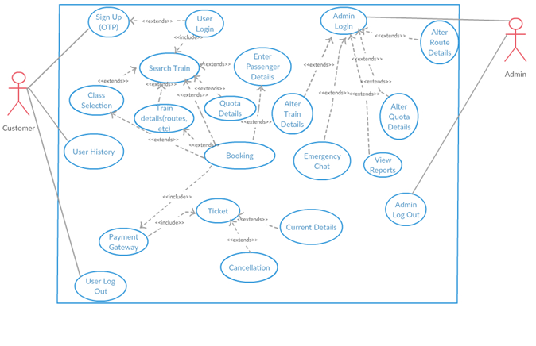

* 1. **ER DIAGRAM [ excluding 11 tables of analysis ]**

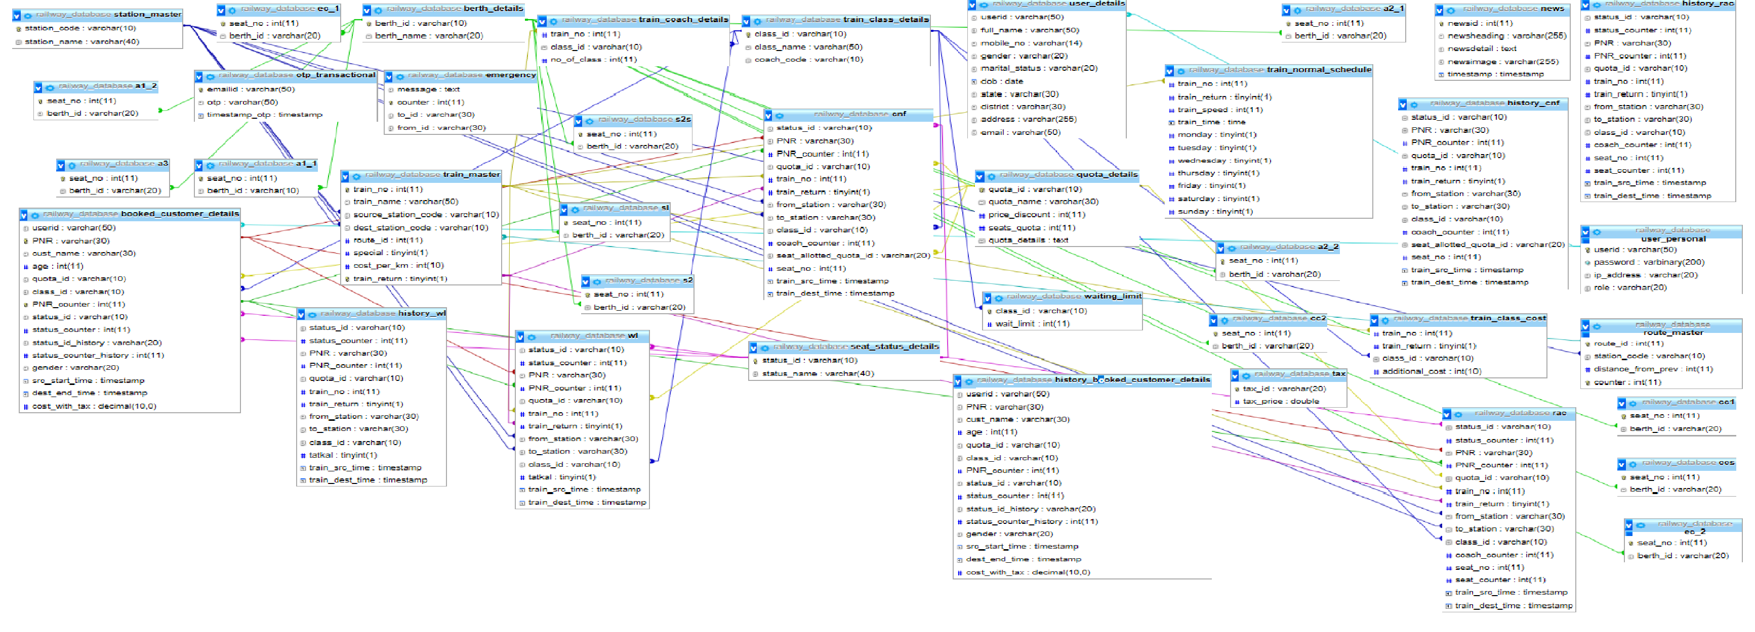

**4.3 FLOWCHART OF ALGORITHMS**

**Cancellation flowchart :**

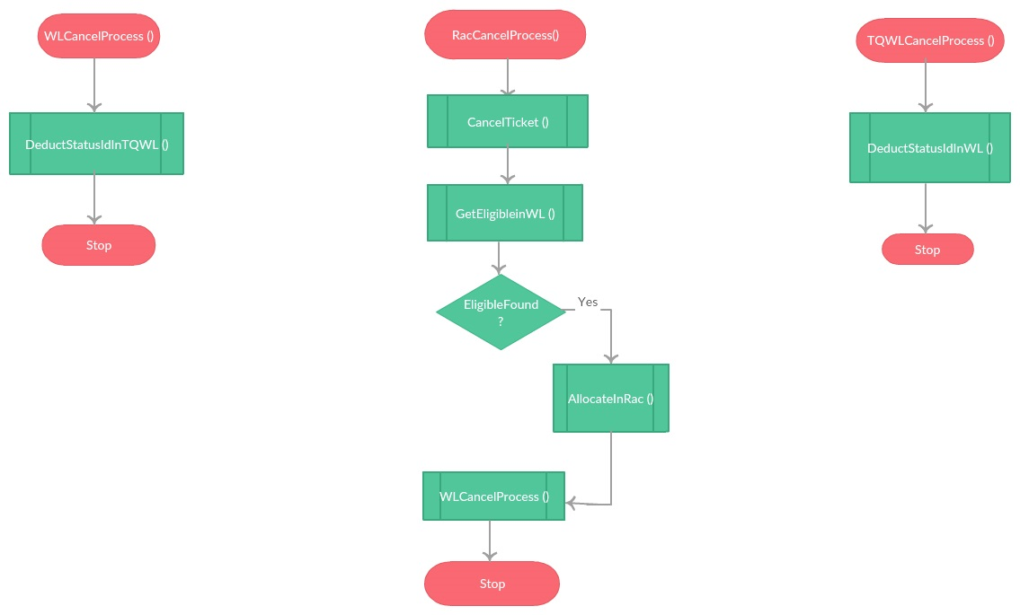

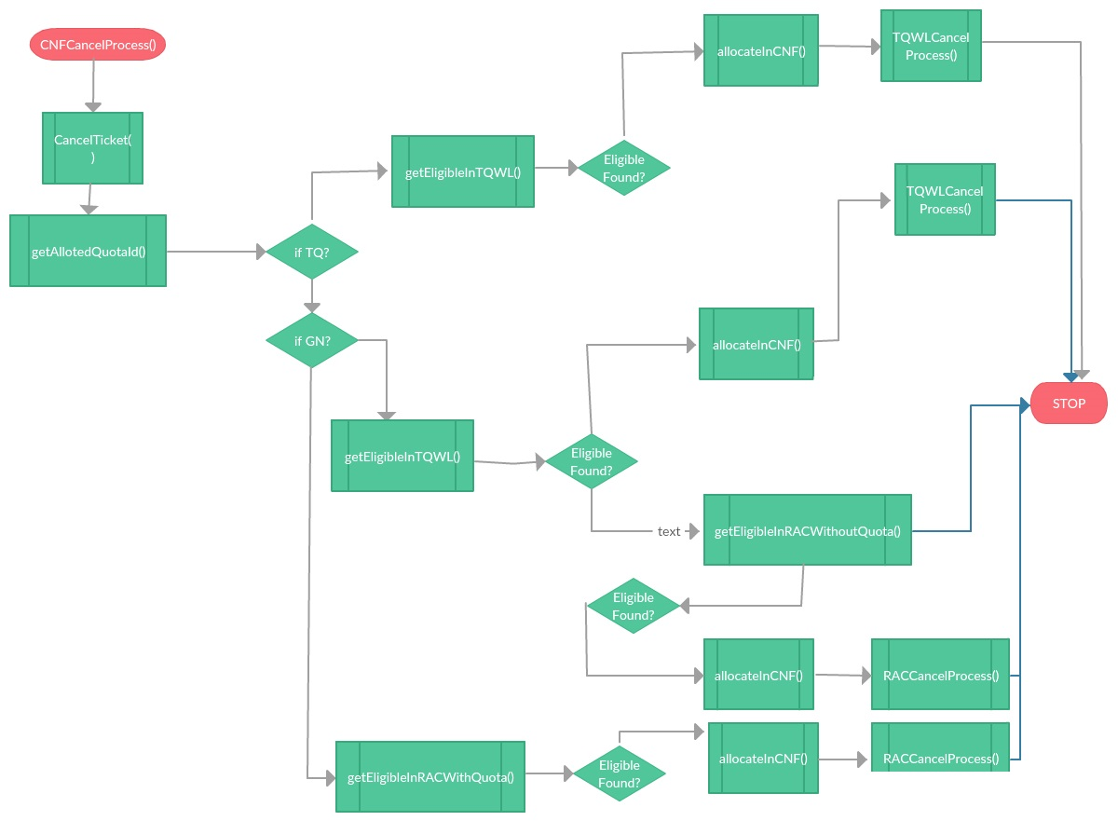

**SeatAllocation Flowchart :**

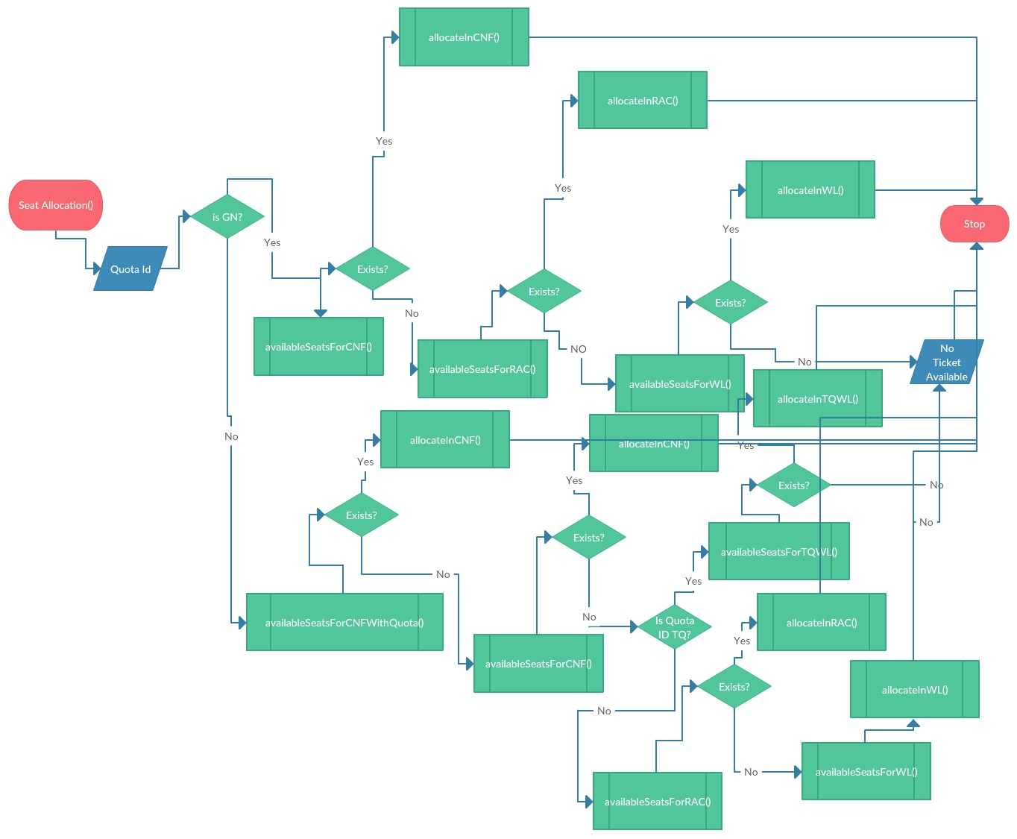

**Seat Availability flowchart :**

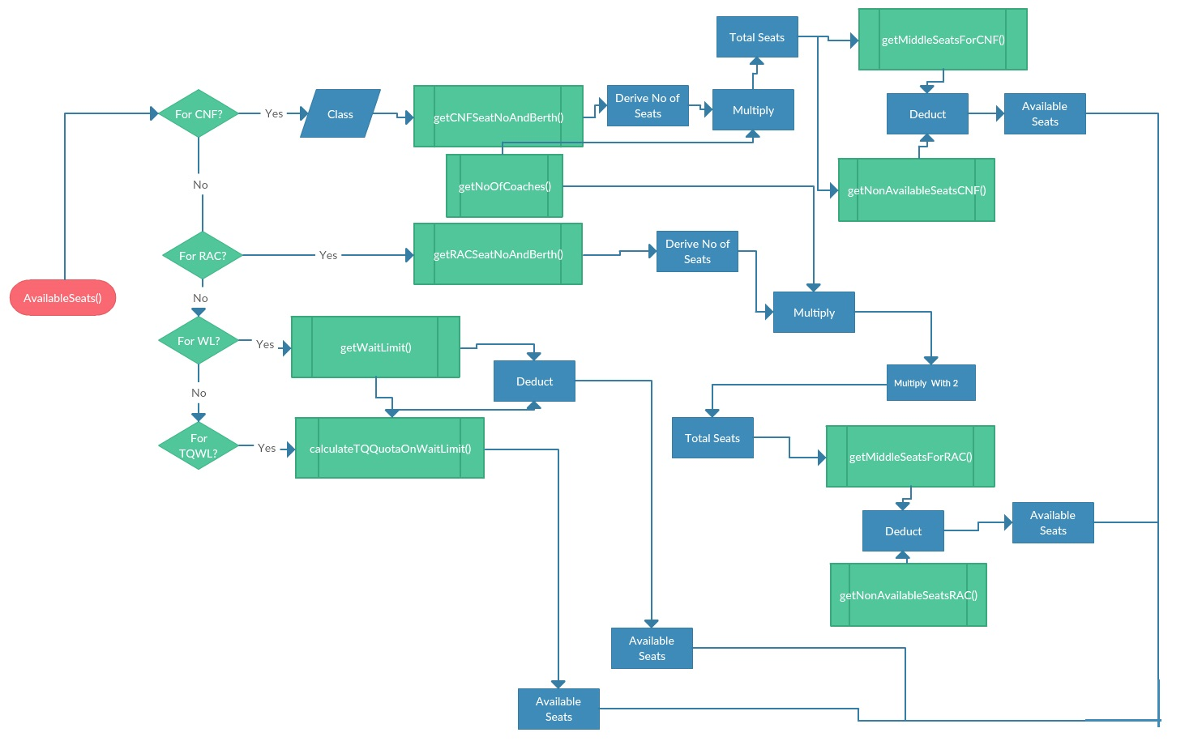

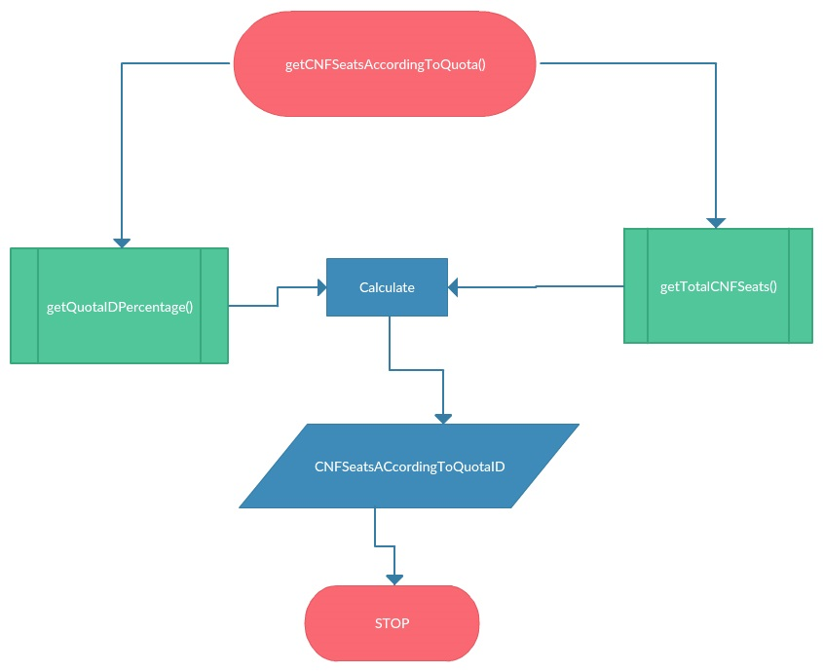

**4.4 GANTT CHART**

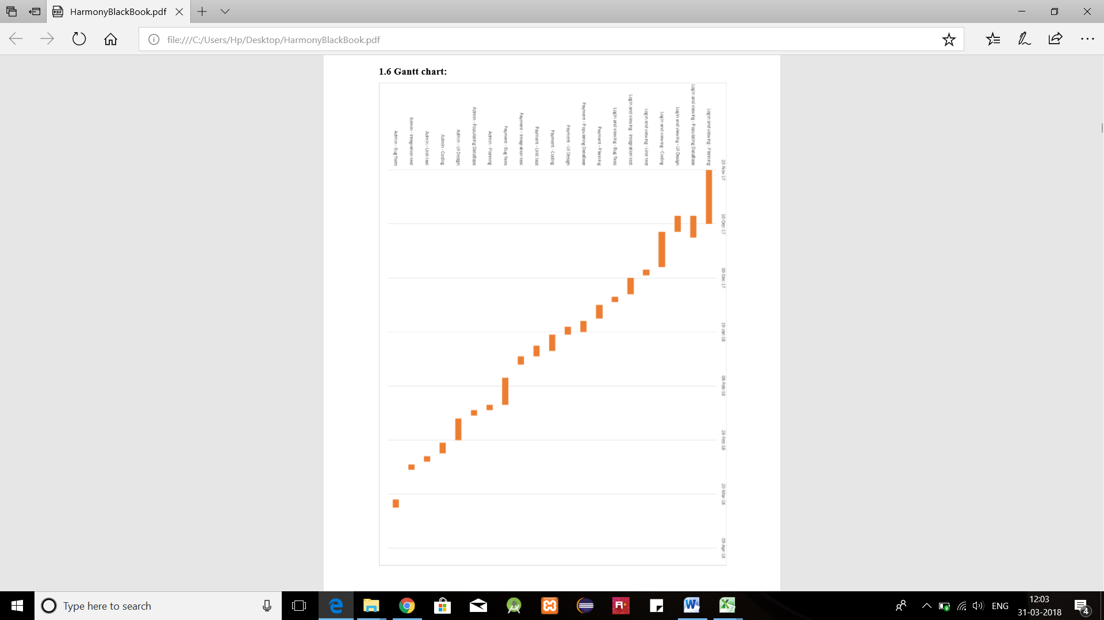

**System coding**

**5.1 list of tables**

Tables are the collection of rows and fields with appropriate data inside the database.

There are about 50 tables used for this project. Every table has some valuable attributes and corresponding constrains.

Below are the Screenshots of some of the tables used for User’s module:

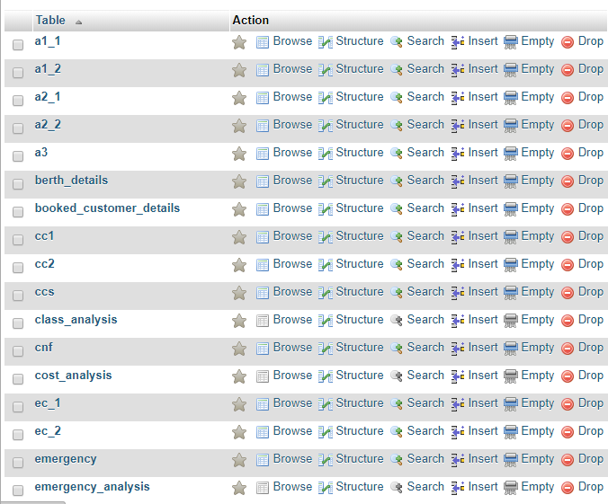

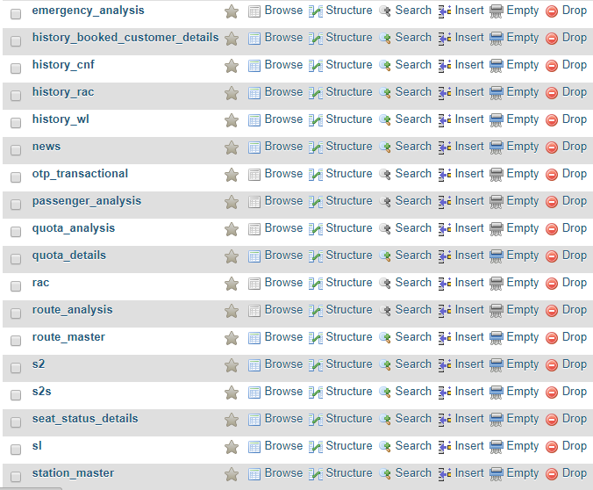

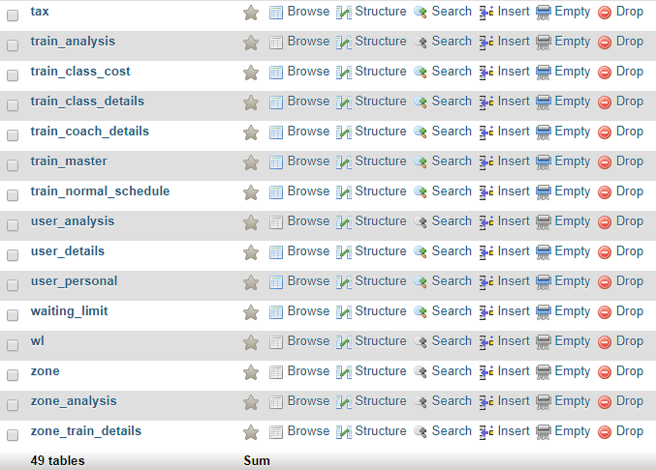

**5.2 SCREEN SHOTS**

**1. INDEX PAGE**

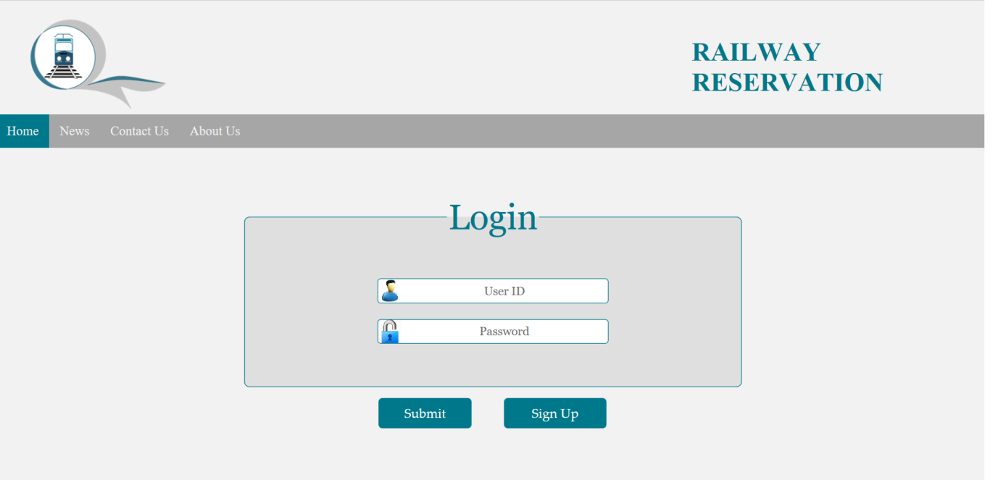

2. **SIGNUP PAGE**

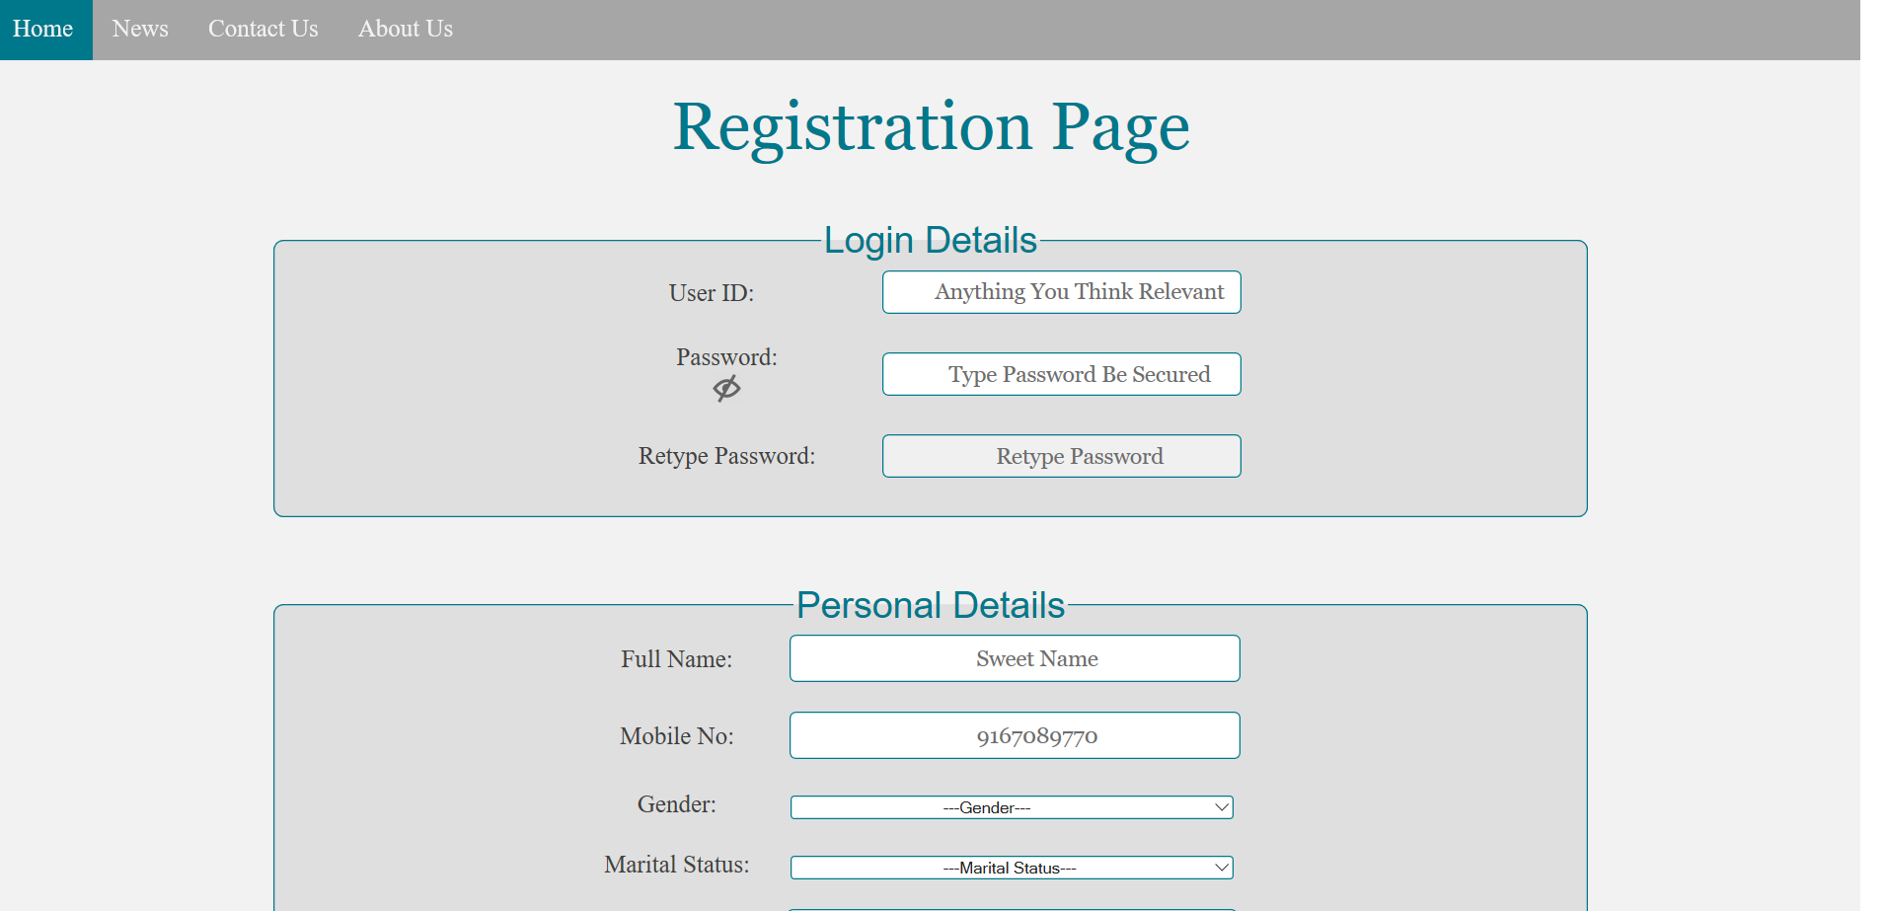

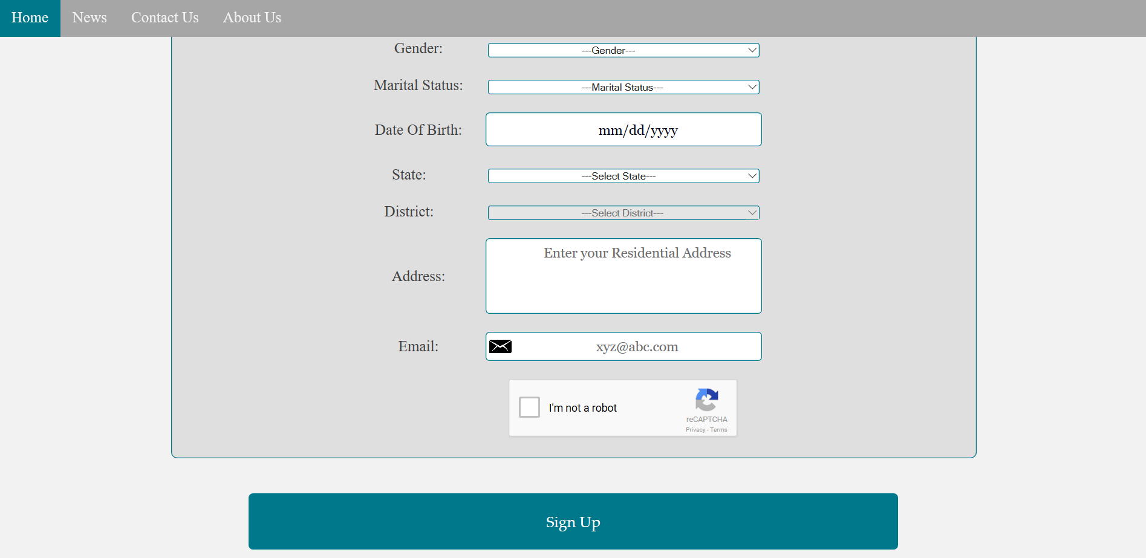

OTP in Signup Page:

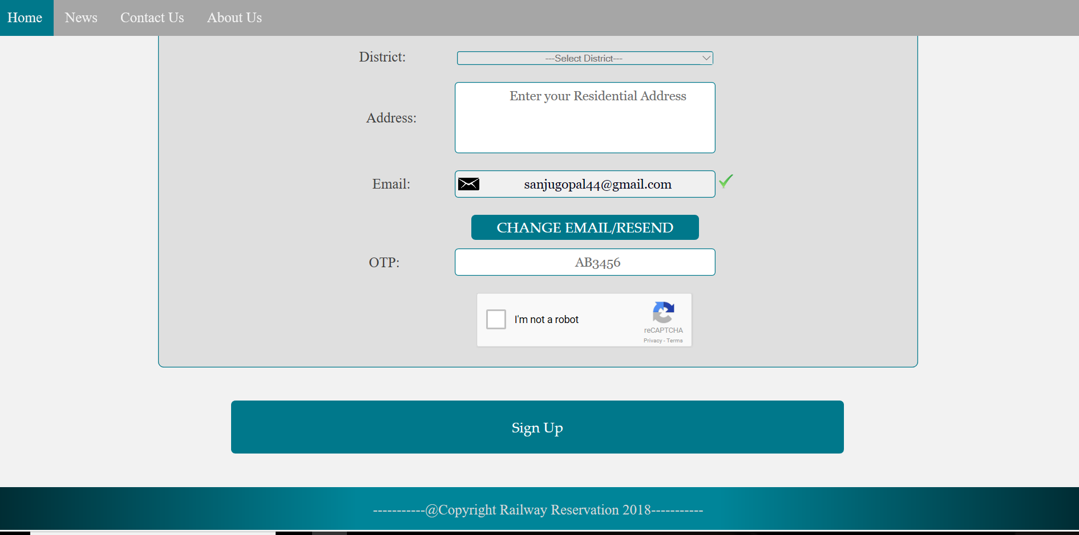

**3. VIEWDETAILS :**

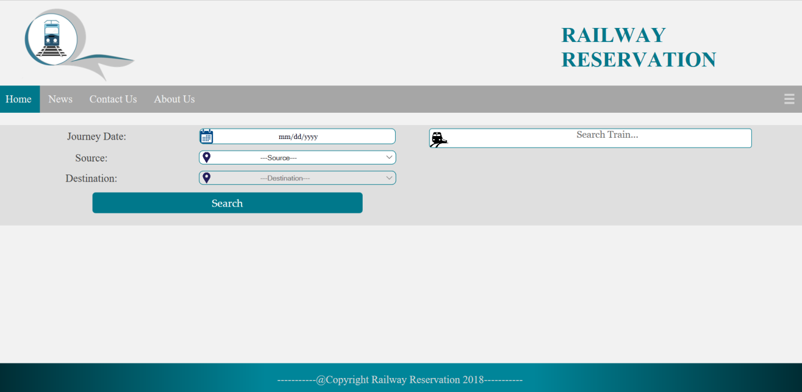

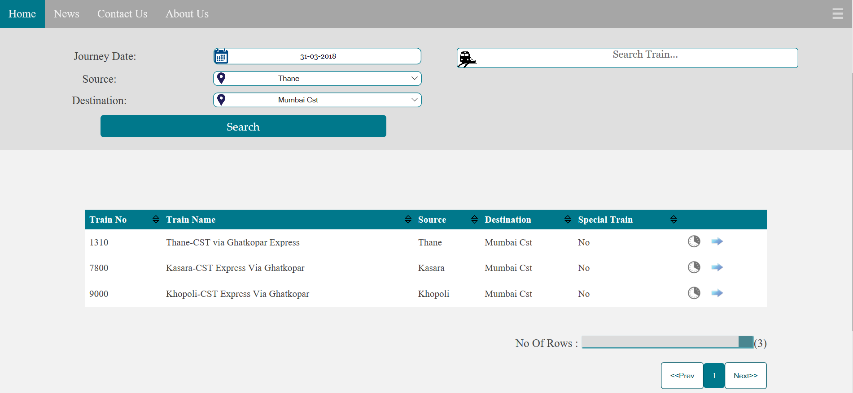

Display of timing expected to reach destination from source provided.

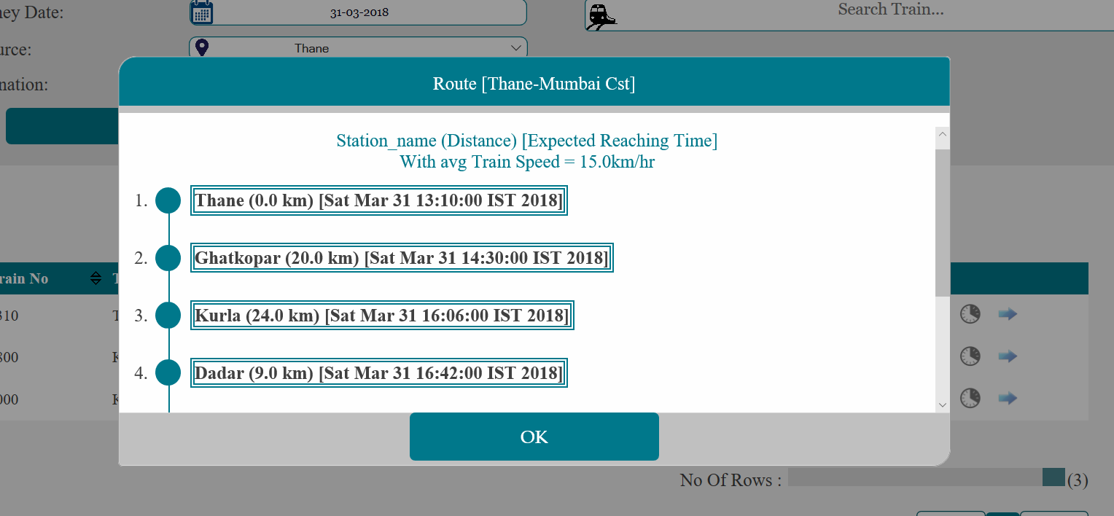

**4. CLASS SELECTION:**

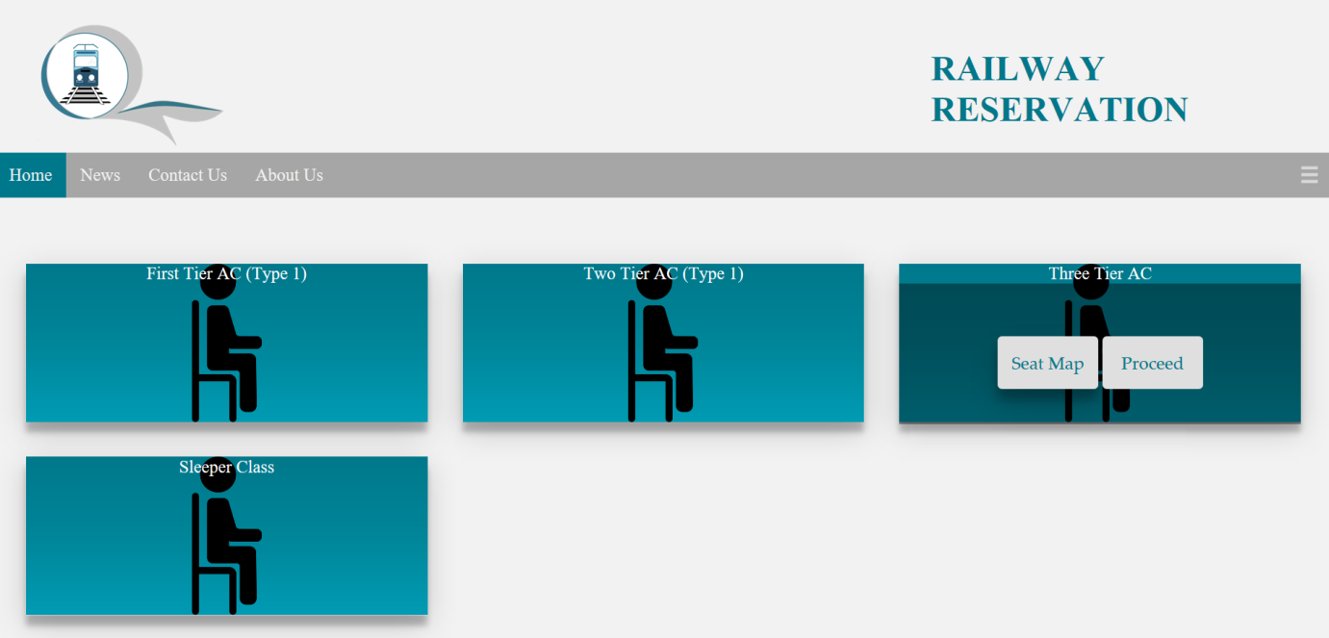

On click of Seat Map:

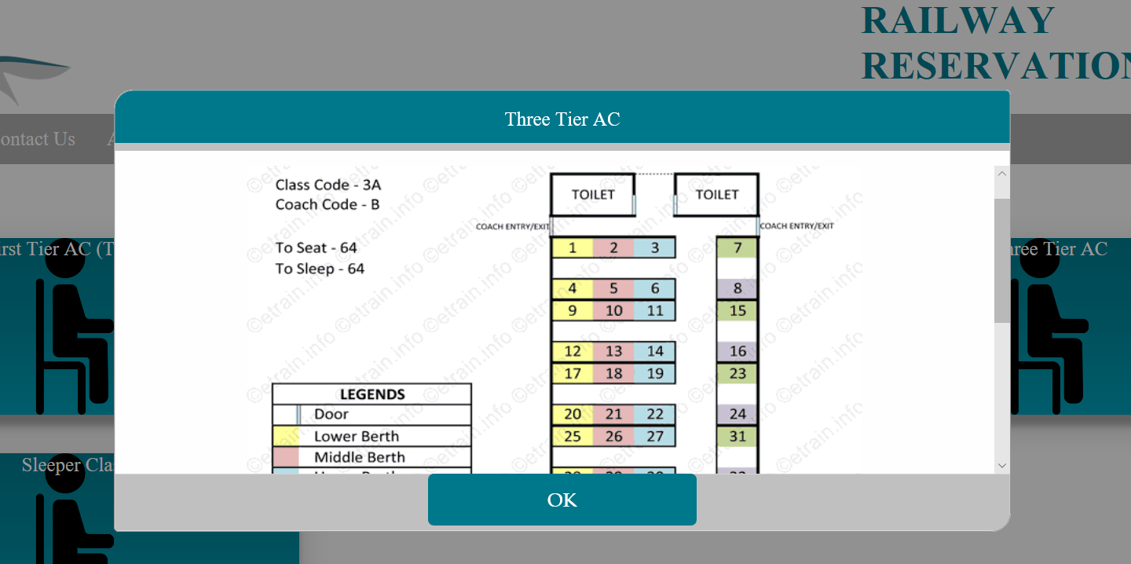

1. **QUOTA_DETAILS:**

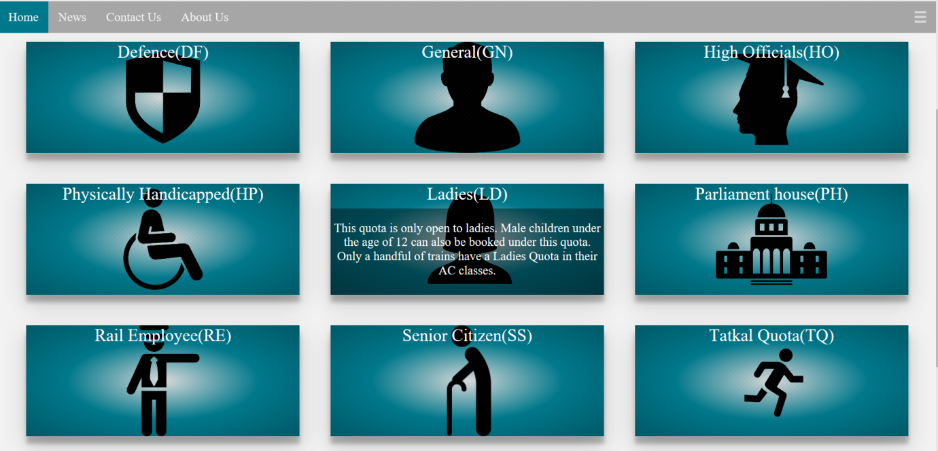

1. **SEAT_AVAILABILITY WITH CORRESOPONDING COST AND QUOTA :**

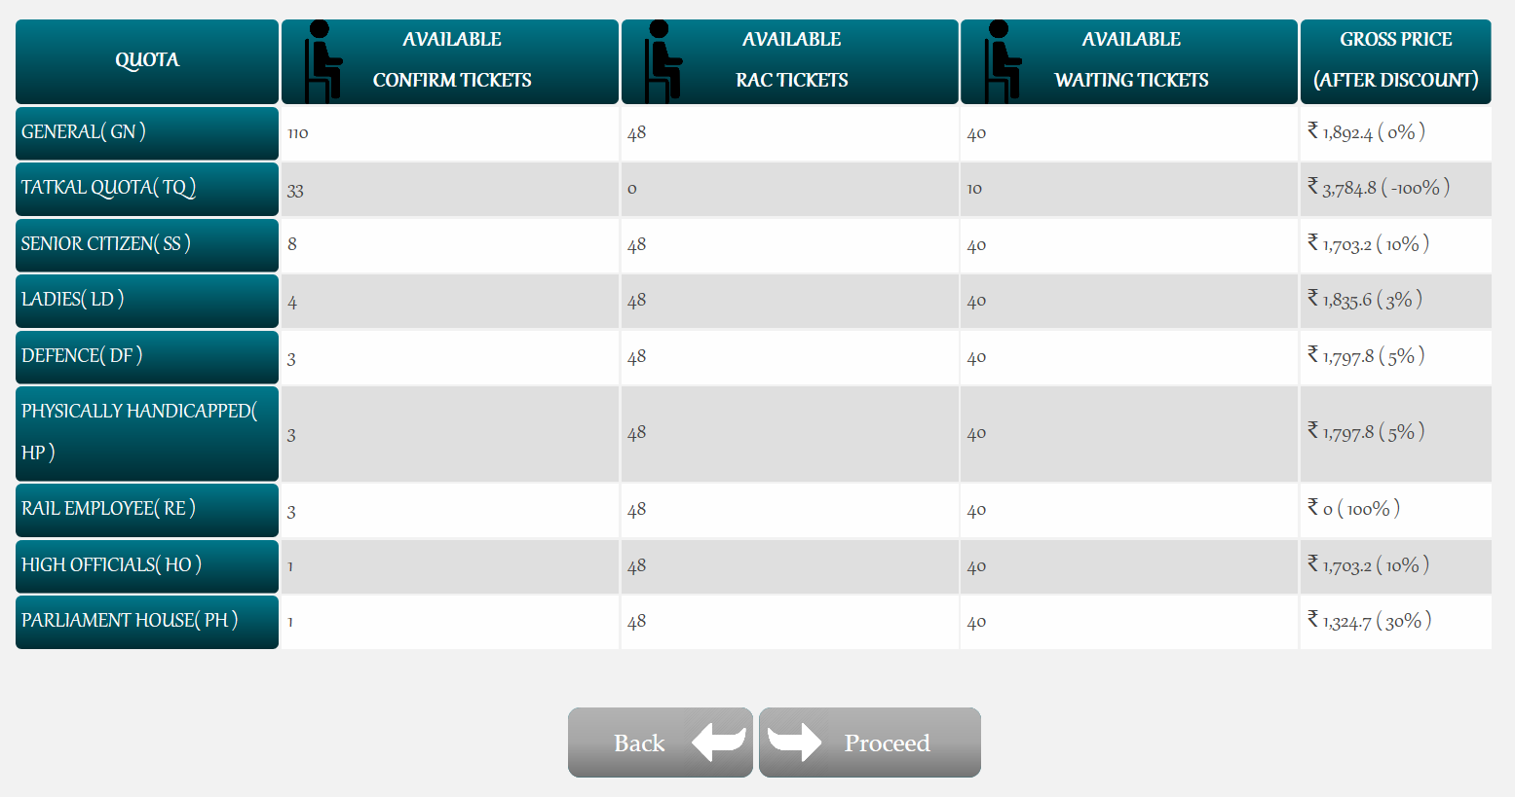

1. **BOOKING :**

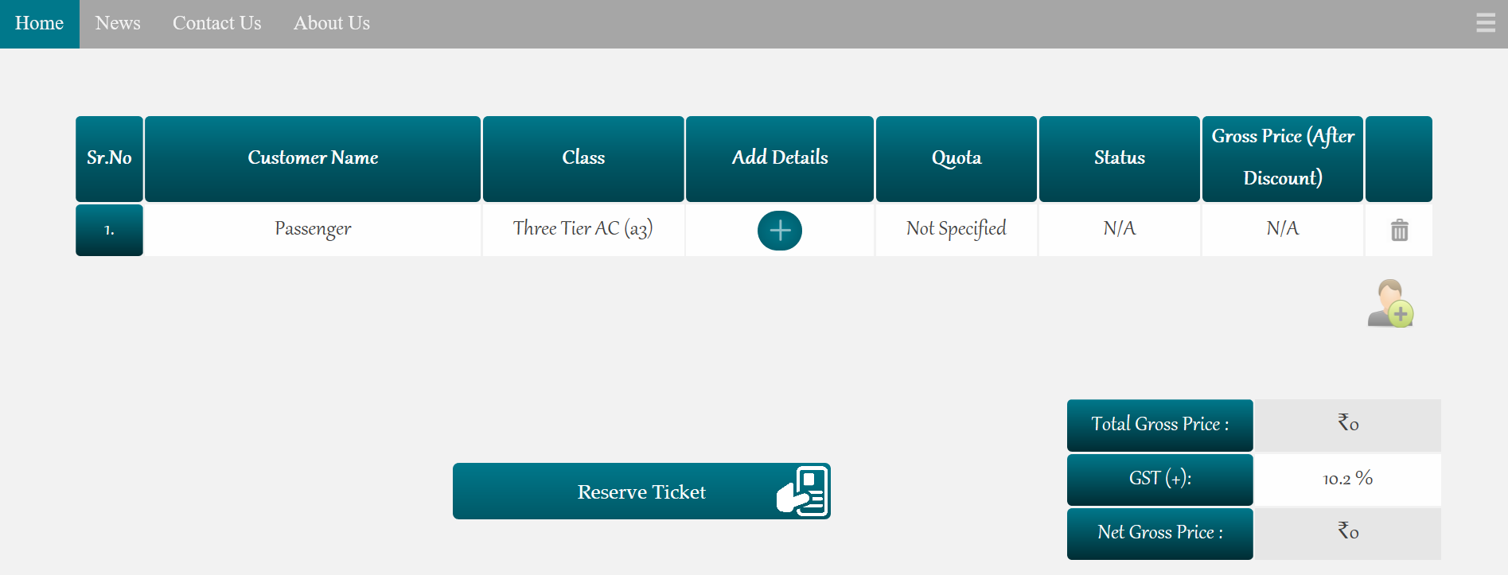

ADDING NUMBER OF PASSENGERS:

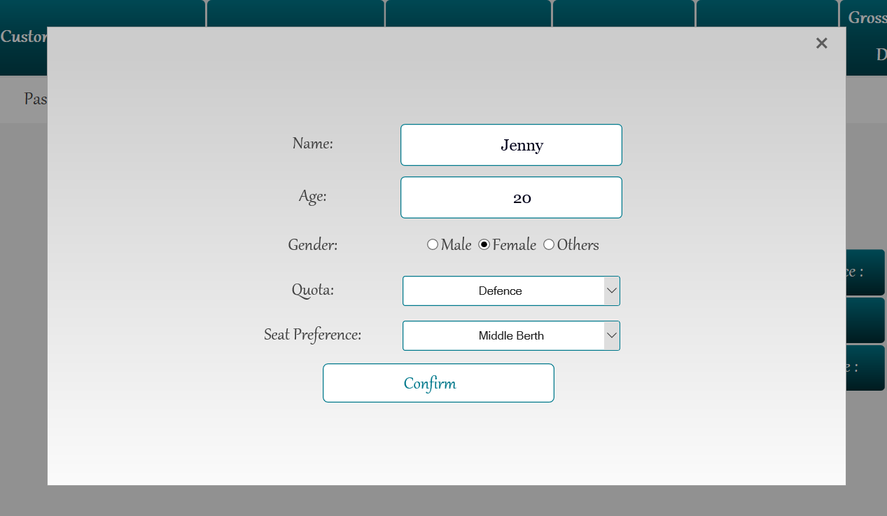

Display of number of passengers and cost :

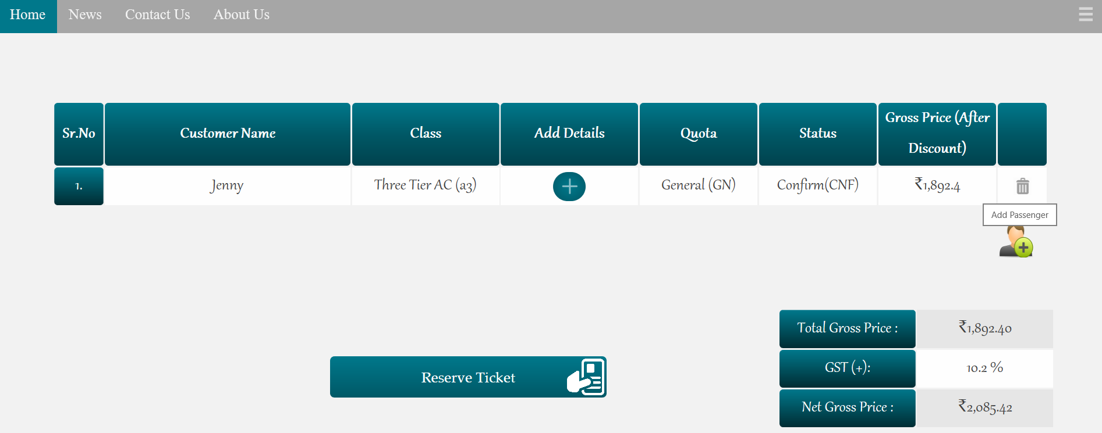

1. **BOOKED :** Ticket display which can be downloaded or send to your mail account.

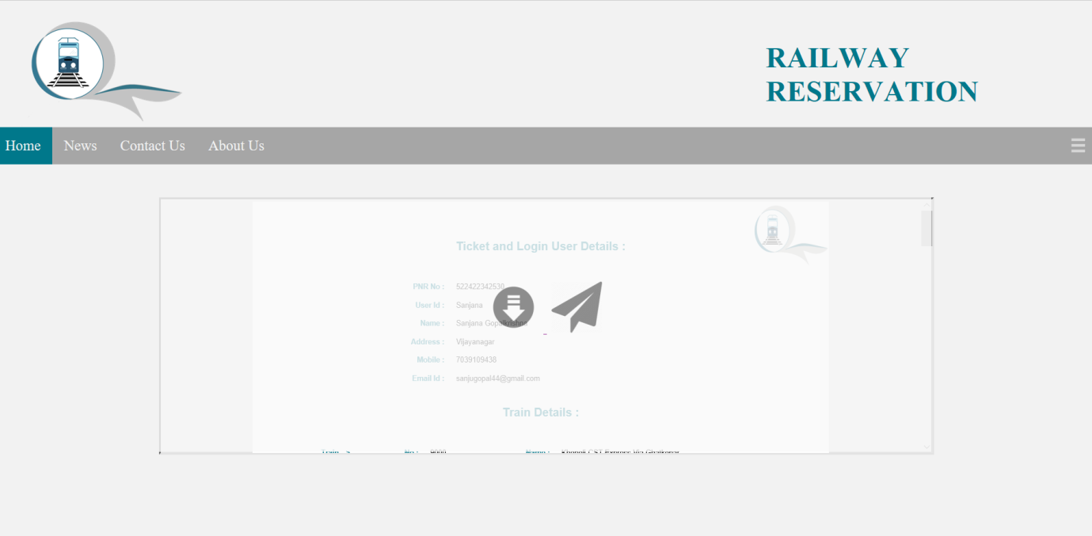

1. **TICKET :**

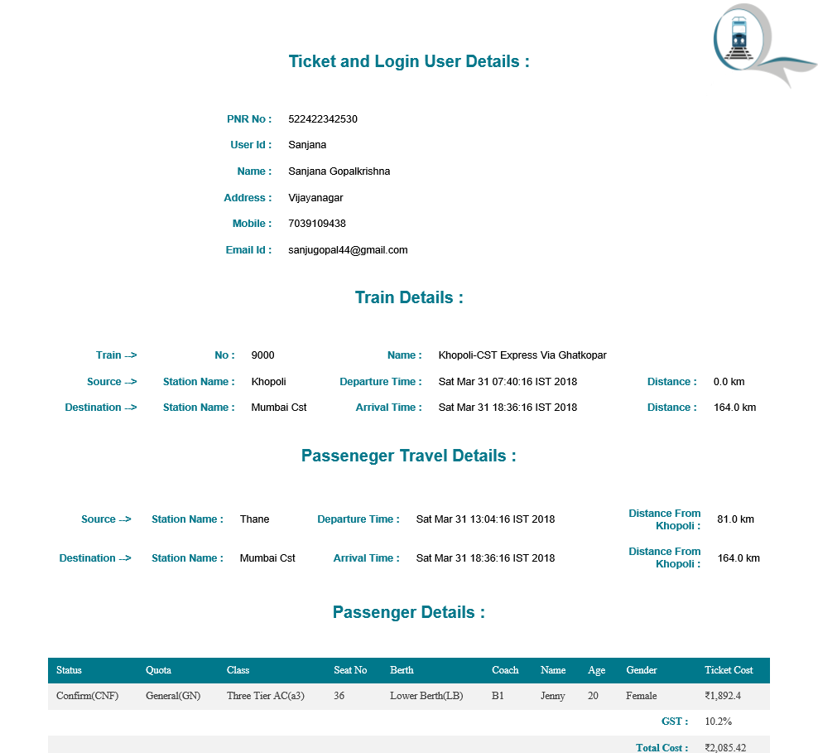

1. **CANCELLATION OF TICKET :**

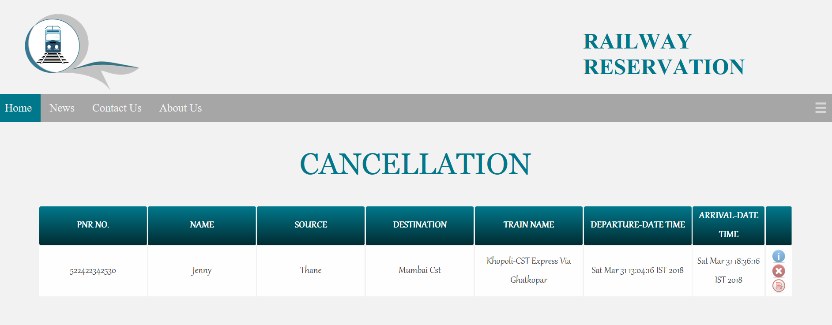

On Clicking Show-details Icon: All the information is displayed regarding passengers travelling.

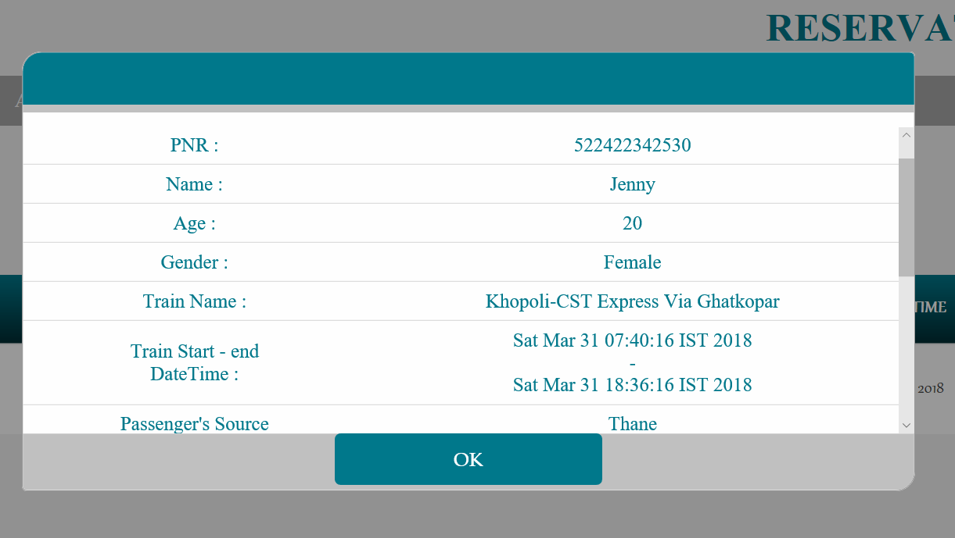

On Clicking Cancel button: By clicking Yes, the ticket gets cancelled.

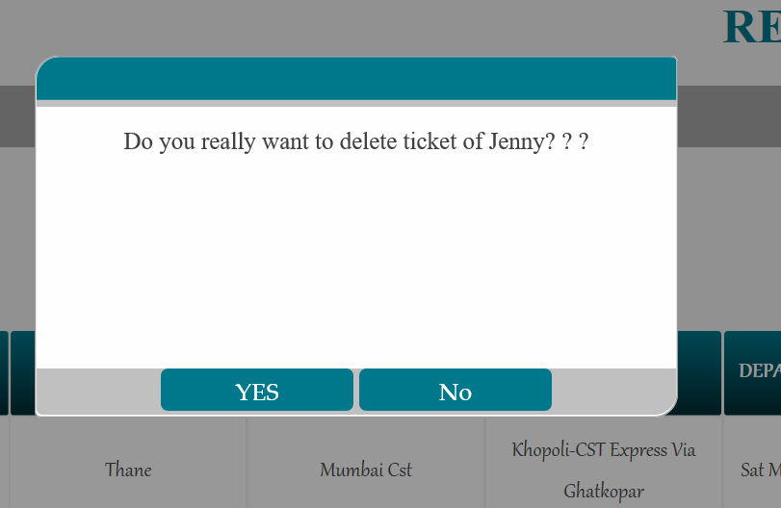

1. **HISTORY OF USER :**

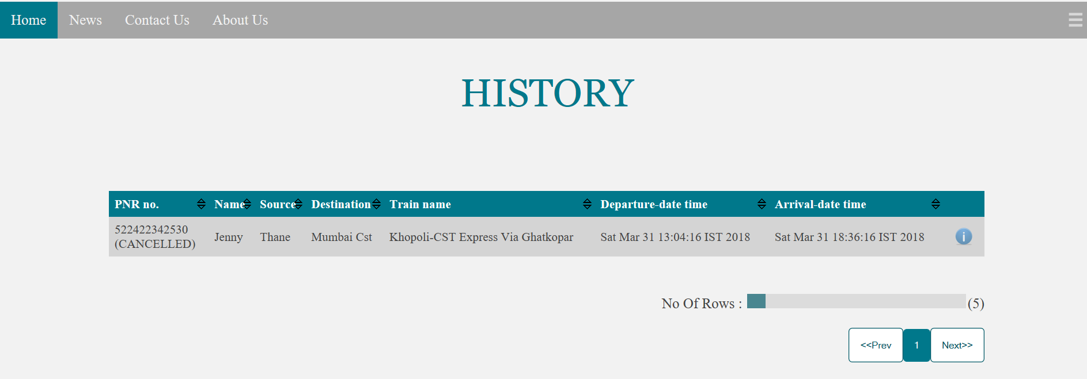

1. **EMERGENCY CHAT BOARD :**

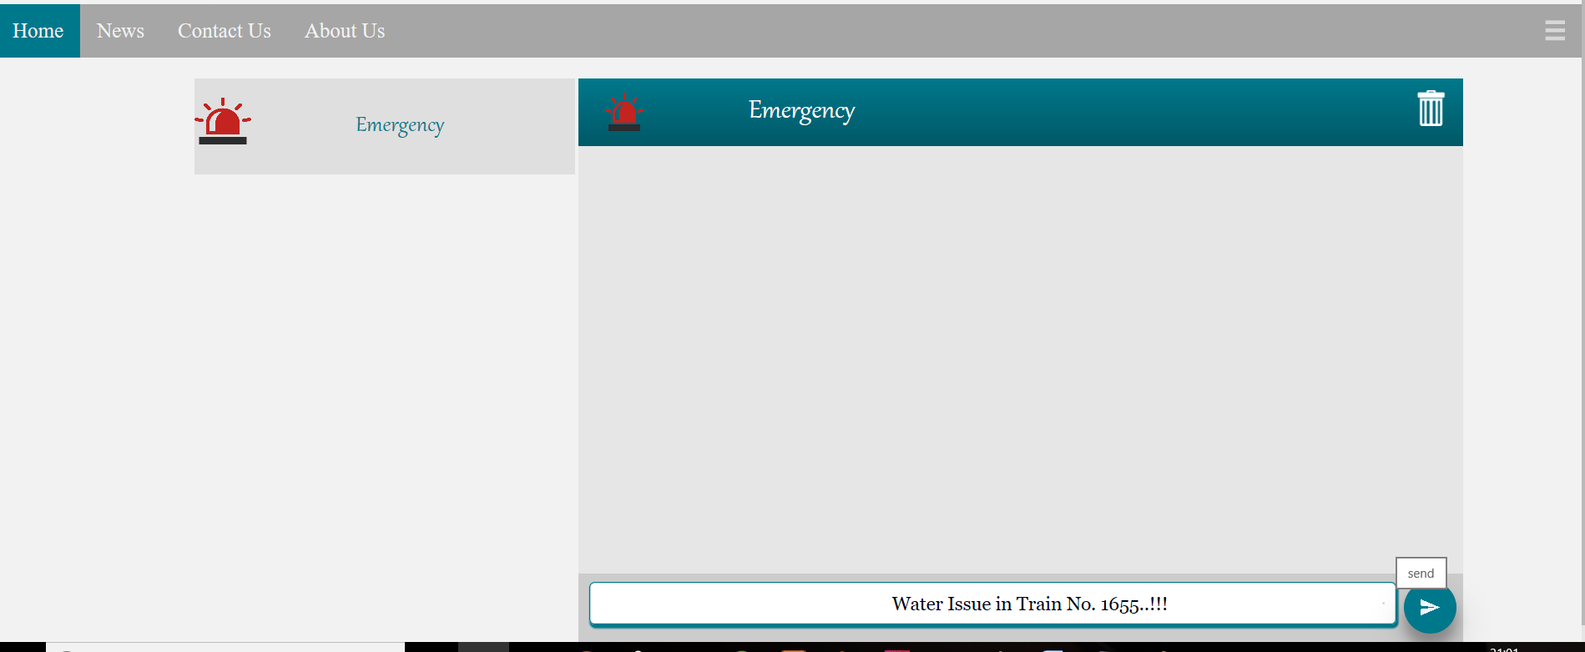

After Admin responding to the user :

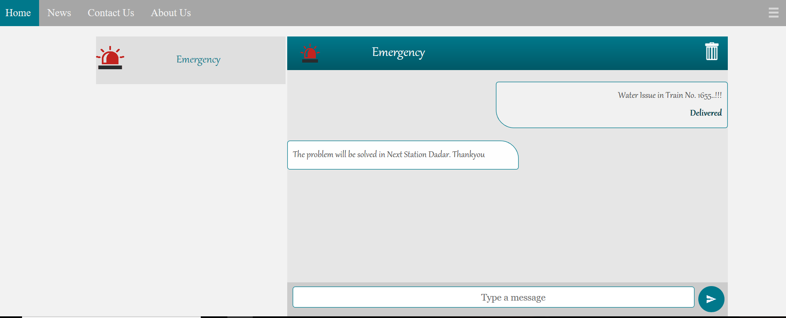

1. **CONTACT US :**

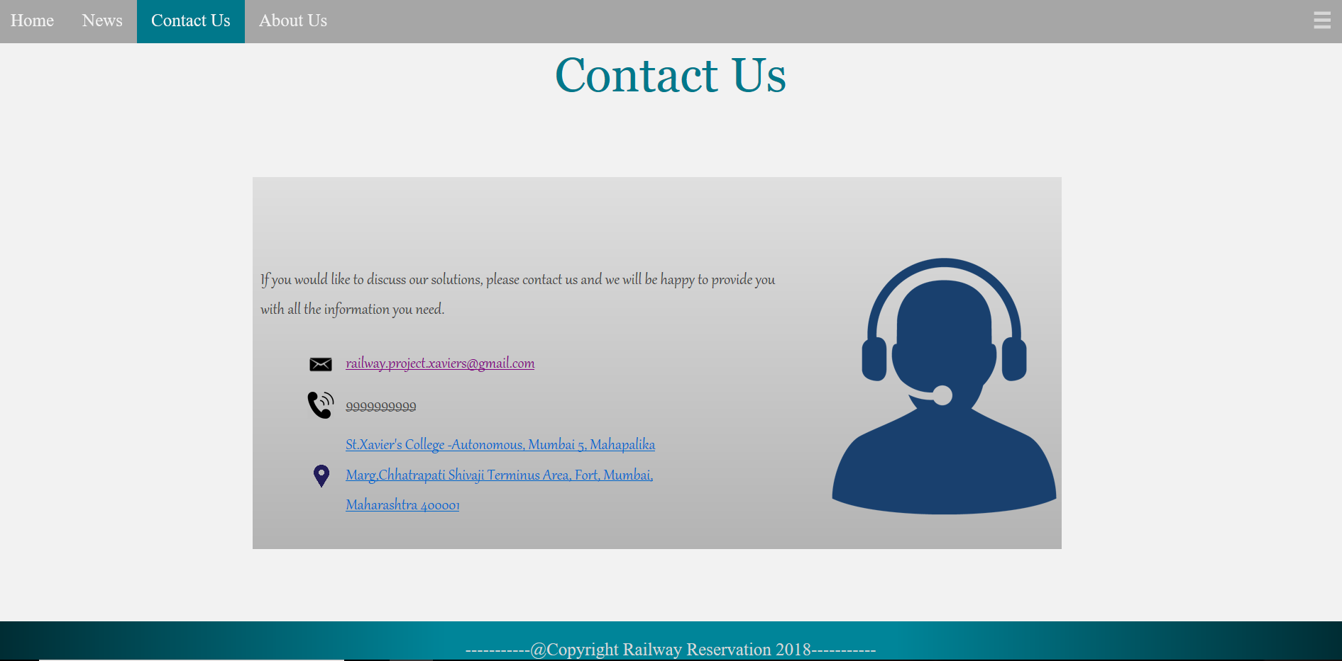

1. **NEWS :**

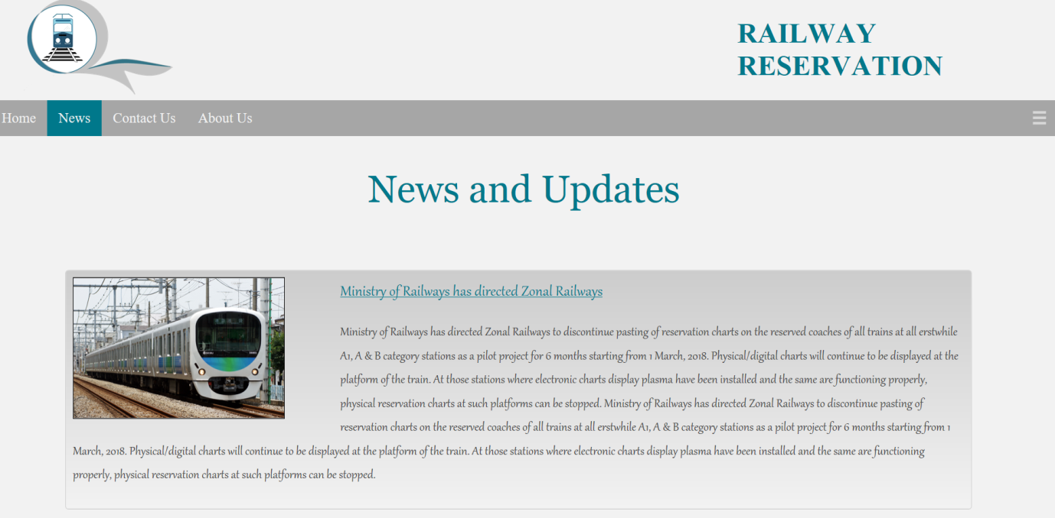

1. **CAMERA_SCANNER TO SCAN QR CODE IN TICKET :**

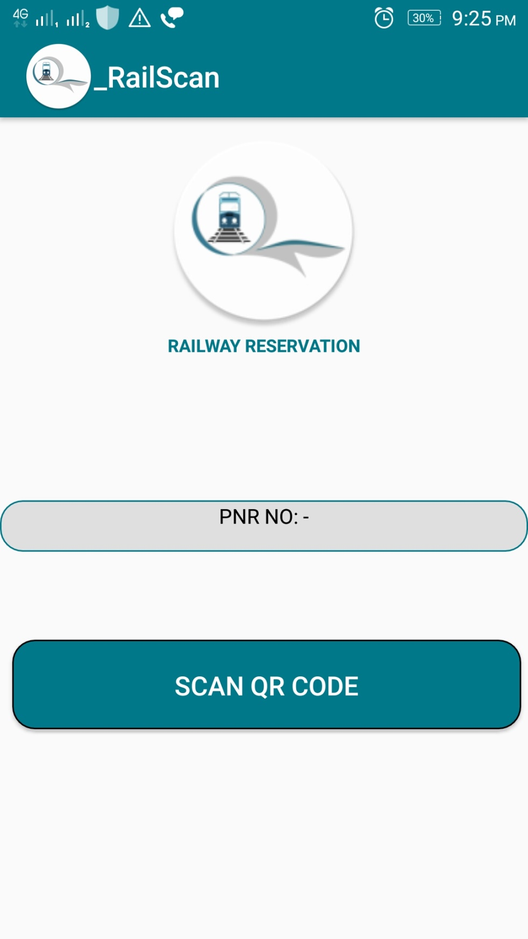

After Scanning QR Code: The PNR Displays.

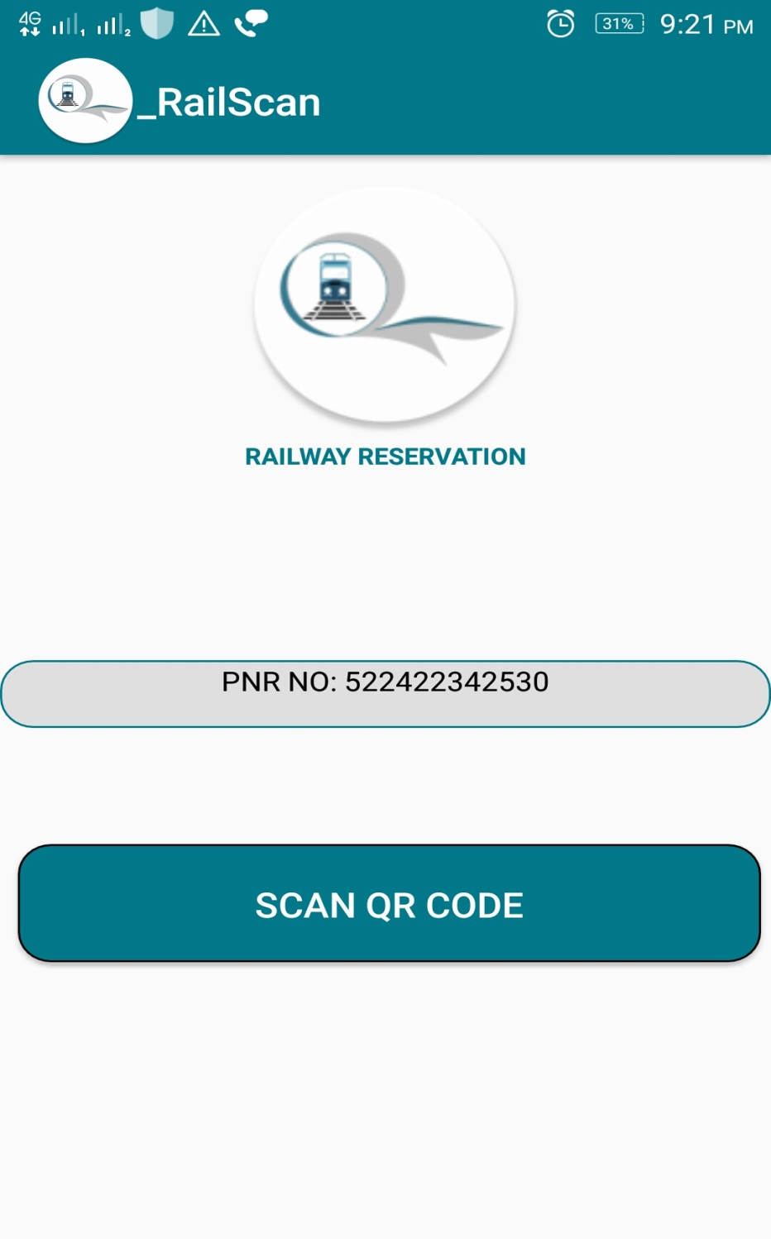

**5.3 CODES**

1. **JSP PAGES :**

**Header.jsp**

<%@ page language=*"java"* contentType=*"text/html; charset=ISO-8859-1"*

pageEncoding=*"ISO-8859-1"*%>

<!DOCTYPE html PUBLIC "-//W3C//DTD HTML 4.01 Transitional//EN" "http://www.w3.org/TR/html4/loose.dtd">

<%@ include file=*"../JSTLTagLib/jstlTaglib.jsp"* %>

<html lang=*"en"*>

<head>

<meta http-equiv=*"Content-Type"* content=*"text/html; charset=ISO-8859-1"*>

<title>RAILWAY</title>

<link href=*"../CSS/stylee.css"* rel=*"stylesheet"* type=*"text/css"*>

<link href=*"../CSS/imageForm.css"* rel=*"stylesheet"* type=*"text/css"*>

<script src=*"../js/jquery.js"*></script>

<script src=*"../js/HtmlandCommon.js"*></script>

</head>

<body>

<div class=*"pageloading"*></div>

<div class=*"alert"*>

<div class=*"alertBox"*>

<div class=*"alertHeader"*>RAILWAY ALERT</div>

<div id=*"alertContent"*></div>

<div class=*"alertFooter"*>

<button type=*"button"* style="width:*30%*; height:*90%*;" id=*"alertButton"*>OK</button>

</div>

</div>

</div>

<div class=*"modal"*>

<div class=*"modal-box"* >

<div class=*"modal-header"*>

<div style="background-color:*#c0c0c0*;width:*100%*;height:*15%*;

top:*100%*;position:*relative*;">

</div>

<div style="height:*10px*;">

</div>

</div>

<br>

<div id=*"modal-content"*>

</div>

<div class=*"modal-footer"*>

<button type=*"button"* style="width:*30%*; height:*90%*;" id=*"modalButton"*>OK</button>

</div>

</div>

</div>

<div class=*"modalConfirm"*>

<div class=*"modalConfirm-box"* >

<div class=*"modalConfirm-header"*>

<div style="background-color:*#c0c0c0*;width:*100%*;height:*15%*;

top:*100%*;position:*relative*;">

</div>

<div style="height:*10px*;">

</div>

</div>

<br>

<div id=*"modalConfirm-content"*>

</div>

<div class=*"modalConfirm-footer"*>

<button type=*"button"* style="width:*30%*; height:*90%*;" id=*"modalConfirmButtonYes"*>YES</button>

<button type=*"button"* style="width:*30%*; height:*90%*;" id=*"modalConfirmButtonNo"*>No</button>

</div>

</div>

</div>

<div id=*"header"*>

<h1 id=*"title"*>RAILWAY RESERVATION</h1>

<img src=*"../images/logo.png"* alt=*"logo"* id=*"logo"* width=*18%*>

<div id=*"nav"*>

<ul>

<li><a class=*"active"* href=*"../Phase2/viewdetails.jsp"* id=*"viewdetailsss"*>Home</a></li>

<li><a href=*"../Phase1/News.jsp"* id=*"newsss"*>News</a></li>

<li><a href=*"../Phase1/ContactUs.jsp"* id=*"contactusss"*>Contact Us</a></li>

<li><a href=*"../Phase1/AboutUs.jsp"* id=*"aboutusss"*>About Us</a></li>

<% **if**(session.getAttribute("userid")!=**null**){

**if**(((String)session.getAttribute("role")).equalsIgnoreCase("customer")){

%>

<script type=*"text/javascript"*>

**if**((window.location.pathname.includes("/RAILWAY_PROJECT/Phase1/index.jsp"))

||(window.location.pathname.includes("/RAILWAY_PROJECT/Phase1/signup.jsp"))

){

window.location.href="../Phase2/viewdetails.jsp";

}

</script>

<li style="float:*right*">

<button title=*"Cancel Booking"*

class=*"imagebutton nobuttonhover nobuttondefaultstyle"* style="width:*50px*;height:*50px*;" id=*"menuClick"*>

<img src=*"../images/menu.png"* class=*"imagebuttonImage"* id=*"cancelTicket"* />

</button>

</li>

</ul>

<div class=*"dropdown"*>

<a href=*"../Phase6/history.jsp"*><img src=*"../images/user-history.png"* style="width:*20%*;height:*40px*;background:*transparent*;">User-History</a>

<a href=*"../Phase6/cancellation.jsp"*><img src=*"../images/Ticket-Cancellation.png"* style="width:*15%*;height:*40px*;background:*transparent*;">Ticket Cancellation</a>

<a href=*"../Phase7/chatting.jsp"*><img src=*"../images/emergency.png"* style="width:*15%*;height:*40px*;background:*transparent*;">Emergency Chat</a>

<a href=*"../Phase7/logout.jsp"*><img src=*"../images/logout.png"* style="width:*15%*;height:*40px*;background:*transparent*;">Logout</a>

</div>

<%}**else**{

%>

<script type=*"text/javascript"*>

**if**(!((window.location.pathname.includes("/RAILWAY_PROJECT/Phase1/index.jsp"))

|| (window.location.pathname.includes("/RAILWAY_PROJECT/Phase1/signup.jsp"))

|| (window.location.pathname.includes("/RAILWAY_PROJECT/Phase1/News.jsp"))

|| (window.location.pathname.includes("/RAILWAY_PROJECT/Phase1/ContactUs.jsp"))

|| (window.location.pathname.includes("/RAILWAY_PROJECT/Phase1/AboutUs.jsp")) )){

window.location.href="../Phase1/index.jsp";

}

</script>

<%

}

}**else**{%>

<script type=*"text/javascript"*>

**if**(!((window.location.pathname.includes("/RAILWAY_PROJECT/Phase1/index.jsp"))

|| (window.location.pathname.includes("/RAILWAY_PROJECT/Phase1/signup.jsp"))

|| (window.location.pathname.includes("/RAILWAY_PROJECT/Phase1/News.jsp"))

|| (window.location.pathname.includes("/RAILWAY_PROJECT/Phase1/ContactUs.jsp"))

|| (window.location.pathname.includes("/RAILWAY_PROJECT/Phase1/AboutUs.jsp")) )){window.location.href="../Phase1/index.jsp";

}

</script><%

}

%>

</div></div>

**Footer.jsp**

<footer>

<div id=*"grad"*>

<p>-----------@Copyright Railway Reservation

2018-----------</p>

</div>

</footer>

</body>

</html>

**Index.jsp**

<%@ page language=*"java"* contentType=*"text/html; charset=ISO-8859-1"*

pageEncoding=*"ISO-8859-1"*%>

<!DOCTYPE html PUBLIC "-//W3C//DTD HTML 4.01 Transitional//EN" "http://www.w3.org/TR/html4/loose.dtd">

<%@ include file=*"../JSTLTagLib/jstlTaglib.jsp"* %>

<jsp:include page=*"../COMMON/header.jsp"* />

<script src=*"../js/index.js"*></script>

<!-- -->

<c:if test=*"*${param.success != null}*"*>

<script>

$(document).ready(**function**(){

alertBox("Sign Up Successful!");

});

</script>

</c:if>

<!-- -->

<center>

<form method=*"post"* id=*"authenticate"* action=*"/RAILWAY_PROJECT/railway/loginAuth"* >

<fieldset style="width: *30%*">

<legend>

<H2>Login</H2>

</legend>

<table style="width: *400px*; height: *120px*">

<tr>

<td colspan=*"2"*><label id=*"userhideeffect"*><b>User ID</b></label></td>

</tr>

<tr>

<td colspan=*"2"*><input type=*"text"* placeholder=*"User ID"*

name=*"userid"* id=*"userhideeffectinput"* class=*"user-icon"* autocomplete=*"off"*/></td>

</tr>

<tr>

<td colspan=*"2"*><label id=*"passhideeffect"*><b>Password</b></label></td>

</tr>

<tr>

<td colspan=*"2"*><input type=*"password"*

name=*"password"* placeholder=*"Password"* id=*"passhideeffectinput"* class=*"password-icon"* />

</td>

</tr>

</table>

<br>

<br>

</fieldset>

<table width=*"400"* height=*"80"*>

<tr>

<td>

<button type=*"button"* id=*"goToValidate"*>Submit</button>

</td>

<td>

<button type=*"button"* id=*"signup"*>Sign Up</button>

</td>

</tr>

</table>

</form>

</center>

<jsp:include page=*"../COMMON/footer.jsp"* />

**Signup.jsp**

<%@ page import=*"railwayFrequentFunctions.DateFunctions"*%>

<%@ include file=*"../JSTLTagLib/jstlTaglib.jsp"* %>

<jsp:include page=*"../COMMON/header.jsp"* />

<script src=*'https://www.google.com/recaptcha/api.js'*></script>

<script src=*"../js/signup.js"*></script>

<center>

<H2>Registration Page</H2>

<form name=*"form1"* method=*"post"* action=*"/RAILWAY_PROJECT/railway/signUpSuccessful"*>

<fieldset>

<legend>Login Details</legend>

<table style="width: *570px*; height: *120px*">

<tr>

<td>User ID:

<img src=*"../images/loading.gif"* class=*"loading"* id=*"userid_loading"*>

</td>

<td><input type=*"text"* name=*"txt_userid"*

placeholder=*"Anything You Think Relevant"*>

<img src=*""* class=*"validity"* id=*"userid_validity"*>

</td>

</tr>

<tr>

<td></td>

<td class=*"warning"* id=*"userid_warn"*></td>

</tr>

<tr>

<td>Password:<br>

<button type=*"button"* title=*"Show Password"* class=*"imagebutton nobuttonhover nobuttondefaultstyle"*>

<img src=*"../images/eyeclose.png"* class=*"eyepassword"*></button></td>

<td><input type=*"password"* name=*"txt_password"*

placeholder=*"Type Password Be Secured"*>

<img src=*""* class=*"validity"* id=*"password_validity"*></td>

</tr>

<tr>

<td></td>

<td class=*"warning"* id=*"password_warn"*></td>

</tr>

<tr>

<td>Retype Password:</td>

<td><input type=*"password"* name=*"txt_retypepassword"*

placeholder=*"Retype Password"* disabled>

<img src=*""* class=*"validity"* id=*"retypepassword_validity"*></td>

</tr>

<tr>

<td></td>

<td class=*"warning"* id=*"retypepassword_warn"*></td>

</tr>

</table>

</fieldset>

<br>

<fieldset>

<legend>Personal Details</legend>

<table style="width: *570px*; height: *500px*;">

<tr>

<td>Full Name:</td>

<td><input type=*"text"* name=*"txt_fname"*

placeholder=*"Sweet Name"*><img src=*""* class=*"validity"* id=*"fname_validity"*></td>

</tr>

<tr>

<td></td>

<td class=*"warning"* id=*"fname_warn"*></td>

</tr>

<tr>

<td>Mobile No:</td>

<td><input type=*"text"* name=*"mobile"*

placeholder=*"9999999999"*><img src=*""* class=*"validity"* id=*"mobile_validity"*></td>

</tr>

<tr>

<td></td>

<td class=*"warning"* id=*"mobile_warn"*></td>

</tr>

<tr>

<td>Gender:</td>

<td><select name=*"gender"*>

<option value=*""* disabled selected hidden=*"true"*>---Gender---</option>

<option value=*"male"*>Male</option>

<option value=*"female"*>Female</option>

<option value=*"others"*>Others</option>

</select>

<img src=*""* class=*"validity"* id=*"gender_validity"*></td>

</tr>

<tr>

<td></td>

<td class=*"warning"* id=*"gender_warn"*></td>

</tr>

<tr>

<td>Marital Status:</td>

<td><select name=*"marital"*>

<option value=*""* disabled selected hidden=*"true"*>---Marital Status---</option>

<option value=*"married"*>Married</option>

<option value=*"unmarried"*>Unmarried</option>

</select>

<img src=*""* class=*"validity"* id=*"marital_validity"*></td>

</tr>

<tr>

<td></td>

<td class=*"warning"* id=*"marital_warn"*></td>

</tr>

<tr>

<td>Date Of Birth:</td>

<td><input type=*"date"* name=*"DOB"* id=*"DOB"*

max=*"*<%= (**new** DateFunctions()).dateforMinAge(18) %>*"*

min=*"*<%= (**new** DateFunctions()).dateforMinAge(60) %>*"*>

<img src=*""* class=*"validity"* id=*"dob_validity"*></td>

</tr>

<tr>

<td></td>

<td class=*"warning"* id=*"dob_warn"*></td>

</tr>

<tr>

<td>State:

<img src=*"../images/loading.gif"* class=*"loading"* id=*"state_loading"*>

</td>

<td><select name=*"state"*>

<option value=*""* disabled selected hidden=*"true"*>---Select

State---</option>

</select>

<img src=*""* class=*"validity"* id=*"state_validity"*>

</td>

</tr>

<tr>

<td></td>

<td class=*"warning"* id=*"state_warn"*></td>

</tr>

<tr>

<td>District:

<img src=*"../images/loading.gif"* class=*"loading"* id=*"district_loading"*>

</td>

<td><select name=*"district"* disabled>

<option value=*""* disabled selected hidden=*"true"*>---Select

District---</option>

</select>

<img src=*""* class=*"validity"* id=*"district_validity"*>

</td>

</tr>

<tr>

<td></td>

<td class=*"warning"* id=*"district_warn"*></td>

</tr>

<tr>

<td>Address:</td>

<td><textarea rows=*"4"* cols=*"30"*

name=*"address"* placeholder=*"Enter your Residential Address"*></textarea>

<img src=*""* class=*"validity"* id=*"address_validity"*></td>

</tr>

<tr>

<td></td>

<td class=*"warning"* id=*"address_warn"*></td>

</tr>

<tr>

<td>Email:</td>

<td><input type=*"email"* name=*"email"*

id=*"email"* placeholder=*"xyz@abc.com"* class=*"email-icon"*>

<img src=*""* class=*"validity"* id=*"email_validity"*></td>

</tr>

<tr>

<td></td>

<td class=*"warning"* id=*"email_warn"*></td>

</tr>

<tr id=*"emailotptd"*>

<td><img src=*"../images/loading.gif"* class=*"loading"* id=*"otp_loading"*></td>

<td>

<button type=*"button"* id=*"forotp"* class=*"nobuttonhover"*

style="width:*80%*;height:*100%*;">GET OTP</button>

<button type=*"button"* id=*"foremail"* class=*"nobuttonhover"*

style="width:*80%*;height:*100%*;">CHANGE EMAIL/RESEND</button>

<img src=*""* class=*"validity"*></td>

</tr>

<tr id=*"otptd"*>

<td>OTP:<img src=*"../images/loading.gif"* class=*"loading"* id=*"otpcheck_loading"*></td>

<td><input type=*"text"* name=*"OTP"* placeholder=*"AB3456"*>

<img src=*""* class=*"validity"* id=*"otp_validity"*></td>

</tr>

<tr id=*"otptd1"*>

<td></td>

<td class=*"warning"* id=*"otp_warn"*></td>

</tr>

<tr>

<td></td>

<td>

<div style="text-align: *center*">

<div class=*"g-recaptcha"*

data-sitekey=*"6Lc48jwUAAAAAP3LTfSG8y7blgt1EgBhu-jCzora"* style=" display: *inline-block*;">

</div>

<img src=*""* class=*"validity"*>

</div>

</td>

</tr>

<tr>

<td colspan=*"2"* class=*"warning"* id=*"recaptcha_warn"*></td>

</tr>

</table>

</fieldset>

<br> <br>

<button type=*"button"* name=*"signup"* id=*"button1"*>Sign Up</button>

</form>

</center>

<jsp:include page=*"../COMMON/footer.jsp"* />

**Aboutus.jsp**

<%@ page language=*"java"* contentType=*"text/html; charset=ISO-8859-1"*

pageEncoding=*"ISO-8859-1"*%>

<!DOCTYPE html PUBLIC "-//W3C//DTD HTML 4.01 Transitional//EN" "http://www.w3.org/TR/html4/loose.dtd">

<%@ include file=*"../JSTLTagLib/jstlTaglib.jsp"* %>

<jsp:include page=*"../COMMON/header.jsp"* />

<script src=*"../js/AboutUs.js"*></script>

<h2>About Us</h2>

<div id=*"general-info"*>

<div id=*"about-content"*><b style="color:*#00788b*">Railway Reservation</b> is a website

which helps consumers in online booking of Train Tickets very easily and quickly with the comfort of the home or office.

Railways are the most important means of transport in India. Till 1985, All tickets were issued manually and Stand-alone

Computerized ticketing and reservation was introduced in multiple phases.<br>

The main functionality of the project is Reserving train seats and cancellation of seats online. <br>

At Present, where India is moving towards Digital India , this is a small effort taken by us.

</div>

</div>

<div style="background:*linear-gradient(#00788b,#005866)*;font-family:*fantasy*;color:*#fefefe*;text-align:*left*;width:*80%*;position:*relative*;height:*30px*;left:*10%*;top:*30px*">

DEVELOPED BY:

</div>

<div style="float:*left*;left:*10%*;position:*relative*;top:*50px*;width:*30%*;height:*200px*;">

<img src=*""* id=*"photo1"* style="border:*1px solid #00788b*;height:*200px*;width:*100%*;">

<h2>Rahul Mukesh Singh</h2>

</div>

<div style="width:*30%*;height:*200px*;float:*right*;right:*10%*;position:*relative*;top:*50px*">

<img src=*""* id=*"photo2"* style="border:*1px solid #00788b*;height:*200px*;width:*100%*">

<h2>Sanjana Gopalkrishna</h2>

</div>

<BR><BR><BR><br><br><br><br><br><BR><BR><BR><br><br><br><br><br>

<jsp:include page=*"../COMMON/footer.jsp"* />

**ContactUs.jsp**

<%@ page language=*"java"* contentType=*"text/html; charset=ISO-8859-1"*

pageEncoding=*"ISO-8859-1"*%>

<!DOCTYPE html PUBLIC "-//W3C//DTD HTML 4.01 Transitional//EN" "http://www.w3.org/TR/html4/loose.dtd">

<%@ include file=*"../JSTLTagLib/jstlTaglib.jsp"* %>

<jsp:include page=*"../COMMON/header.jsp"* />

<script src=*"../js/ContactUs.js"*></script>

<h2>Contact Us</h2>

<div id=*"contact"*>

<p style="left:*1%*;position:*relative*;top:*100px*;">If you would like to discuss our solutions, please contact us and we will be happy to provide you

<br>with all the information you need.</p>

<img src=*"../images/contact.png"* style="float:*right*;position:*relative*;height:*300px*;">

<table style="top:*100px*;position:*relative*;width:*50%*;left:*6%*" >

<tr>

<td><img src=*"../images/email.png"* style="height:*30px*"></td>

<td><a href=*"mailto:railway.project.xaviers@gmail.com"*>railway.project.xaviers@gmail.com</a></td>

</tr>

<tr>

<td><img src=*"../images/call.png"* style="height:*30px*"></td>

<td>9999999999</td>

</tr>

<tr>

<td><img src=*"../images/source.png"* style="height:*30px*"></td>

<td><a href=*""*>St.Xavier's College -Autonomous, Mumbai 5, Mahapalika Marg,Chhatrapati Shivaji Terminus Area, Fort, Mumbai, Maharashtra 400001</a></td>

</table>

</div>

<jsp:include page=*"../COMMON/footer.jsp"* />

**News.jsp**

<%@page import=*"railwayFrequentFunctions.DatabaseConnection"*%>

<%@ page language=*"java"* contentType=*"text/html; charset=ISO-8859-1"*

pageEncoding=*"ISO-8859-1"*%>

<!DOCTYPE html PUBLIC "-//W3C//DTD HTML 4.01 Transitional//EN" "http://www.w3.org/TR/html4/loose.dtd">

<%@ include file=*"../JSTLTagLib/jstlTaglib.jsp"* %>

<jsp:include page=*"../COMMON/header.jsp"* />

<script src=*"../js/News.js"*></script>

<sql:setDataSource var=*"con"* driver=*"*<%= (**new** DatabaseConnection()).getDriver() %>*"* url=*"*<%= (**new** DatabaseConnection()).getURL() %>*"*

user=*"*<%= (**new** DatabaseConnection()).getUsername() %>*"* password=*"*<%= (**new** DatabaseConnection()).getPassword() %>*"*/>

<sql:query dataSource=*"*${con}*"* var=*"rs"*>

SELECT * FROM `news`;

</sql:query>

<h2>News and Updates</h2>

<c:forEach var=*"row"* items=*"*${rs.rows}*"*>

<div id=*"news-container"*>

<div id=*"news-block"*>

<div id=*"news-image"*>

<img src=*"*${row.newsimage}*"* class=*"news-image"*>

</div>

<div id=*"news-content"*>

<div id=*"news-header"*>${row.newsheading}

</div>

<p>

${row.newsdetail}

</p>

</div>

</div>

</div>

</c:forEach>

<br><br><br><br>

<jsp:include page=*"../COMMON/footer.jsp"* />

**Viewdetails.jsp**

<%@page import=*"railwayFrequentFunctions.DatabaseConnection"*%>

<%@page import=*"java.time.LocalDate"*%>

<%@page import=*"java.util.Date"*%>

<%@ page language=*"java"* contentType=*"text/html; charset=ISO-8859-1"*

pageEncoding=*"ISO-8859-1"*%>

<!DOCTYPE html PUBLIC "-//W3C//DTD HTML 4.01 Transitional//EN" "http://www.w3.org/TR/html4/loose.dtd">

<%@ include file=*"../JSTLTagLib/jstlTaglib.jsp"* %>

<jsp:include page=*"../COMMON/header.jsp"* />

<script src=*"../js/jquery.tablesorter.js"*></script>

<script src=*"../js/viewdetails.js"*></script>

<br>

<c:set var=*"now"* value=*"*<%=**new** Date(System.currentTimeMillis()+(1000*60*60*24)) %>*"*/>

<c:set var=*"maxMonth"* value=*"*<%=LocalDate.now().plusMonths(4)%>*"* />

<c:set var=*"exists"* value=*"false"* />

<div id=*"search-train"*>

<form action=*"viewdetails.jsp"* method=*"post"* name=*"details"*>

<table style="width:*50%*;float:*left*;">

<tr>

<td>Journey Date:</td>

<td><input type=*"date"* name=*"date"* min=*'*<fmt:formatDate pattern=*"yyyy-MM-dd"* value="${now}"/>*'* max=*"*${maxMonth}*"*

style="padding:*1%*;border-radius:*8px*;font-size:*63%*;width:*97%*;" class=*"calendar-icon"* value=*"*${param.date}*"*></td>

</tr>

<tr>

<td>Source:<img src=*"../images/loading.gif"* class=*"loading"*

id=*"source_station_loading"*></td>

<td>

<select name=*"source"* style="width:*100%*;padding:*1%*;border-radius:*8px*;padding-left:*30%*" class=*"source-icon"*>

<option value=*""* disabled selected hidden=*"true"*>---Source---</option>

</select>

</td>

</tr>

<tr>

<td>Destination:<img src=*"../images/loading.gif"*

class=*"loading"* id=*"dest_station_loading"*></td>

<td>

<select name=*"destination"* style="width:*100%*;padding:*1%*;border-radius:*8px*;padding-left:*30%*;" class=*"source-icon"* disabled>

<option value=*""* disabled selected hidden=*"true"*>---Destination---</option>

</select></td>

</tr>

<tr></tr>

<tr>

<td colspan=*"2"* style="padding-left:*15%*"><button type=*"button"* id=*"search-train-button"* style="width:*80%*;">Search</button></td>

</tr>

</table>

<table style="width:*50%*;height:*190px*">

<tr>

<td colspan=*"3"* style="vertical-align:*top*">

<input type=*"text"* style="width:*75%*;padding-top:*0*;" class=*"train-icon searchtrainnow"* placeholder=*"Search Train..."* autocomplete=*"off"*>

<div id=*"searchtrain-box"*>

</div>

</td>

<td style="vertical-align:*top*">

</td>

</tr>

</table>

</form>

</div>

<c:if test=*"*${param.date !=null}*"*>

<form name=*"proceedToNextPage"* action=*"/RAILWAY_PROJECT/railway/trainSeltoClassSel"* method=*"post"*>

<input type=*"hidden"* name=*"selectedDatee"* value=*"*${param.date}*"*/>

<input type=*"hidden"* name=*"selectedSrcStation1"* id=*"selectedSrcStation"* value=*"*${param.source}*"*/>

<input type=*"hidden"* name=*"selectedDestStation1"* id=*"selectedDestStation"* value=*"*${param.destination}*"*/>

<input type=*"hidden"* name=*"selectedTrainno"* value=*""*/>

<input type=*"hidden"* name=*"selectedTrainreturn"* value=*""*/>

</form>

<fmt:parseDate var=*"journeydate"* pattern=*"yyyy-MM-dd"* value=*"*${param.date}*"*/>

<fmt:formatDate var=*"weekjourneydate"* pattern=*"EEEE"* value=*"*${journeydate}*"*/>

<sql:setDataSource var=*"con"* driver=*"*<%= (**new** DatabaseConnection()).getDriver() %>*"* url=*"*<%= (**new** DatabaseConnection()).getURL() %>*"*

user=*"*<%= (**new** DatabaseConnection()).getUsername() %>*"* password=*"*<%= (**new** DatabaseConnection()).getPassword() %>*"*/>

<sql:query dataSource=*"*${con}*"* var=*"rs"*>

SELECT train_no,train_name,(SELECT station_name FROM station_master WHERE station_code = source_station_code) AS source_station,

(SELECT station_name FROM station_master WHERE station_code = dest_station_code) AS dest_station,special,train_return

FROM train_master t where t.route_id IN

(SELECT DISTINCT route_id FROM route_master r WHERE r.station_code=t.dest_station_code AND counter

>= (SELECT counter from route_master r1 where r1.route_id=r.route_id AND r1.station_code=

(SELECT station_code FROM station_master WHERE station_name = ?) AND counter

> (SELECT counter from route_master r2 where r2.route_id=r.route_id AND r2.station_code=

(SELECT station_code FROM station_master WHERE station_name = ?) AND counter

>= (SELECT counter from route_master r3 where r3.route_id=r.route_id AND r3.station_code=t.source_station_code))))

AND (t.train_no,t.train_return) IN (SELECT train_no,train_return FROM train_normal_schedule where ${weekjourneydate}=1);

<sql:param value=*"*${param.destination}*"*/>

<sql:param value=*"*${param.source}*"*/>

</sql:query>

<div class=*"pagination"*>

<table class=*"displayTableDesign"*>

<thead>

<tr>

<th>Train No</th>

<th>Train Name</th>

<th>Source</th>

<th>Destination</th>

<th>Special Train</th>

<th></th>

</tr>

</thead>

<tbody>

<script>

$(document).ready(**function**(){

$('#searchtrain-box').empty();

});

</script>

<c:forEach var=*"row"* items=*"*${rs.rows}*"*>

<c:set var=*"exists"* value=*"true"*/>

<tr>

<td><c:out value=*"*${row.train_no}*"* />

<input type=*"hidden"* value=*"*${row.train_return}*"* />

</td>

<td><c:out value=*"*${row.train_name}*"* /></td>

<td><c:out value=*"*${row.source_station}*"* /></td>

<td><c:out value=*"*${row.dest_station}*"* /></td>

<td>

<c:choose>

<c:when test=*"*${row.special}*"* >

Yes

</c:when>

<c:otherwise>

No

</c:otherwise>

</c:choose>

</td>

<td><button type=*"button"* title=*"Time"* class=*"imagebutton nobuttonhover nobuttondefaultstyle routetime"*>

<img src=*"../images/time.png"* class=*"imagebuttonImage"*></button>

<button type=*"button"* title=*"Proceed"* class=*"imagebutton nobuttonhover nobuttondefaultstyle proceed"* >

<img src=*"../images/rightarrow.png"* class=*"imagebuttonImage"*></button></td>

</tr>

<script>

$(document).ready(**function**(){

$('#searchtrain-box').append('<div><input type="radio" name="Train-search" style="float:left;">${fnc:toLowerCase(row.train_name)}</div>');

});

</script>

</c:forEach>

</tbody>

</table>

<div class=*"divpaginationbutton"*>

</div>

</div>

<c:choose>

<c:when test=*"*${exists **eq true**}*"*>

<script>

$(document).ready(**function**(){

$(".pagination").show();

});

</script>

</c:when>

<c:otherwise>

<script>

$(document).ready(**function**(){

$(".pagination").hide();

alertBox("No Trains Found!!!");

});

</script>

</c:otherwise>

</c:choose>

</c:if>

<br><br><br><br><br><br>

<jsp:include page=*"../COMMON/footer.jsp"* />

**Class_selection.jsp**

<%@page import=*"railwayFrequentFunctions.DatabaseConnection"*%>

<%@ page language=*"java"* contentType=*"text/html; charset=ISO-8859-1"*

pageEncoding=*"ISO-8859-1"*%>

<!DOCTYPE html PUBLIC "-//W3C//DTD HTML 4.01 Transitional//EN" "http://www.w3.org/TR/html4/loose.dtd">

<%@ include file=*"../JSTLTagLib/jstlTaglib.jsp"* %>

<jsp:include page=*"../COMMON/header.jsp"* />

<script src=*"../js/classselection.js"*></script>

<c:set var=*"trainno"* value=*"*${sessionScope.trainno}*"* />

<sql:setDataSource var=*"con"* driver=*"*<%=(**new** DatabaseConnection()).getDriver() %>*"*

url=*"*<%=(**new** DatabaseConnection()).getURL() %>*"* user=*"*<%=(**new** DatabaseConnection()).getUsername() %>*"*

password=*"*<%=(**new** DatabaseConnection()).getPassword() %>*"* />

<sql:query var=*"rs"* dataSource=*"*${con}*"*>

SELECT class_id,class_name from train_class_details where class_id in

(SELECT class_id FROM train_coach_details where train_no=?);

<sql:param value=*"*${trainno}*"* />

</sql:query>

<c:set var=*"counter"* value=*"0"*/>

<table class=*"train_class_container"*>

<tr>

<c:forEach var=*"row"* items=*"*${rs.rows}*"*>

<td><div class=*"train_class"* style="background:*url(../images/seat.png),linear-gradient(#00788b, #008599,#009bb3)*;

background-repeat:*no-repeat*;background-size:*contain*;background-position:*center*">

<c:out value=*"*${row.class_name}*"* />

<input type=*"hidden"* value=*"*${row.class_id}*"*>

<div class=*"train_class_know_more"*>

<button type=*"button"* style="width:*25%*;height:*60px*;background-color:*#dfdfdf*;color:*#00788b*;top:*60px*;

position:*relative*;border-radius:*5px*;" class=*"seatmap"*>Seat Map</button>

<button type=*"button"* style="width:*25%*;height:*60px*;background-color:*#dfdfdf*;color:*#00788b*;top:*60px*;

position:*relative*;border-radius:*5px*;" class=*"proceedtoquotadetails"*>Proceed</button>

</div>

</div></td>

<c:set var=*"counter"* value=*"*${counter + 1}*"*/>

<c:if test=*"*${counter%3==0}*"*>

</tr><tr>

</c:if>

</c:forEach>

</tr>

</table>

<form name=*"proceedToQuotaDetails"* method=*"post"* action=*"/RAILWAY_PROJECT/railway/classSelToQuotaDetails"*>

<input type=*"hidden"* name=*"classid"* value=*""*>

</form>

<button style="background:*url(../images/back.png),radial-gradient(#00788b, #005866)*;background-repeat:*no-repeat*;

background-size:*contain*;background-position:*left*;padding-left:*60px*;width:*12%*;top:*70px*;left:*85%*;position:*relative*"

id=*"goToViewDetails"*>Back</button>

<jsp:include page=*"../COMMON/footer.jsp"* />

**Quota_details.jsp**

<%@page import=*"railwayFrequentFunctions.DatabaseConnection"*%>

<%@ page language=*"java"* contentType=*"text/html; charset=ISO-8859-1"*

pageEncoding=*"ISO-8859-1"*%>

<!DOCTYPE html PUBLIC "-//W3C//DTD HTML 4.01 Transitional//EN" "http://www.w3.org/TR/html4/loose.dtd">

<%@ include file=*"../JSTLTagLib/jstlTaglib.jsp"* %>

<jsp:include page=*"../COMMON/header.jsp"* />

<script type=*"text/javascript"* src=*"../js/quotadetails.js"*></script>

<sql:setDataSource var=*"con"* driver=*"*<%=(**new** DatabaseConnection()).getDriver() %>*"*

url=*"*<%=(**new** DatabaseConnection()).getURL() %>*"* user=*"*<%=(**new** DatabaseConnection()).getUsername() %>*"*

password=*"*<%=(**new** DatabaseConnection()).getPassword() %>*"* />

<sql:query var=*"rs"* dataSource=*"*${con}*"*>

SELECT quota_name,quota_id,quota_details FROM quota_details;

</sql:query>

<c:set var=*"counter"* value=*"0"*/>

<table class=*"quota_class_container"*>

<tr>

<c:forEach var=*"row"* items=*"*${rs.rows}*"*>

<td>

<div class=*"quota_class"* style=*"background-image:url(../images/*${row.quota_id}*-icon.png),radial-gradient(#d9d9d9, #00788b,#005866);background-repeat:no-repeat;background-position:center;background-size:contain"*>

<c:out value=*"*${row.quota_name}*(*${row.quota_id}*)"*/>

<div class=*"quota_class_know_more"*>

<p><c:out value=*"*${fnc:trim(row.quota_details)}*"*/></p>

</div>

</div></td>

<c:set var=*"counter"* value=*"*${counter + 1}*"*/>

<c:if test=*"*${counter%3==0}*"*>

</tr><tr>

</c:if>

</c:forEach>

</tr>

</table>

<button id=*"backToClassSelection"* style="background-image:*url(../images/back-button.png),linear-gradient(#b3b3b3,#a6a6a6,#737373)*;border-radius:*10px*;left:*40%*;padding-right:*40px*;color:*#fefefe*;top:*60px*;position:*relative*;background-repeat:*no-repeat*;width:*10%*;background-position:*right*;background-size:*contain*">Back</button>

<button id=*"proceedToSeatAvailability"* style="background-image:*url(../images/next-button.png),linear-gradient(#b3b3b3,#a6a6a6,#737373)*;border-radius:*10px*;left:*40%*;;padding-left:*35px*;color:*#fefefe*;top:*60px*;position:*relative*;background-repeat:*no-repeat*;width:*12%*;background-position:*left*;background-size:*contain*">Proceed</button>

<jsp:include page=*"../COMMON/footer.jsp"* />

**Seat_availability.jsp**

<%@page import=*"railwayFrequentFunctions.DatabaseConnection"*%>

<%@ page language=*"java"* contentType=*"text/html; charset=ISO-8859-1"*

pageEncoding=*"ISO-8859-1"*%>

<!DOCTYPE html PUBLIC "-//W3C//DTD HTML 4.01 Transitional//EN" "http://www.w3.org/TR/html4/loose.dtd">

<%@ include file=*"../JSTLTagLib/jstlTaglib.jsp"* %>

<jsp:include page=*"../COMMON/header.jsp"* />

<script type=*"text/javascript"* src=*"../js/seatavailability.js"*></script>

<jsp:useBean id=*"price"* class=*"railwayFrequentFunctions.DatabasePrice"* />

<c:set var=*"pricewithoutquota"* value=*"*${price.getTrainRoutePrice(sessionScope.source,sessionScope.destination,sessionScope.routeId,

sessionScope.trainno,sessionScope.trainreturn,sessionScope.classid)}*"*/>

<sql:setDataSource var=*"con"* driver=*"*<%= (**new** DatabaseConnection()).getDriver() %>*"* url=*"*<%= (**new** DatabaseConnection()).getURL() %>*"*

user=*"*<%= (**new** DatabaseConnection()).getUsername() %>*"* password=*"*<%= (**new** DatabaseConnection()).getPassword() %>*"*/>

<sql:query dataSource=*"*${con}*"* var=*"rs"*>

SELECT quota_id,quota_name,price_discount FROM quota_details order by seats_quota desc;

</sql:query>

<table class=*"available-seats-display"* align=*"center"*>

<tr>

<th>Quota</th>

<th class=*"seat-icon"*>Available<br>Confirm Tickets</th>

<th class=*"seat-icon"*>Available<br>RAC Tickets</th>

<th class=*"seat-icon"*>Available<br>Waiting Tickets</th>

<th>Gross Price<br>(After Discount)</th>

</tr>

<c:forEach var=*"row"* items=*"*${rs.rows}*"*>

<tr>

<td><c:out value=*"*${row.quota_name}*(* ${row.quota_id} *)"*/></td>

<td></td>

<td></td>

<td></td>

<td>

&#8377;

<fmt:formatNumber var=*"pricewithquota"* value=*'*${pricewithoutquota - (pricewithoutquota * row.price_discount / 100)}*'*

type=*"NUMBER"* maxFractionDigits=*"1"*/>

<c:out value=*"*${pricewithquota} *(* ${row.price_discount}*% )"*/></td>

</tr>

</c:forEach>

</table>

<br><br>

<button id=*"backToQuotaDetails"* style="background-image:*url(../images/back-button.png),linear-gradient(#b3b3b3,#a6a6a6,#737373)*;border-radius:*10px*;left:*40%*;padding-right:*40px*;color:*#fefefe*;top:*60px*;position:*relative*;background-repeat:*no-repeat*;width:*10%*;background-position:*right*;background-size:*contain*">Back</button>

<button id=*"proceedToBooking"* style="background-image:*url(../images/next-button.png),linear-gradient(#b3b3b3,#a6a6a6,#737373)*;border-radius:*10px*;left:*40%*;;padding-left:*35px*;color:*#fefefe*;top:*60px*;position:*relative*;background-repeat:*no-repeat*;width:*12%*;background-position:*left*;background-size:*contain*">Proceed</button>

<br>

<jsp:include page=*"../COMMON/footer.jsp"* />

**Booking.jsp**

<%@page import=*"railwayFrequentFunctions.DatabaseConnection"*%>

<%@ page language=*"java"* contentType=*"text/html; charset=ISO-8859-1"*

pageEncoding=*"ISO-8859-1"*%>

<!DOCTYPE html PUBLIC "-//W3C//DTD HTML 4.01 Transitional//EN" "http://www.w3.org/TR/html4/loose.dtd">

<%@ include file=*"../JSTLTagLib/jstlTaglib.jsp"*%>

<jsp:include page=*"../COMMON/header.jsp"* />

<script type=*"text/javascript"* src=*"../js/booking.js"*></script>

<sql:setDataSource var=*"con"* driver=*"*<%= (**new** DatabaseConnection()).getDriver() %>*"* url=*"*<%= (**new** DatabaseConnection()).getURL() %>*"*

user=*"*<%= (**new** DatabaseConnection()).getUsername() %>*"* password=*"*<%= (**new** DatabaseConnection()).getPassword() %>*"*/>

<sql:query dataSource=*"*${con}*"* var=*"rs"*>

SELECT class_name FROM train_class_details where class_id=?;

<sql:param value=*"*${sessionScope.classid}*"*/>

</sql:query>

<c:forEach var=*"row"* items=*"*${rs.rows}*"*>

<input type=*"hidden"* id=*"classNameWithID"* value=*"*${row.class_name} *(*${sessionScope.classid}*)"*/>

</c:forEach>

<div class=*"addcustomer-modal"*>

<div class=*"addcustomer-modal-box"*>

<div class=*"addcustomer-modal-header"*>

<button id=*"closeAddCustomerModal"* style="left: *47%*; position: *relative*; margin-top: *0px*"

class=*"imagebutton nobuttonhover nobuttondefaultstyle"* title=*"Close"*>

<span class=*"imagebuttonImage"* style="font-size: *30px*">&times;</span>

</button>

</div>

<div id=*"addcustomer-modal-content"*>

<form>

<input type=*"hidden"* id=*"tableRowNoInModal"*/>

<table style="width: *50%*; left: *24%*; position: *relative*; top: *70px*;">

<tr>

<td>Name:</td>

<td><input type=*"text"* name=*"nameModal"* style="height: *35px*" placeholder=*"Name"*></td>

</tr>

<tr>

<td>Age:</td>

<td><input type=*"text"* name=*"ageModal"* style="height: *35px*" placeholder=*"Age"*></td>

</tr>

<tr>

<td>Gender:</td>

<td><input type=*"radio"* name=*"gender"* value=*"Male"*>Male

<input type=*"radio"* name=*"gender"* value=*"Female"*>Female

<input type=*"radio"* name=*"gender"* value=*"Others"*>Others</td>

</tr>

<tr>

<td>Quota:</td>

<td><select name=*"quota"* style="height: *35px*">

</select>

</td>

</tr>

<tr>

<td>Seat Preference:</td>

<td><select name=*"seatpref"* style="height: *35px*">

</select>

</td>

</tr>

<tr>

<td colspan=*"2"*><button type=*"button"* id=*"confirmDetails"*

style="width: *60%*; height: *45px*; font: *23px fantasy, serif, sans-serif*;

background-color: *white*;border: *1px solid #00788b*;color: *#00788b*;">

Confirm<img src=*"../images/loading.gif"*

class=*"loading"* id=*"confirmDetailsLoading"*></button></td>

</tr>

</table>

</form>

</div>

</div>

</div>

<table class=*"addcustomer-display"*>

<tr>

<th style="width: *5%*">Sr.No</th>

<th style="width: *25%*">Customer Name</th>

<th style="width: *15%*">Class</th>

<th style="width: *14%*">Add Details</th>

<th>Quota</th>

<th>Status</th>

<th>Gross Price (After Discount)</th>

<th style="width: *5%*"></th>

</tr>

<tr>

<td>1.</td>

<td>Passenger</td>

<td></td>

<td>

<button title=*"Add Details"* id=*"adddetails"*

class=*"imagebutton nobuttonhover nobuttondefaultstyle"*

style="width: *25%*; border-radius: *160px*; height: *40px*; background: *radial-gradient(#00788b, #005866)*;">

<img src=*"../images/add.png"* class=*"imagebuttonImage"* />

</button>

</td>

<td>

Not Specified

</td>

<td>N/A</td>

<td class=*"calculate"*>N/A</td>

<td>

<button type=*"button"* title=*"Delete Passenger"* id=*"delPassenger"*

class=*"imagebutton nobuttonhover nobuttondefaultstyle"*>

<img src=*"../images/del.png"* class=*"imagebuttonImage"* />

</button>

<input type=*"hidden"* value=*""*>

</td>

</tr>

</table>

<button title=*"Add Passenger"* id=*"addCustomer"*

class=*"imagebutton nobuttonhover nobuttondefaultstyle"*

style="width:*4%*;top:*80px*;left:*90%*;position:*relative*;height:*50px*;">

<img src=*"../images/add-customer.png"* class=*"imagebuttonImage"* style="height:*50px*;width:*100%*" />

</button>

<sql:setDataSource var=*"con"* driver=*"*<%= (**new** DatabaseConnection()).getDriver() %>*"* url=*"*<%= (**new** DatabaseConnection()).getURL() %>*"*

user=*"*<%= (**new** DatabaseConnection()).getUsername() %>*"* password=*"*<%= (**new** DatabaseConnection()).getPassword() %>*"*/>

<sql:query dataSource=*"*${con}*"* var=*"rs"*>

SELECT tax_id,tax_price from tax;

</sql:query>

<table class=*"addcustomerprice-display"*>

<tr>

<td>Total Gross Price :</td>

<td>&#8377;0</td>

</tr>

<c:forEach var=*"row"* items=*"*${rs.rows}*"*>

<tr>

<td><c:out value=*"*${row.tax_id}*"*/> (+):</td>

<td class=*"taxcalculate"*><c:out value=*"*${row.tax_price}*"*/> %</td>

</tr>

</c:forEach>

<tr>

<td>Net Gross Price :</td>

<td>&#8377;0</td>

</tr>

</table>

<button style="width:*25%*;top:*50px*;position:*relative*;left:*30%*;

background:*url(../images/book.png),linear-gradient(#00788b, #005866)*;background-position:*right*;

background-repeat:*no-repeat*;background-size:*contain*" id=*"res_ticket"*>Reserve Ticket</button>

<form name=*"moveToPaymentGateway"* method=*"post"* action=*"../railway/bookTopaymentgateway"*>

<input type=*"hidden"* name=*"ticketData"* value=*""*/>

</form>

<br><br><br><br><br><br><br><br><br><br>

<jsp:include page=*"../COMMON/footer.jsp"* />

**Booked.jsp**

<%@page import=*"railwayFrequentFunctions.DatabaseConnection"*%>

<%@ page language=*"java"* contentType=*"text/html; charset=ISO-8859-1"*

pageEncoding=*"ISO-8859-1"*%>

<!DOCTYPE html PUBLIC "-//W3C//DTD HTML 4.01 Transitional//EN" "http://www.w3.org/TR/html4/loose.dtd">

<%@ include file=*"../JSTLTagLib/jstlTaglib.jsp"*%>

<jsp:include page=*"../COMMON/header.jsp"* />

<script src=*"../js/booked.js"*></script>

<c:set var=*"userid"* value=*"*${sessionScope.userid}*"* />

<sql:setDataSource var=*"con"*

driver=*"*<%=(**new** DatabaseConnection()).getDriver()%>*"*

url=*"*<%=(**new** DatabaseConnection()).getURL()%>*"*

user=*"*<%=(**new** DatabaseConnection()).getUsername()%>*"*

password=*"*<%=(**new** DatabaseConnection()).getPassword()%>*"* />

<sql:query var=*"rs"* dataSource=*"*${con}*"*>

SELECT email FROM user_details WHERE userid=?;

<sql:param value=*"*${userid}*"* />

</sql:query>

<c:forEach var=*"row"* items=*"*${rs.rows}*"*>

<c:set var=*"email"* value=*"*${row.email}*"* />

</c:forEach>

<br />

<br />

<center>

<div class=*"sendMailNowLoading"*></div>

<div id=*"pdfContainer"*>

<div class=*"sendMailNowLoading"*></div>

<iframe src=*"../railway/ticket"* id=*"iframePDF"*> </iframe>

<div id=*"buttonsContainer"*>

<center>

<br/><br/><br/><br/><br/>

<div id=*"showButtons"*>

<a href=*"../railway/ticket"* download>

<button type=*"button"* title=*"Download"*

class=*"imagebutton nobuttonhover nobuttondefaultstyle"*>

<img src=*"../images/download.png"*

style="width: *70px*; height: *70px*;" class=*"imagebuttonImage"*>

</button>

</a>

<button type=*"button"* title=*"Send Mail (* ${email} *)"*

class=*"imagebutton nobuttonhover nobuttondefaultstyle"* id=*"sendMailNow"*>

<img src=*"../images/sendmail.png"*

style="width: *70px*; height: *70px*;" class=*"imagebuttonImage"*>

</button>

</div>

</center>

</div>

</div>

</center>

<jsp:include page=*"../COMMON/footer.jsp"* />

**Cancellation.jsp**

<%@page import=*"java.util.Date"*%>

<%@page import=*"java.text.SimpleDateFormat"*%>

<%@page import=*"java.util.Calendar"*%>

<%@page import=*"java.sql.ResultSet"*%>

<%@page import=*"java.sql.PreparedStatement"*%>

<%@page import=*"java.sql.Connection"*%>

<%@page import=*"railwayFrequentFunctions.DatabaseConnection"*%>

<%@ page language=*"java"* contentType=*"text/html; charset=ISO-8859-1"*

pageEncoding=*"ISO-8859-1"*%>

<!DOCTYPE html PUBLIC "-//W3C//DTD HTML 4.01 Transitional//EN" "http://www.w3.org/TR/html4/loose.dtd">

<%@ include file=*"../JSTLTagLib/jstlTaglib.jsp"* %>

<jsp:include page=*"../COMMON/header.jsp"* />

<script src=*"../js/cancellation.js"*></script>

<h2>CANCELLATION</h2>

<table align=*"center"* class=*"cancellation"*>

<tr>

<th>PNR no.</th>

<th>Name</th>

<th>Source</th>

<th>Destination</th>

<th>Train name</th>

<th>Departure-date time</th>

<th>Arrival-date time</th>

<th></th>

</tr>

<%

**try**{

Connection con=(**new** DatabaseConnection()).dbConnect();

String query="SELECT `PNR`, `cust_name`, `age`,`quota_id`, "+

"`class_id`, `PNR_counter`, `status_id`, "+

"`status_counter`, `gender`, `src_start_time`, `dest_end_time`, "+

"`cost_with_tax`,(SELECT `quota_name` FROM `quota_details` WHERE `quota_id`=b.quota_id), "+

"(SELECT `class_name` FROM `train_class_details` WHERE `class_id`=b.`class_id`), "+

"(SELECT `coach_code` FROM `train_class_details` WHERE `class_id`=b.`class_id`), "+

"(SELECT `status_name` FROM `seat_status_details` WHERE `status_id`=b.`status_id`) "+

"FROM `booked_customer_details` b where `userid`=? ORDER BY `src_start_time`,`PNR`,`PNR_counter`";

PreparedStatement ps=con.prepareStatement(query);

ps.setString(1, (String)session.getAttribute("userid"));

ResultSet rs=ps.executeQuery();

**while**(rs.next()){

String statusTableQuery="";

**if**(!rs.getString(7).equalsIgnoreCase("wl")){

statusTableQuery="SELECT (SELECT train_name from train_master t where t.train_no=s.train_no AND "

+"t.train_return=s.train_return),(SELECT station_name from station_master s where s.station_code=from_station),"+

"(SELECT station_name from station_master s where s.station_code=to_station), "+

"`coach_counter`, `seat_no`, `train_src_time`, `train_dest_time` ,(SELECT `berth_id` FROM `berth_details` "+

"WHERE `berth_id` IN (SELECT `berth_id` FROM "+rs.getString(5)+" WHERE `seat_no`=s.`seat_no`)), "+

"(SELECT `berth_name` FROM `berth_details` "+

"WHERE `berth_id` IN (SELECT `berth_id` FROM "+rs.getString(5)+" WHERE `seat_no`=s.`seat_no`)) "+

"FROM "+rs.getString(7)+" s WHERE PNR=? AND PNR_counter=?";}

**else**{

statusTableQuery="SELECT (SELECT train_name from train_master t where t.train_no=s.train_no AND "

+"t.train_return=s.train_return),(SELECT station_name from station_master s where s.station_code=from_station),"+

"(SELECT station_name from station_master s where s.station_code=to_station), "+

"0, 0, `train_src_time`, `train_dest_time` ,'none', "+

"'none'"+

"FROM "+rs.getString(7)+" s WHERE PNR=? AND PNR_counter=?";

}

PreparedStatement ps1=con.prepareStatement(statusTableQuery);

ps1.setString(1, rs.getString(1));

ps1.setInt(2, rs.getInt(6));

ResultSet rs1=ps1.executeQuery();

**while**(rs1.next()){

%>

<tr>

<td><%= rs.getString(1) %></td>

<td><%= rs.getString(2) %></td>

<td><%= rs1.getString(2) %></td>

<td><%= rs1.getString(3) %></td>

<td><%= rs1.getString(1) %></td>

<td><% Calendar c=Calendar.getInstance();

SimpleDateFormat sd=**new** SimpleDateFormat("yyyy-MM-dd HH:mm:ss");

c.setTime(sd.parse(rs.getString(10)));

Date departure=c.getTime();

out.print(c.getTime());

%></td>

<td><% c.setTime(sd.parse(rs.getString(11)));

Date arrival=c.getTime();

out.print(c.getTime());

%></td>

<td>

<center>

<button title=*"Show Details"*

class=*"imagebutton nobuttonhover nobuttondefaultstyle"*>

<img src=*"../images/show-details.png"* class=*"imagebuttonImage"* id=*"showDetailsForPassenger"* />

</button>

<button title=*"Cancel Booking"*

class=*"imagebutton nobuttonhover nobuttondefaultstyle"*>

<img src=*"../images/cancel.png"* class=*"imagebuttonImage"* id=*"cancelTicket"* />

</button>

<a href=*"../railway/ticketdownloadlatest?pnr=*<%= rs.getString(1).trim() %>*"* download>

<button title=*"Download Pdf"*

class=*"imagebutton nobuttonhover nobuttondefaultstyle"*>

<img src=*"../images/pdf.png"* class=*"imagebuttonImage"* />

</button>

</a>

</center>

<input type=*"hidden"* class=*"pnr"* value=*"*<%= rs.getString(1) %>*"* />

<input type=*"hidden"* class=*"cust_name"* value=*"*<%= rs.getString(2) %>*"* />

<input type=*"hidden"* class=*"age"* value=*"*<%= rs.getInt(3) %>*"* />

<input type=*"hidden"* class=*"quota_id"* value=*"*<%= rs.getString(4) %>*"* />

<input type=*"hidden"* class=*"class_id"* value=*"*<%= rs.getString(5) %>*"* />

<input type=*"hidden"* class=*"PNR_counter"* value=*"*<%= rs.getInt(6) %>*"* />

<input type=*"hidden"* class=*"status_id"* value=*"*<%= rs.getString(7) %>*"* />

<input type=*"hidden"* class=*"status_counter"* value=*"*<%= rs.getInt(8) %>*"* />

<input type=*"hidden"* class=*"gender"* value=*"*<%= rs.getString(9) %>*"* />

<input type=*"hidden"* class=*"src_start_time"* value=*"*<%=departure %>*"* />

<input type=*"hidden"* class=*"dest_end_time"* value=*"*<%=arrival %>*"* />

<input type=*"hidden"* class=*"cost_with_tax"* value=*"*<%= rs.getDouble(12) %>*"* />

<input type=*"hidden"* class=*"quota_name"* value=*"*<%= rs.getString(13) %>*"* />

<input type=*"hidden"* class=*"class_name"* value=*"*<%= rs.getString(14) %>*"* />

<input type=*"hidden"* class=*"coach_code"* value=*"*<%= rs.getString(15) %>*"* />

<input type=*"hidden"* class=*"status_name"* value=*"*<%= rs.getString(16) %>*"* />

<input type=*"hidden"* class=*"train_name"* value=*"*<%= rs1.getString(1) %>*"* />

<input type=*"hidden"* class=*"from_station_name"* value=*"*<%= rs1.getString(2) %>*"* />

<input type=*"hidden"* class=*"to_station_name"* value=*"*<%= rs1.getString(3) %>*"* />

<input type=*"hidden"* class=*"coach_counter"* value=*"*<%= rs1.getInt(4) %>*"* />

<input type=*"hidden"* class=*"seat_no"* value=*"*<%= rs1.getInt(5) %>*"* />

<input type=*"hidden"* class=*"train_src_time"* value=*"*<% c.setTime(sd.parse(rs1.getString(6))); out.print(c.getTime()); %>*"* />

<input type=*"hidden"* class=*"train_dest_time"* value=*"*<% c.setTime(sd.parse(rs1.getString(7))); out.print(c.getTime()); %>*"* />

<input type=*"hidden"* class=*"berth_id"* value=*"*<%= rs1.getString(8) %>*"* />

<input type=*"hidden"* class=*"berth_name"* value=*"*<%= rs1.getString(9) %>*"* />

</td>

</tr>

<%

}}

con.close();

}**catch**(Exception e){

e.printStackTrace();

}

%>

</table>

<BR><BR><BR>

<jsp:include page=*"../COMMON/footer.jsp"* />

**History.jsp**

<%@page import=*"java.util.Date"*%>

<%@page import=*"java.text.SimpleDateFormat"*%>

<%@page import=*"java.util.Calendar"*%>

<%@page import=*"java.sql.ResultSet"*%>

<%@page import=*"java.sql.PreparedStatement"*%>

<%@page import=*"java.sql.Connection"*%>

<%@page import=*"railwayFrequentFunctions.DatabaseConnection"*%>

<%@ page language=*"java"* contentType=*"text/html; charset=ISO-8859-1"*

pageEncoding=*"ISO-8859-1"*%>

<!DOCTYPE html PUBLIC "-//W3C//DTD HTML 4.01 Transitional//EN" "http://www.w3.org/TR/html4/loose.dtd">

<%@ include file=*"../JSTLTagLib/jstlTaglib.jsp"* %>

<jsp:include page=*"../COMMON/header.jsp"* />

<script src=*"../js/jquery.tablesorter.js"*></script>

<script src=*"../js/history.js"*></script>

<h2>HISTORY</h2>

<div class=*"pagination"*>

<table align=*"center"* class=*"history displayTableDesign"*>

<thead>

<tr>

<th>PNR no.</th>

<th>Name</th>

<th>Source</th>

<th>Destination</th>

<th>Train name</th>

<th>Departure-date time</th>

<th>Arrival-date time</th>

<th></th>

</tr>

</thead>

<tbody>

<%

**try**{

Connection con=(**new** DatabaseConnection()).dbConnect();

String query="SELECT `PNR`, `cust_name`, `age`,`quota_id`, "+

"`class_id`, `PNR_counter`, `status_id`, "+

"`status_counter`, `gender`, `src_start_time`, `dest_end_time`, "+

"`cost_with_tax`,(SELECT `quota_name` FROM `quota_details` WHERE `quota_id`=b.quota_id), "+

"(SELECT `class_name` FROM `train_class_details` WHERE `class_id`=b.`class_id`), "+

"(SELECT `coach_code` FROM `train_class_details` WHERE `class_id`=b.`class_id`), "+

"(SELECT `status_name` FROM `seat_status_details` WHERE `status_id`=b.`status_id`) "+

"FROM `history_booked_customer_details` b where `userid`=? ORDER BY `src_start_time`,`PNR`,`PNR_counter`";

PreparedStatement ps=con.prepareStatement(query);

ps.setString(1, (String)session.getAttribute("userid"));

ResultSet rs=ps.executeQuery();

**while**(rs.next()){

String statusTableQuery="";

**if**(!rs.getString(7).equalsIgnoreCase("wl")){

statusTableQuery="SELECT (SELECT train_name from train_master t where t.train_no=s.train_no AND "

+"t.train_return=s.train_return),(SELECT station_name from station_master s where s.station_code=from_station),"+

"(SELECT station_name from station_master s where s.station_code=to_station), "+

"`coach_counter`, `seat_no`, `train_src_time`, `train_dest_time` ,(SELECT `berth_id` FROM `berth_details` "+

"WHERE `berth_id` IN (SELECT `berth_id` FROM "+rs.getString(5)+" WHERE `seat_no`=s.`seat_no`)), "+

"(SELECT `berth_name` FROM `berth_details` "+

"WHERE `berth_id` IN (SELECT `berth_id` FROM "+rs.getString(5)+" WHERE `seat_no`=s.`seat_no`)) "+

"FROM history_"+rs.getString(7)+" s WHERE PNR=? AND PNR_counter=?";}

**else**{

statusTableQuery="SELECT (SELECT train_name from train_master t where t.train_no=s.train_no AND "

+"t.train_return=s.train_return),(SELECT station_name from station_master s where s.station_code=from_station),"+

"(SELECT station_name from station_master s where s.station_code=to_station), "+

"0, 0, `train_src_time`, `train_dest_time` ,'none', "+

"'none'"+

"FROM history_"+rs.getString(7)+" s WHERE PNR=? AND PNR_counter=?";

}

PreparedStatement ps1=con.prepareStatement(statusTableQuery);

ps1.setString(1, rs.getString(1));

ps1.setInt(2, rs.getInt(6));

ResultSet rs1=ps1.executeQuery();

**while**(rs1.next()){

%>

<tr>

<td><%= rs.getString(1) %></td>

<td><%= rs.getString(2) %></td>

<td><%= rs1.getString(2) %></td>

<td><%= rs1.getString(3) %></td>

<td><%= rs1.getString(1) %></td>

<td><% Calendar c=Calendar.getInstance();

SimpleDateFormat sd=**new** SimpleDateFormat("yyyy-MM-dd HH:mm:ss");

c.setTime(sd.parse(rs.getString(10)));

Date departure=c.getTime();

out.print(c.getTime());

%></td>

<td><% c.setTime(sd.parse(rs.getString(11)));

Date arrival=c.getTime();

out.print(c.getTime());

%></td>

<td>

<center>

<button title=*"Show Details"*

class=*"imagebutton nobuttonhover nobuttondefaultstyle"*>

<img src=*"../images/show-details.png"* class=*"imagebuttonImage"* id=*"showDetailsForPassenger"* />

</button>

</center>

<input type=*"hidden"* class=*"pnr"* value=*"*<%= rs.getString(1) %>*"* />

<input type=*"hidden"* class=*"cust_name"* value=*"*<%= rs.getString(2) %>*"* />

<input type=*"hidden"* class=*"age"* value=*"*<%= rs.getInt(3) %>*"* />

<input type=*"hidden"* class=*"quota_id"* value=*"*<%= rs.getString(4) %>*"* />

<input type=*"hidden"* class=*"class_id"* value=*"*<%= rs.getString(5) %>*"* />

<input type=*"hidden"* class=*"PNR_counter"* value=*"*<%= rs.getInt(6) %>*"* />

<input type=*"hidden"* class=*"status_id"* value=*"*<%= rs.getString(7) %>*"* />

<input type=*"hidden"* class=*"status_counter"* value=*"*<%= rs.getInt(8) %>*"* />

<input type=*"hidden"* class=*"gender"* value=*"*<%= rs.getString(9) %>*"* />

<input type=*"hidden"* class=*"src_start_time"* value=*"*<%=departure %>*"* />

<input type=*"hidden"* class=*"dest_end_time"* value=*"*<%=arrival %>*"* />

<input type=*"hidden"* class=*"cost_with_tax"* value=*"*<%= rs.getDouble(12) %>*"* />

<input type=*"hidden"* class=*"quota_name"* value=*"*<%= rs.getString(13) %>*"* />

<input type=*"hidden"* class=*"class_name"* value=*"*<%= rs.getString(14) %>*"* />

<input type=*"hidden"* class=*"coach_code"* value=*"*<%= rs.getString(15) %>*"* />

<input type=*"hidden"* class=*"status_name"* value=*"*<%= rs.getString(16) %>*"* />

<input type=*"hidden"* class=*"train_name"* value=*"*<%= rs1.getString(1) %>*"* />

<input type=*"hidden"* class=*"from_station_name"* value=*"*<%= rs1.getString(2) %>*"* />

<input type=*"hidden"* class=*"to_station_name"* value=*"*<%= rs1.getString(3) %>*"* />

<input type=*"hidden"* class=*"coach_counter"* value=*"*<%= rs1.getInt(4) %>*"* />

<input type=*"hidden"* class=*"seat_no"* value=*"*<%= rs1.getInt(5) %>*"* />

<input type=*"hidden"* class=*"train_src_time"* value=*"*<% c.setTime(sd.parse(rs1.getString(6))); out.print(c.getTime()); %>*"* />

<input type=*"hidden"* class=*"train_dest_time"* value=*"*<% c.setTime(sd.parse(rs1.getString(7))); out.print(c.getTime()); %>*"* />

<input type=*"hidden"* class=*"berth_id"* value=*"*<%= rs1.getString(8) %>*"* />

<input type=*"hidden"* class=*"berth_name"* value=*"*<%= rs1.getString(9) %>*"* />

</td>

</tr>

<%

}}

con.close();

}**catch**(Exception e){

e.printStackTrace();

}

%>

</tbody>

</table>

<div class=*"divpaginationbutton"*>

</div>

</div>

<BR><BR><BR>

<jsp:include page=*"../COMMON/footer.jsp"* />

**Chatting.jsp**

<%@ page language=*"java"* contentType=*"text/html; charset=ISO-8859-1"*

pageEncoding=*"ISO-8859-1"*%>

<!DOCTYPE html PUBLIC "-//W3C//DTD HTML 4.01 Transitional//EN" "http://www.w3.org/TR/html4/loose.dtd">

<%@ include file=*"../JSTLTagLib/jstlTaglib.jsp"* %>

<jsp:include page=*"../COMMON/header.jsp"* />

<script src=*"../js/chatting.js"*></script>

<center>

<div class=*"chat-screen"*>

<div id=*"vertical-bar"*>

<img src=*"../images/emergency.png"* style="width:*15%*;top:*16px*;position:*relative*;height:*50px*;float:*left*"><a href=*"#Emergency"*>Emergency</a>

</div>

<div id=*"chat-content"*>

<table id=*"message-header"*>

<td style="width:*10%*"><img src=*"../images/emergency.png"* style="width:*50%*;height:*40px*"></td>

<td style="width:*30%*"><div class=*"chat-name"*>Emergency</div></td>

<td style="float:*right*"><button title=*"Delete"* class=*"imagebutton nobuttonhover nobuttondefaultstyle"*

style="background:*transparent*;top:*3px*;position:*relative*" id=*"deleteChats"*>

<img src=*"../images/delete.png"* style="height:*35px*;">

</button>

</td>

</table>

<div id=*"message-content"*>

</div>

<div id=*"message-footer"*>

<input type=*"text"* placeholder=*"Type a message"* style="height:*5px*;" id=*"chatChat-box"*>

<button title=*"send"* style="width:*50px*;border-radius:*40px*;left:*0.5%*;top:*7px*;position:*relative*;height:*50px*" id=*"sendChatNow"*><img src=*"../images/send.png"* style="width:*50%*"></button>

</div>

</div>

</div>

<input type=*"hidden"* id=*"lastReceivedID"* value=*"0"*/>

<input type=*"hidden"* id=*"userid"* value=*"*${sessionScope.userid}*"*/>

</center>

**Logout.jsp**

<%@ page language=*"java"* contentType=*"text/html; charset=ISO-8859-1"*

pageEncoding=*"ISO-8859-1"*%>

<%

session.invalidate();

response.sendRedirect("../Phase1/index.jsp");

%>

**RailwayRenameExtra.jsp**

<%@ page import=*"railwayFrequentFunctions.pdfGeneration"*%>

<%@ page import =*"railwayFrequentFunctions.emailattachmentrailway"*%>

<%@ page import =*"railwayFrequentFunctions.TableGenerator"*%>

<%@ page import =*"railwayFrequentFunctions.mailnow"*%>

<html>

<head>

<title>Send Attachment Email using JSP</title>

</head>

<body>

<h1>Send Attachment Email using JSP</h1>

<p align = *"center"*>

<%

emailattachmentrailway ea=**new** emailattachmentrailway();

TableGenerator fisg=**new** TableGenerator();

mailnow mn=**new** mailnow();

String[] headers={"FirstName","Lastname","Previous"};

String[][] data={{"Rahul","Singh","59"},{"Sanjana","GopalKrishna","68"},{"Railway","Project","NewNow"}};

String address="rahulsinghmukesh@gmail.com";

String subject="Railway Ticket";

String attachedname="RAILWAY TICKET";

String msg=fisg.MsgGeneratortable(headers, data,"table1",**false**);

out.println("Normal Mail Done : "+mn.MailNowMsg(address,msg,subject)+"<br>");

msg=fisg.MsgGeneratortable(headers, data,"table2",**true**);

String PNR="PNR";

String csss="";

out.println("Attached Mail Done : "+ea.createattachandemail(address, subject, attachedname));

%>

</p>

</body>

</html>

**CommonInAllFile.jsp**

<%@ page language=*"java"* contentType=*"text/html; charset=ISO-8859-1"*

pageEncoding=*"ISO-8859-1"*%>

<!DOCTYPE html PUBLIC "-//W3C//DTD HTML 4.01 Transitional//EN" "http://www.w3.org/TR/html4/loose.dtd">

<%@ include file=*"../JSTLTagLib/jstlTaglib.jsp"* %>

<jsp:include page=*"../COMMON/header.jsp"* />

<jsp:include page=*"../COMMON/footer.jsp"* />

${sessionScope.userid}<br>

${sessionScope.fname}<br>

${sessionScope.role}<br>

${sessionScope.date}<br>

${sessionScope.source}<br>

${sessionScope.destination}<br>

${sessionScope.trainno}<br>

${sessionScope.trainreturn}<br>

**Style.css**

*.pageloading*{

position: *fixed*;

left: *0px*;

top: *0px*;

width: *100%*;

height: *100%*;

z-index: *999*;

background: *url('../images/loading.gif')* *50%* *50%* *no-repeat* *rgb(249,249,249)*;

opacity:*0.8*;

}

@font-face {

font-family: *headings*;

src: *url(Quicksand-Light.otf)*;

}

/*------------------------------------------------------------------------------*/

*.alert* {

display:*none*;

z-index: *100*;

position: *fixed*;

left: *0*;

top: *0*;

bottom: *0*;

right:*0*;

overflow: *auto*;

background-color: *rgba(0,0,0,0.4)*;

width: *100%*;

height: *100%*;

}

*.alertBox* {

position:*absolute*;

left: *0*;

top:*20%*;

right:*0*;

border-radius:*20px* *5px* *20px* *5px*;

background-color: *#fefefe*;

margin: *auto*;

height:*30%*;

border: *1px* *solid* *#999999*;

width: *30%*;

display: *table*;

overflow: *hidden*;

}

*.alertHeader*{

border-radius:*19px* *5px* *0px* *0px*;

text-align:*center*;

height:*17%*;

width:*100%*;

position:*absolute*;

left:*0*;

top:*0*;

background-color:*#00788b*;

font: *20px* *Palatino* *Linotype* *sans-serif* *Lucida* *Fax*;

color:*white*;

width:*100%*;

}

*.alertFooter* {

border-radius:*0px* *0px* *19px* *5px*;

text-align:*center*;

height:*19%*;

width:*100%*;

position:*absolute*;

left:*0*;

bottom:*0*;

background-color:*#c0c0c0*;

font: *20px* *Palatino* *Linotype* *sans-serif* *Lucida* *Fax*;

}

*#alertContent*{

display: *table-cell*;

vertical-align: *middle*;

width: *100%*;

margin: *0* *auto*;

text-align: *center*;

word-break: *break-all*;

}

/*------------------------------------------------------------------------------*/

*.modal* {

display:*none*;

z-index: *50*;

position: *fixed*;

left: *0*;

top: *0*;

bottom: *0*;

right:*0*;

background-color: *rgba(0,0,0,0.4)*;

width: *100%*;

height: *100%*;

}

*.modal-box* {

position:*relative*;

left: *0*;

top:*20%*;

right:*0*;

border-radius:*20px* *5px* *20px* *5px*;

background-color: *#fefefe*;

margin: *0* *auto*;

height:*60%*;

border: *1px* *solid* *#999999*;

width: *60%*;

overflow:*hidden*;

}

*.modal-header*{

border-radius:*19px* *5px* *0px* *0px*;

text-align:*center*;

height:*12%*;

width:*100%*;

position:*relative*;

left:*0*;

top:*0*;

background-color:*#00788b*;

font: *20px* *Palatino* *Linotype* *sans-serif* *Lucida* *Fax*;

color:*white*;

}

*.modal-footer* {

border-radius:*0px* *0px* *19px* *5px*;

text-align:*center*;

height:*13%*;

width:*100%*;

position:*relative*;

left:*0*;

bottom:*0*;

background-color:*#c0c0c0*;

font: *20px* *Palatino* *Linotype* *sans-serif* *Lucida* *Fax*;

}

*#modal-content*{

position:*relative*;

height:*70%*;

font: *20px* *Palatino* *Linotype* *sans-serif* *Lucida* *Fax*;

border-color:*#c0c0c0*;

vertical-align: *middle*;

width: *100%*;

overflow:*auto*;

}

/*------------------------------------------------------------------------------*/

*.displayTableDesign* {

margin:*0* *auto*;

margin-top:*7%*;

border-collapse: *collapse*;

width: *80%*;

font: *17px* *Palatino* *Linotype* *sans-serif* *Lucida* *Fax*;

}

*.displayTableDesign* **th,***.displayTableDesign* **td** {

text-align: *left*;

padding: *8px*;

}

*.displayTableDesign* **tbody** **tr***:nth-child(even)* **td**{background-color: *white*}

*.displayTableDesign* **tbody** **tr***:nth-child(odd)* **td**{background-color: *#d4d4d4*}

*.displayTableDesign* **th** {

background-color: *#00788b*;

color: *white*;

}

*.displayTableDesign* **th***.header* {

background-image: *url(../images/bothsort.png)*;

background-size: *20px* *20px*;

background-repeat: *no-repeat*;

background-position: *right*;

cursor: *pointer*;

}

*.displayTableDesign* **th***.headerSortUp* {

background-image: *url(../images/sortup.png)*;

background-size: *20px* *20px*;

background-repeat: *no-repeat*;

background-position: *right*;

background-color: *#005866*;

}

*.displayTableDesign* **th***.headerSortDown* {

background-image: *url(../images/sortdown.png)*;

background-size: *20px* *20px*;

background-repeat: *no-repeat*;

background-position: *right*;

background-color: *#005866*;

}

*.paginationbutton:not*(*#activepaginationbutton*){

background-color: *white*;

padding:*1%*;

border: *1px* *solid* *#005866*;

color: *#005866*;

cursor : *pointer*;

text-decoration : *none*;

border-radius:*5px*;

}

*.paginationbutton:hover:not*(*#activepaginationbutton*){

padding:*1.3%*;

}

*.divpaginationbutton*{

position:*relative*;

top:*50px*;

text-align: *right*;

right:*10%*;

margin-bottom:*0*;

}

*#activepaginationbutton*{

background-color: *#00788b*;

padding:*1%*;

border: *none*;

color: *white*;

cursor : *pointer*;

text-decoration : *none*;

border-radius:*5px*;

}

*.noofrowpagination* {

-webkit-appearance: *none*;

width: *20%*;

height: *20px*;

background: *#d3d3d3*;

outline: *none*;

opacity: *0.7*;

-webkit-transition: *.2s*;

}

*.noofrowpagination:hover* {

opacity: *1*;

}

*.noofrowpagination::-webkit-slider-thumb* {

-webkit-appearance: *none*;

appearance: *none*;

width: *25px*;

height: *25px*;

background: *#005866*;

cursor: *pointer*;

}

/*-------------------------------------------------------------------------------*/

\**:focus* {

outline: *none*;

}

*#logo* {

display: *inline-block*;

float: *left*;

position: *absolute*;

top: *0px*;

left: *0px*;

}

*#title* {

padding-left: *70%*;

color: *#00788b*;

float: *right*;

font-family: *Britannic* *Palatino* *Linotype* *sans-serif* *Lucida* *Fax*;

margin-top: *10px*;

margin-right: *20px*;

position: *relative*;

display: *inline-block*;

}

**body** {

color: *#404040*;

background-color: *#f2f2f2*;

font: *20px* *Palatino* *Linotype* *sans-serif* *Lucida* *Fax*;

margin: *0%*;

}

**input***:not*(*.noofrowpagination*)**,** **textarea** {

border-radius: *5px*;

border: *solid* *1px* *#00788b*;

padding: *1%*;

padding-bottom: *2%*;

padding-top: *2%*;

}

*#nav* **ul** {

list-style-type: *none*;

margin: *0*;

padding: *0*;

overflow: *hidden*;

background-color: *#a6a6a6*;

position: *relative*;

top: *0*;

width: *100%*;

}

*#nav* **li** {

float: *left*;

display: *inline-block*;

}

*#nav* **li** **a** {

display: *block*;

color: *#f2f2f2*;

text-align: *center*;

padding: *14px* *16px*;

text-decoration: *none*;

}

*#nav* **ul** **li** **a***:hover:not*(*.active*) {

background-color: *#dfdfdf*;

color: *#00788b*;

}

*#nav* *.active* {

background-color: *#00788b*;

}

*#nav* {

position: *relative*;

margin-top: *3%*;

}

/*--------------------------------------------------------------------*/

*#grad* {

position:*absolute*;

height: *60px*;

background: *-webkit-linear-gradient(left,* *#002c33,#008599,#008599,#002c33* *)*;

/* For Safari 5.1 to 6.0 */

background: *-o-linear-gradient(left,* *#002c33,#008599,#008599,#002c33)*;

/* For Opera 11.1 to 12.0 */

background: *-moz-linear-gradient(left,* *#002c33,#008599,#008599,#002c33)*;

/* For Fx 3.6 to 15 */

background: *linear-gradient(to* *right,* *#002c33,#008599,#008599,#002c33)*;

/* Standard syntax (must be last) */

width:*100%*;

bottom: *0*;

}

**H2** {

text-align:*center*;

color: *#00788b*;

font: *normal* *54px* *Georgia,* *Times,* *serif*;

}

**button***:hover:not*(*.nobuttonhover*) {

box-shadow: *0* *12px* *16px* *0* *rgba(0,* *0,* *0,* *0.24),* *0* *17px* *50px* *0*

*rgba(0,* *0,* *0,* *0.19)*;

}

**button***:not*(*.nobuttondefaultstyle*) {

background-color: *#00788b*;

border: *none*;

color: *white*;

cursor : *pointer*;

text-decoration : *none*;

border-radius : *6px*;

font-size :*100%*;

font-family: *Palatino* *Linotype*;

-webkit-transition-duration : *0.4s*; /* Safari */

transition-duration: *0.4s*;

padding-bottom: *1%*;

padding-top: *1%*;

width: *80%*;

height: *70%*;

}

**footer** {

position: *relative*;

bottom:*0px*;

width: *100%*;

text-align: *center*;

margin-top: *8%*;

height:*60px*;

color:*#d9d9d9*;

}

**fieldset**

{

margin-bottom: *4%*;

border:*1px* *solid* *#00788b*;

border-radius:*8px*;

background-color:*#dfdfdf*;

margin-top: *2%*;

margin-bottom:*0%*;

width:*50%*;

padding-left:*10%*;

padding-top: *0%*;

padding-right: *10%*;

pading-bottom:*0%*;

}

**select**

{ padding-left:*30%*;

border: *solid* *1px* *#00788b*;

width:*90%*;

border-radius:*3px*;

height: *100%*;

}

**input**[type=text]**,input**[type=password]**,input**[type=date]**,input**[type=email]**,textarea**

{

width: *80%*;

text-align:*center*;

color: *#00001a*;

font: *normal* *18px* *Georgia,* *Times,* *serif*;

padding-left:*10%*;

}

*#button1*

{

position:*absolute*;

left:*21.7%*;

width:*56.5%*;

height: *10%*

}

**H3** {

padding-right: *50%*;

color: *#00788b*;

font: *normal* *54px* *Georgia,* *Times,* *serif*;

}

**legend**{

color:*#00788b*;

font-size:*30px*;

font-family:*sans-serif*;

text-decoration:*bold*;

}

**td**

{

text-align: *center*;

padding: *5px*;

}

*#userhideeffect***,***#passhideeffect*

{

display:*none*;

}

*.warning*

{

color:*red*;

padding : *0px*;

font-size: *15px*;

}

*.validity*

{

height: *20px*;

width: *20px*;

visibility: *hidden*;

}

*.imagebutton*

{

background-color: *Transparent*;

background-repeat:*no-repeat*;

border: *none*;

cursor:*pointer*;

overflow: *hidden*;

outline:*none*;

}

*.imagebutton:hover* *.eyepassword*

{

filter:*opacity(100%)*;

}

*.imagebutton:hover* *.imagebuttonImage*

{

filter:*opacity(100%)*;

}

*.eyepassword***,***.imagebuttonImage*

{

filter:*opacity(55%)*;

height: *25px*;

width: *25px*;

}

*#otptd***,***#emailotptd***,***#foremail***,***#otptd1*

{

display: *none*;

}

*.loading*

{

height: *20px*;

width: *20px*;

visibility:*hidden*;

}

*#searchtrain-box*{

display:*none*;

width:*86%*;

height:*120px*;

background-color:*#fefefe*;

border:*solid* *1px* *#00788b*;

border-radius:*3px*;

overflow-y:*auto*;

margin-left:*7%*;

}

*#search-train*{

top:*0*;

position:*relative*;

background-color:*#dfdfdf*;

}

**input***:focus***,textarea***:focus*{

box-shadow:*1px* *2px* *1px* *1px* *#00788b*;

}

/*------------------------------------------------------------------------------------------------------------*/

*.routestation* **li** {

padding-bottom: *40px*;

position:*relative*;

}

*.routestation* **li** **span**{

padding: *3px* *14px*;

border-radius: *50%*;

margin-right: *10px*;

background:*#00788b*;

color:*black*;

}

*.routestation* **li** **span***:before*{

content:*''*;

position:*absolute*;

border:*1px* *solid* *#00788b* ;

left:*14px*;

height:*100%*;

color:*black*;

}

*.routestation* **li***:last-child* **span***:before*{

content:*none*;

}

/*-------------------------------------------------------------------------------------------------------------*/

*.train_class_container*{

width:*100%*;

height:*100%*;

top:*40px*;

position:*relative*;

border-spacing:*30px*;

table-layout:*fixed*;

}

*.train_class*{

height:*180px*;

width:*100%*;

background: *linear-gradient(to* *bottom* *right,* *#dfdfdf* *50px,* *#00788b* *160px)*;

box-shadow:*0* *12px* *10px* *0* *rgba(0,* *0,* *0,* *0.24),* *0* *10px* *50px* *0*

*rgba(0,* *0,* *0,* *0.19)*;

color:*#fefefe*;

text-align:*center*;

}

*.train_class_know_more*{

z-index: *1*;

background-color: *rgba(0,0,0,0.4)*;

width:*100%*;

height:*160px*;

display:*none*;

}

/*-----------------------------------------------------------------------------------------*/

*.available-seats-display*{

width:*80%*;

top:*60px*;

position:*relative*;

font-family:*fantasy,serif,sans-serif*;

font-size:*20px*;

}

*.available-seats-display* **td**{

text-align:*left*;

width:*18%*;

}

*.available-seats-display* **th**{

color:*#fefefe*;

border-radius:*5px*;

background:*linear-gradient(#00788b,#002c33)*;

text-transform: *uppercase*;

}

*.available-seats-display* *.seat-icon*{

background-image:*url(../images/seat.png),linear-gradient(#00788b,#002c33)*;

background-position:*left*;

background-repeat:*no-repeat*;

background-size:*contain*;

text-transform: *uppercase*;

padding-left:*4px*;

width:*23%*;

}

*.available-seats-display* **tr***:nth-child(even)*{background-color:*#fefefe*}

*.available-seats-display* **tr***:nth-child(odd)*{background-color: *#dfdfdf*}

*.available-seats-display* **tr** **td***:nth-child(1)* {background:*linear-gradient(#00788b,#002c33)*;color:*#fefefe*;

text-transform: *uppercase*;border-radius:*5px*;}

*.back-icon*{

background-image:*url(../images/back.png)*;

background-position:*left*;

background-repeat:*no-repeat*;

background-size:*contain*;

}

*.quota_class_container*{

width:*100%*;

height:*100%*;

top:*40px*;

position:*relative*;

border-spacing:*40px*;

table-layout: *fixed*;

}

*.quota_class*{

height:*180px*;

width:*100%*;

box-shadow:*0* *12px* *10px* *0* *rgba(0,* *0,* *0,* *0.24),* *0* *15px* *50px* *0*

*rgba(0,* *0,* *0,* *0.19)*;

color:*#fefefe*;

font-size:*28px*;

text-align:*center*;

overflow:*hidden*;

position:*relative*;

}

*.quota_class_know_more*{

z-index: *1*;

background-color:*rgba(0,0,0,0.4)*;

position:*absolute*;

left: *0*;

bottom: *0*;

width:*100%*;

height:*140px*;

display:*none*;

font-size:*20px*;

}

/*--------------------------------------------------------------------------------------------------------*/

*.addcustomer-modal* {

display:*none*;

z-index: *90*;

position: *fixed*;

left: *0*;

top: *0*;

bottom: *0*;

right:*0*;

font:*25px* *fantasy,serif,sans-serif*;

background-color: *rgba(0,0,0,0.4)*;

width: *100%*;

height: *100%*;

}

*.addcustomer-modal-box* {

position:*fixed*;

left: *0*;

top:*20%*;

right:*0*;

background-color: *#fefefe*;

margin: *0* *auto*;

height:*70%*;

border: *1px* *solid* *#999999*;

width: *60%*;

overflow:*hidden*;

}

*.addcustomer-modal-header*{

text-align:*center*;

height:*6.4%*;

width:*100%*;

left:*0*;

top:*0*;

background:*#cccccc*;

}

*#addcustomer-modal-content*{

position:*relative*;

height:*100%*;

font: *23px* *fantasy,serif,sans-serif*;

vertical-align: *middle*;

width: *100%*;

background:*linear-gradient(#cccccc,#fefefe)*;

overflow:*auto*;

}

*.addcustomer-display*{

top:*60px*;

left:*75px*;

width:*90%*;

position:*relative*;

font:*25px* *fantasy,serif,sans-serif*;

table-layout: *fixed*;

}

*.addcustomer-display* **th**{

color:*#fefefe*;

border-radius:*5px*;

background:*linear-gradient(#00788b,#005866,#00424d)*;

}

*.addcustomer-display* **tr***:nth-child(even)*{background-color:*#fefefe*}

*.addcustomer-display* **tr***:nth-child(odd)*{background-color:*#e6e6e6*}

*.addcustomer-display* **tr** **td***:nth-child(1)* {

background:*linear-gradient(#00788b,#002c33)*;

color:*#fefefe*;

border-radius:*5px*;}

*.addcustomerprice-display*{

top:*150px*;

left:*70.5%*;

width:*25%*;

position:*relative*;

font:*25px* *fantasy,serif,sans-serif*;

table-layout: *fixed*;

}

*.addcustomerprice-display* **tr***:nth-child(even)*{background-color:*#fefefe*}

*.addcustomerprice-display* **tr***:nth-child(odd)*{background-color:*#e6e6e6*}

*.addcustomerprice-display* **tr** **td***:nth-child(1)* {

background:*linear-gradient(#00788b,#002c33)*;

color:*#fefefe*;

border-radius:*5px*;}

/*------------------------------------------------------------------------------------------------------*/

*#pdfContainer*{

width: *70%*;

height: *350px*;

position:*relative*;

}

*#buttonsContainer*{

display:*none*;

position:*absolute*;

background-color: *rgb(249,249,249)*;

left: *0%*;

top: *0%*;

width: *100%*;

height: *100%*;

z-index: *2*;

opacity:*0.8*;

}

*#iframePDF*{

width: *100%*;

height: *350px*;

}

*.sendMailNowLoading*{

display:*none*;

position:*fixed*;

left: *0px*;

top: *0px*;

width: *100%*;

height: *100%*;

z-index: *80*;

background: *url('../images/sendmailloading.gif')* *50%* *50%* *no-repeat*;

background-size: *300px* *200px*;

opacity:*0.8*;

}

/*----------------------------------------------------------------------------------------------------*/

*.cancellation*{

width:*90%*;

font-family: *fantasy,serif,sans-serif*;

}

*.cancellation* **th**{

color:*#fefefe*;

border-radius:*3px*;

background:*linear-gradient(#00788b,#002c33)*;

text-transform: *uppercase*;

}

*.cancellation* **tr***:nth-child(even)*{background-color:*#fefefe*}

*.cancellation* **tr***:nth-child(odd)*{background-color: *#dfdfdf*}

*.cancellation* **td**{

text-align:*center*;

width:*15%*;

}

/*--------------------------------------------------------------------------------------------------------*/

*#modal-content* *#displayPassengerDetailsModel* {

border-collapse: *collapse*;

width: *100%*;

}

*#modal-content* *#displayPassengerDetailsModel* **th,** *#modal-content* *#displayPassengerDetailsModel* **td** {

padding: *8px*;

text-align: *center*;

border-bottom: *1px* *solid* *#ddd*;

color:*#00788b*;

}

*#modal-content* *#displayPassengerDetailsModel* **tr***:hover* {background-color:*#f5f5f5*;}

/*--------------------------------------------------------------------------------------------------------*/

*.modalConfirm* {

display:*none*;

z-index: *50*;

position: *fixed*;

left: *0*;

top: *0*;

bottom: *0*;

right:*0*;

background-color: *rgba(0,0,0,0.4)*;

width: *100%*;

height: *100%*;

}

*.modalConfirm-box* {

position:*relative*;

left: *0*;

top:*20%*;

right:*0*;

border-radius:*20px* *5px* *20px* *5px*;

background-color: *#fefefe*;

margin: *0* *auto*;

height:*40%*;

border: *1px* *solid* *#999999*;

width: *35%*;

overflow:*hidden*;

}

*.modalConfirm-header*{

border-radius:*19px* *5px* *0px* *0px*;

text-align:*center*;

height:*12%*;

width:*100%*;

position:*relative*;

left:*0*;

top:*0*;

background-color:*#00788b*;

font: *20px* *Palatino* *Linotype* *sans-serif* *Lucida* *Fax*;

color:*white*;

}

*.modalConfirm-footer* {

border-radius:*0px* *0px* *19px* *5px*;

text-align:*center*;

height:*13%*;

width:*100%*;

position:*relative*;

left:*0*;

bottom:*0*;

background-color:*#c0c0c0*;

font: *20px* *Palatino* *Linotype* *sans-serif* *Lucida* *Fax*;

}

*#modalConfirm-content*{

position:*relative*;

height:*67%*;

font: *20px* *Palatino* *Linotype* *sans-serif* *Lucida* *Fax*;

border-color:*#c0c0c0*;

vertical-align: *middle*;

width: *100%*;

overflow:*auto*;

}

/*------------------------------------------------------------------------------*/

*.chat-screen*{

width:*80%*;

background-color:*#fefefe*;

position:*relative*;

font-family: *fantasy*;

left:*2.5%*;

}

*#chat-header*{

height:*150px*;

background:*linear-gradient(#a6a6a6,#dfdfdf)*;

}

*#chat-content*{

height:*540px*;

font-family:*fantasy*;

width:*69.7%*;

top:*20px*;

position:*relative*;

background-color:*#e6e6e6*;

float:*right*;

}

*#Container-dark*{

border: *1px* *solid* *#00788b*;

background-color: *#f1f1f1*;

border-radius:*5px* *5px* *5px* *35px*;

padding: *10px*;

width:*50%*;

margin: *12px* *0*;

float:*right*;

top:*10px*;

position:*relative*;

text-align:*right*;

}

*#Container*{

border: *1px* *solid* *#00788b*;

background-color:*#fefefe*;

border-radius: *5px* *35px* *5px* *5px*;

padding: *10px*;

width:*50%*;

float:*left*;

top:*10px*;

position:*relative*;

margin: *12px* *0*;

text-align:*left*;

}

*#vertical-bar*{

width:*30%*;

top:*20px*;

position:*relative*;

float:*left*;

background-color:*#dfdfdf*;

}

*#vertical-bar* **a**{

color:*#00788b*;

display: *block*;

padding: *25px*;

text-decoration:*none*;

font-size:*25px*;

}

*#vertical-bar* **a***:hover*{

background-color:*#00788b*;

color:*#fefefe*;

}

*#message-content*{

width:*100%*;

overflow-y:*auto*;

height:*410px*;

}

*#message-header*{

background:*linear-gradient(#00788b,#005866)*;

width:*100%*;

}

*#message-footer*{

height:*65px*;

background-color:*#cccccc*;

top:*0px*;

text-align:*center*;

position:*relative*;

}

*.chat-name*{

color:*#fefefe*;

font-size:*30px*;

}

*#ack*{

color:*#00424d*;

position:*relative*;

font-weight: *bold*;

}

/*------------------------------------------------------------------------------*/

*.dropdown* {

position:*absolute*;

display:*none*;

right:*0px*;

background-color: *#f9f9f9*;

box-shadow: *0px* *8px* *16px* *0px* *rgba(0,0,0,0.2)*;

width:*17%*;

z-index:*35*;

border-radius:*6px*;

}

*.dropdown* **a** {

padding: *12px* *16px*;

display:*block*;

text-align:*left*;

color:*#404040*;

text-decoration:*none*;

}

*.dropdown* **a***:hover* {background-color: *#dfdfdf*;color:*#00788b*}

/*------------------------------------------------------------------------------*/

*#general-info*{

width:*80%*;

background-color:*#dfdfdf*;

left:*10%*;

position:*relative*;

font-family:*fantasy*

}

*#about-content*{

left:*10%*;

right:*10%*;

position:*relative*;

width:*80%*

}

*#contact*{

height:*420px*;

width:*60%*;

left:*19%*;

position:*relative*;

top:*40px*;

background:*linear-gradient(#dfdfdf,#b3b3b3)*;

font-family: *fantasy*;

}

*#contact* **td**{

text-align:*left*}

/*--------------------------------------------------------------------------------------------------------*/

*#news-container*{

width:*85%*;

left:*7%*;

position:*relative*;

top:*40px*;

font-family: *fantasy*;

}

*#news-block*{

padding:*10px*;

background:*linear-gradient(#cccccc,#dfdfdf,#f2f2f2)*;

margin: *35px* *0*;

border:*1px* *solid* *#d4d4d4*;

border-radius:*5px*;

}

*#news-image*{

height:*200px*;

float:*left*;

width:*30%*

}

*#news-content*{

text-align:*left*;

min-height: *180px*;

}

*#news-header*{

color:*#00788b*;

font-size:*25px*;

text-decoration: *underline*;}

*.news-image*{

height:*200px*;

border:*1px* *solid* *#000000*

}

**ImageForm.css**

*.calendar-icon*{

background-image:*url(../images/calendar.png)*;

background-position:*left*;

background-repeat:*no-repeat*;

padding-left:*30px*;

background-size:*contain*;

}

*.train-icon*{

background-image:*url(../images/Train.png)*;

background-position:*left*;

background-repeat:*no-repeat*;

background-size:*contain*;

padding-left:*30px*;

}

*.source-icon*{

background-image:*url(../images/source.png)*;

background-position:*left*;

background-repeat:*no-repeat*;

background-size:*contain*;

padding-left:*30px*;

}

*.email-icon*{

background-image:*url(../images/email.png)*;

background-position:*left*;

background-repeat:*no-repeat*;

background-size:*contain*;

padding-left:*30px*;

}

*.password-icon*{

background-image:*url(../images/password.png)*;

background-position:*left*;

background-repeat:*no-repeat*;

background-size:*contain*;

padding-left:*30px*;

}

*.user-icon*{

background-image:*url(../images/user.png)*;

background-position:*left*;

background-repeat:*no-repeat*;

background-size:*contain*;

padding-left:*30px*;

}

*::-ms-clear* {

  display: *none*;

}

1. **Servlet pages :**

**DatabaseConnection.java**

package railwayFrequentFunctions;

import java.sql.Connection;

import java.sql.DriverManager;

public class DatabaseConnection {

private static Connection con=null;

public final String getDriver(){

return "com.mysql.jdbc.Driver";

}

public final String getURL(){

return "jdbc:mysql://localhost:3306/railway_database";

}

public final String getUsername(){

return "railway_project";

}

public final String getPassword(){

return "railway";

}

public Connection dbConnect()

{

try {

Class.forName(getDriver());

con = DriverManager.getConnection(

getURL(), getUsername(),

getPassword());

} catch (Exception e) {

e.printStackTrace();

}

return con;

}

}

**DatabasePrice.java**

package railwayFrequentFunctions;

import java.sql.Connection;

import java.sql.PreparedStatement;

import java.sql.ResultSet;

import org.json.simple.JSONArray;

import org.json.simple.JSONObject;

public class DatabasePrice {

public double getTrainRoutePrice(String fromId, String toId,

String routeId, String trainNo, String trainReturn, String classId) {

Double trainCostWithoutQuota = 0.0;

try {

Connection con = (new DatabaseConnection()).dbConnect();

String trainCostQuery = "SELECT cost_per_km FROM train_master WHERE train_no=? and train_return=?";

PreparedStatement ps = con.prepareStatement(trainCostQuery);

ps.setInt(1, Integer.parseInt(trainNo));

ps.setInt(2, Integer.parseInt(trainReturn));

ResultSet rs = ps.executeQuery();

rs.next();

Double traincost = rs.getDouble(1);

String totalFromToRouteDistanceQuery = "select sum(distance_from_prev) from route_master where route_id=? and "

+ "counter>(select counter from route_master where route_id=? and station_code=?) and "

+ "counter<=(select counter from route_master where route_id=? and station_code=?)";

ps = con.prepareStatement(totalFromToRouteDistanceQuery);

ps.setInt(1, Integer.parseInt(routeId));

ps.setInt(2, Integer.parseInt(routeId));

ps.setInt(4, Integer.parseInt(routeId));

ps.setString(3, fromId);

ps.setString(5, toId);

rs = ps.executeQuery();

rs.next();

Double totalfromtoroutedistance = rs.getDouble(1);

Double trainCostWithoutQuotaAndClass = traincost

* totalfromtoroutedistance;

String classCostQuery = "SELECT additional_cost FROM train_class_cost WHERE train_no=? and "

+ "train_return=? and class_id=?";

ps = con.prepareStatement(classCostQuery);

ps.setInt(1, Integer.parseInt(trainNo));

ps.setInt(2, Integer.parseInt(trainReturn));

ps.setString(3, classId);

rs = ps.executeQuery();

rs.next();

Double classCostPercentage = rs.getDouble(1);

trainCostWithoutQuota = trainCostWithoutQuotaAndClass

+ (trainCostWithoutQuotaAndClass * (classCostPercentage / 100));

con.close();

} catch (Exception e) {

e.printStackTrace();

}

return trainCostWithoutQuota;

}

public String formatCurrency(double price) {

String priceWithDecimalString = String.valueOf(price);

String[] priceArray = priceWithDecimalString.split("\\.");

String priceString = priceArray[0];

String formatPrice = "";

int counter = 0;

for (int i = priceString.length() - 1; i >= 0; i--) {

if ((counter - 3) >= 0 && (counter - 3) % 2 == 0) {

formatPrice = "," + formatPrice;

}

char priceAtLocation = priceString.charAt(i);

formatPrice = priceAtLocation + formatPrice;

counter++;

}

String decimall = "";

if (priceArray.length > 1) {

decimall = "." + priceArray[1];

}

return "\u20B9" + formatPrice + decimall;

}

public double getPriceWithoutTax(String fromid, String toid,

String routeid, String trainno, String trainreturn, String classid,

String quotaid) {

double price=0.0;

try {

double priceWithoutQuota = getTrainRoutePrice(fromid, toid, routeid,

trainno, trainreturn, classid);

Connection con = (new DatabaseConnection()).dbConnect();

String query = "SELECT price_discount FROM quota_details where quota_id=?";

PreparedStatement ps = con.prepareStatement(query);

ps.setString(1, quotaid);

ResultSet rs = ps.executeQuery();

rs.next();

double quotaDiscount = rs.getDouble(1);

price = priceWithoutQuota

- (priceWithoutQuota * quotaDiscount / 100);

price = Math.round(price * 10) / 10D;

con.close();

} catch (Exception e) {

// TODO: handle exception

}

return price;

}

public JSONArray getPriceWithTax(double priceWithoutTax) {

JSONArray jarr = new JSONArray();

try {

Connection con = (new DatabaseConnection()).dbConnect();

String taxQuery = "SELECT tax_id,tax_price from tax;";

PreparedStatement ps = con.prepareStatement(taxQuery);

ResultSet rs = ps.executeQuery();

double sumTax = 0.0;

JSONObject jobj = new JSONObject();

while (rs.next()) {

jobj = new JSONObject();

jobj.put("taxid", rs.getString(1));

jobj.put("taxpercent", rs.getDouble(2));

jarr.add(jobj);

sumTax+=rs.getDouble(2);

}

double priceWithTax = priceWithoutTax

+ (priceWithoutTax * sumTax / 100);

jobj = new JSONObject();

jobj.put("pricewithtax", Math.round(priceWithTax * 100D) / 100D);

jarr.add(jobj);

con.close();

} catch (Exception e) {

// TODO: handle exception

}

return jarr;

}

}

**DateFunctions.java**

package railwayFrequentFunctions;

/**

* @author Rahul Mukesh Singh

*

*/

import java.text.DateFormat;

import java.text.ParseException;

import java.text.SimpleDateFormat;

import java.util.Date;

public class DateFunctions {

public String dateforMinAge(int minAge)

{

DateFormat dateFormat = new SimpleDateFormat("MM-dd");

DateFormat adult=new SimpleDateFormat("yyyy");

Date date = new Date();

int adultMinYear=Integer.parseInt(adult.format(date))-minAge;

return (adultMinYear+"-"+dateFormat.format(date));

}

public boolean isTatkalAvailable(String sdate){

boolean tatkalAvailable=false;

sdate+=" 10:00:00";

try {

SimpleDateFormat format=new SimpleDateFormat("yyyy-MM-dd HH:mm:ss");

Date startTimeStamp=format.parse(sdate);

long nowww=System.currentTimeMillis();

long startTrainTime=startTimeStamp.getTime();

long range=1000*60*60*24; // 1 day

if((startTrainTime-nowww) <= range){

tatkalAvailable=true;

}

} catch (ParseException e) {

// TODO Auto-generated catch block

e.printStackTrace();

}

return tatkalAvailable;

}}

**DateTimeOfStation.java**

package railwayFrequentFunctions;

import java.sql.Connection;

import java.sql.PreparedStatement;

import java.sql.ResultSet;

import java.text.SimpleDateFormat;

import java.util.Calendar;

import java.util.Date;

import javax.servlet.http.HttpSession;

import org.json.simple.JSONArray;

import org.json.simple.JSONObject;

public class DateTimeofStation {

public JSONArray getDateAndTimeOfStation(String src, String dest,

String tno, String treturn, String sdate, String rid) {

Connection con;

Date d;

Calendar calendar = Calendar.getInstance();

JSONArray data = new JSONArray();

int trainno = Integer.parseInt(tno);

int trainreturn = Integer.parseInt(treturn);

int routeid = Integer.parseInt(rid);

String selectedDate = sdate;

try {

con = (new DatabaseConnection()).dbConnect();

String routedetails = "SELECT (SELECT station_name FROM station_master sr where "

+ "sr.station_code = rm.station_code) AS station_name,distance_from_prev,station_code from route_master rm where "

+ "rm.station_code IN (SELECT station_code FROM route_master WHERE route_id=? "

+ "AND counter >= (SELECT counter from route_master where route_id=? "

+ "and station_code=(SELECT source_station_code FROM `train_master` WHERE train_no=? AND train_return=?)) "

+ "AND counter <= (SELECT counter from route_master where route_id=? "

+ "and station_code=(SELECT dest_station_code FROM train_master WHERE train_no=? AND train_return=?)) "

+ "ORDER BY route_id,counter) AND route_id = ?;";

String traindetails = "SELECT train_speed,train_time FROM train_normal_schedule"

+ " WHERE train_no=? AND train_return=?";

Double speed = 0.0, distance = 0.0;

int timeinsecs = 0;

String timestamp = "";

String stationName = "";

PreparedStatement ps = con.prepareStatement(traindetails);

ps.setInt(1, trainno);

ps.setInt(2, trainreturn);

ResultSet rs = ps.executeQuery();

if (rs.next()) {

speed = rs.getDouble("train_speed");

timestamp = rs.getString("train_time");

}

timestamp = selectedDate + " " + timestamp;

ps = con.prepareStatement(routedetails);

ps.setInt(1, routeid);

ps.setInt(2, routeid);

ps.setInt(3, trainno);

ps.setInt(4, trainreturn);

ps.setInt(5, routeid);

ps.setInt(6, trainno);

ps.setInt(7, trainreturn);

ps.setInt(8, routeid);

rs = ps.executeQuery();

int loopCounter = 0;

double sumDistance = 0.0;

while (rs.next()) {

stationName = rs.getString("station_name");

if (loopCounter == 0) {

distance = 0.0;

} else {

distance = rs.getDouble("distance_from_prev");

}

sumDistance += distance;

timeinsecs = (int) (Math.round((distance / speed) * 3600));

d = new SimpleDateFormat("yyyy-MM-dd HH:mm:ss")

.parse(timestamp);

calendar.setTime(d);

calendar.add(Calendar.SECOND, timeinsecs);

timestamp = new SimpleDateFormat("yyyy-MM-dd HH:mm:ss")

.format(calendar.getTime());

if (rs.getString("station_code").equals(src)

|| rs.getString("station_code").equals(dest)

|| loopCounter == 0) {

JSONObject jobj = new JSONObject();

jobj.put("stationname", stationName);

jobj.put("stationtime", calendar.getTime());

jobj.put("distance", sumDistance+" km");

data.add(jobj);

}

loopCounter++;

}

JSONObject jobj = new JSONObject();

jobj.put("stationname", stationName);

jobj.put("stationtime", calendar.getTime());

jobj.put("distance", sumDistance+" km");

data.add(jobj);

con.close();

} catch (Exception e) {

e.printStackTrace();

}

return data;

}

}

**DeleteFiles.java**

package railwayFrequentFunctions;

import java.io.File;

import java.io.IOException;

import java.nio.file.Files;

import java.nio.file.Path;

import java.nio.file.Paths;

import java.nio.file.attribute.BasicFileAttributes;

import java.util.Calendar;

import java.util.Timer;

import java.util.TimerTask;

public class DeleteFiles {

public static void main(String[] args) {

// TODO Auto-generated method stub

Timer timer = new Timer();

String pathLocation = "E:\\JSP\\RAILWAY_PROJECT\\WebContent\\WEB-INF\\GeneratedDocuments\\";

TimerTask timertask = new TimerTask() {

public void run() {

Calendar cal = Calendar.getInstance();

int hour = cal.get(Calendar.HOUR_OF_DAY);

if (hour == 12) {

Path paths;

BasicFileAttributes bfa;

try {

File folder = new File(pathLocation);

File[] listOfFiles = folder.listFiles();

for (File file : listOfFiles) {

if (file.isFile()) {

paths = Paths.get(pathLocation + file.getName());

bfa = Files.readAttributes(paths, BasicFileAttributes.class);

long fileTimeInDays=bfa.lastModifiedTime().toMillis()/(60*60*24*1000);

long currentTimeInDays=System.currentTimeMillis()/(60*60*24*1000);

long periodToKeepFileInDays=31*4; //(31 days * 4 = 4 months)

if((currentTimeInDays-fileTimeInDays)>periodToKeepFileInDays){

if(new File(pathLocation + file.getName()).exists()){

new File(pathLocation + file.getName()).delete();

}

}

}

}

} catch (IOException e) {

// TODO Auto-generated catch block

e.printStackTrace();

}

}

}

};

timer.schedule(timertask, 0, 1000*60*60*24);// delay 0 and then run task every 1 day

}

}

**Emailattachmentrailway.java**

/**

*

*/

package railwayFrequentFunctions;

/**

* @author Rahul Mukesh Singh

*

*/

import java.util.HashMap;

import java.util.Map;

import java.util.Properties;

import javax.mail.Authenticator;

import javax.mail.PasswordAuthentication;

import javax.mail.Session;

import javax.mail.Message;

import javax.mail.Transport;

import javax.mail.MessagingException;

import javax.mail.internet.MimeMessage;

import javax.mail.internet.InternetAddress;

import javax.mail.BodyPart;

import javax.mail.internet.MimeBodyPart;

import javax.mail.Multipart;

import javax.mail.internet.MimeMultipart;

import javax.activation.FileDataSource;

import javax.activation.DataSource;

import javax.activation.DataHandler;

import java.io.File;

import java.io.FileOutputStream;

import java.io.OutputStream;

import java.io.InputStream;

import java.io.ByteArrayInputStream;

import com.google.zxing.EncodeHintType;

import com.google.zxing.qrcode.decoder.ErrorCorrectionLevel;

import com.itextpdf.text.Document;

import com.itextpdf.text.Image;

import com.itextpdf.text.pdf.PdfWriter;

import com.itextpdf.tool.xml.XMLWorkerHelper;

public class emailattachmentrailway {

public boolean createattachandemail(String to, String subject,

String attachfilename) {

boolean result;

PersonalData ed = new PersonalData();

String from = ed.user;

String host = "smtp.gmail.com";

String port = "587";

String FromName = "RAILWAY";

String filename = "E:\\JSP\\RAILWAY_PROJECT\\WebContent\\WEB-INF\\GeneratedDocuments\\" +

to.replace(".", "")+ ".pdf";

final String user = ed.user;

final String pass = ed.pass;

Properties properties = System.getProperties();

// Setup mail server

properties.setProperty("mail.smtp.host", host);

properties.setProperty("mail.smtp.port", port);

properties.setProperty("mail.smtp.auth", "true");

properties.setProperty("mail.smtp.starttls.enable", "true");

// creates a new session with an authenticator

Authenticator authenticator = new Authenticator() {

public PasswordAuthentication getPasswordAuthentication() {

return new PasswordAuthentication(user, pass);

}

};

// Get the default Session object.

Session mailSession = Session.getInstance(properties, authenticator);

try {

MimeMessage message = new MimeMessage(mailSession);// Create-a-default-MimeMessage-object.

message.setFrom(new InternetAddress(from, FromName));// Set-From:-header-field-of-the-header.

message.addRecipient(Message.RecipientType.TO, new InternetAddress(

to));// Set-To:-header-field-of-the-header.

message.setSubject(subject);// Set-Subject:-header-field

BodyPart messageBodyPart = new MimeBodyPart();

String bpart = "<center><h3 style='color:#00788b'>"

+ "[Auto-Generated Mail with Attachment and PDF]</h3></center>";

messageBodyPart.setContent(bpart, "text/html");

Multipart multipart = new MimeMultipart();// Create-a-multipart-message

multipart.addBodyPart(messageBodyPart);// Set-text-message-part

messageBodyPart = new MimeBodyPart();// Part-two-is-attachment

DataSource source = new FileDataSource(filename);

messageBodyPart.setDataHandler(new DataHandler(source));

messageBodyPart.setFileName(attachfilename + ".pdf");

multipart.addBodyPart(messageBodyPart);

message.setContent(multipart);// Send-the-complete-message-parts

Transport.send(message);// Send-message

result = true;

} catch (MessagingException mex) {

result = false;

} catch (Exception e) {

result = false;

System.out.println("attach : "+e);

}

return result;

}

}

**Mailnow.java**

/**

*

*/

package railwayFrequentFunctions;

/**

* @author Rahul Mukesh Singh

*

*/

import java.util.Properties;

import javax.mail.Authenticator;

import javax.mail.PasswordAuthentication;

import javax.mail.Session;

import javax.mail.Message;

import javax.mail.Transport;

import javax.mail.MessagingException;

import javax.mail.internet.MimeMessage;

import javax.mail.internet.InternetAddress;

import java.io.UnsupportedEncodingException;

public class mailnow {

public boolean MailNowMsg(String to,String msg,String subject) throws UnsupportedEncodingException

{

boolean result;

PersonalData ed = new PersonalData();

String from = ed.user;

String host = "smtp.gmail.com";

String port="587";

String FromName="RAILWAY";

final String user=ed.user;

final String pass=ed.pass;

Properties properties = System.getProperties();

properties.setProperty("mail.smtp.host", host);

properties.setProperty("mail.smtp.port", port);

properties.setProperty("mail.smtp.auth", "true");

properties.setProperty("mail.smtp.starttls.enable", "true");

// creates a new session with an authenticator

Authenticator authenticator = new Authenticator() {

public PasswordAuthentication getPasswordAuthentication() {

return new PasswordAuthentication(user, pass);

}

};

// Get the default Session object.

Session mailSession = Session.getInstance(properties,authenticator);

try {

// Create a default MimeMessage object.

MimeMessage message = new MimeMessage(mailSession);

// Set From: header field of the header.

message.setFrom(new InternetAddress(from,FromName));

// Set To: header field of the header.

message.addRecipient(Message.RecipientType.TO, new InternetAddress(to));

// message.addRecipient(Message.RecipientType.TO, new InternetAddress(to1));

// Set Subject: header field

message.setSubject(subject);

// Send the actual HTML message, as big as you like

message.setContent(msg, "text/html" );

// Send message

Transport.send(message);

result = true;

}

catch (MessagingException mex) {

result = false;

System.out.println("Non Attach : "+mex);

}

return result;

}}

**Package-info.java**

/**

*

*/

/**

* **@author** Rahul Mukesh Singh

*

*/

**package** railwayFrequentFunctions;

**pdfGeneration.java**

/**

*

*/

package railwayFrequentFunctions;

/**

* @author Rahul Mukesh Singh

*

*/

import java.io.ByteArrayInputStream;

import java.io.File;

import java.io.FileOutputStream;

import java.io.IOException;

import java.io.InputStream;

import java.io.OutputStream;

import java.nio.charset.Charset;

import java.nio.charset.StandardCharsets;

import java.util.HashMap;

import java.util.Map;

import com.google.zxing.EncodeHintType;

import com.google.zxing.qrcode.decoder.ErrorCorrectionLevel;

import com.itextpdf.text.Document;

import com.itextpdf.text.Image;

import com.itextpdf.text.pdf.PdfWriter;

import com.itextpdf.tool.xml.XMLWorkerHelper;

public class pdfGeneration {

public pdfGeneration(String filename, String msg,String seatMapLocation, String qrCodeData,

String qrLocation,String csss,int keyShift) throws IOException {

File directory=new File("E:\\JSP\\RAILWAY_PROJECT\\WebContent\\WEB-INF\\GeneratedDocuments");

if(!(directory.exists())){

directory.mkdirs();

}

if (new File(filename).exists()) {

new File(filename).delete();

}

if(new File(qrLocation).exists()){

new File(qrLocation).delete();

}

OutputStream file = null;

Document document = null;

String imgLocation="E:\\JSP\\RAILWAY_PROJECT\\WebContent\\images\\logo.png";

try {

File fileloc = null;

fileloc = new File(filename);

file = new FileOutputStream(fileloc);

document = new Document();

PdfWriter writer = PdfWriter.getInstance(document, file);

document.open();

// ----------------------------------ADD_LOGO_IMAGE------------------------------------------

Image img = Image.getInstance(imgLocation);

img.scaleAbsolute(100, 90);

img.setAbsolutePosition(document.right()-60, document.top()-45);

document.add(img);

// ----------------------------------ADD_DATA_TABLE------------------------------------------

InputStream is = new ByteArrayInputStream(msg.getBytes(StandardCharsets.UTF_8));

InputStream cs = new ByteArrayInputStream(csss.getBytes());

XMLWorkerHelper.getInstance().parseXHtml(writer, document, is, cs,Charset.forName("UTF-8"));

// ----------------------------------ADD_SEAT_MAP---------------------------------------------

img = Image.getInstance(seatMapLocation);

img.setAlignment(Image.ALIGN_CENTER);

img.scaleAbsolute(300, 400);

document.add(img);

// ----------------------------------ADD_QR_CODE---------------------------------------------

String charset = "UTF-8"; // or "ISO-8859-1"

Map hintMap = new HashMap();

hintMap.put(EncodeHintType.ERROR_CORRECTION, ErrorCorrectionLevel.L);

(new qrGeneration()).createQRCode(qrCodeData, qrLocation, charset,

hintMap, 100, 100,keyShift);

img = Image.getInstance(qrLocation);

img.setAlignment(Image.ALIGN_CENTER);

document.add(img);

//-----------------------------------------------------------------------------------------

} catch (Exception e) {

} finally {

document.close();

file.close();

if(new File(qrLocation).exists()){

new File(qrLocation).delete();

}

}

}

}

**PNR.java**

**package** railwayFrequentFunctions;

**public** **class** PNR {

**public** String getPNR(){

**long** nowww=System.currentTimeMillis() % (**long**)(1000000000000.0);

String pnr=String.valueOf(nowww);

**return** pnr;

}

}

**properFormat.pdf**

package railwayFrequentFunctions;

import java.sql.Connection;

import java.sql.PreparedStatement;

import java.sql.ResultSet;

public class properFormatForPDF {

public String[] getProperFormatForPDF(String quotaid,String classId,String berthType,String coachCounter){

String[] properFormatForPDFF=new String[4];

try {

Connection con=(new DatabaseConnection()).dbConnect();

PreparedStatement ps;

ResultSet rs;

String quotaNameQuery="SELECT quota_name FROM quota_details WHERE quota_id=?";

String classCoachNameQuery="SELECT class_name,coach_code FROM train_class_details WHERE class_id=?";

String berthNameQuery="SELECT berth_name FROM berth_details WHERE berth_id=?";

ps=con.prepareStatement(quotaNameQuery);

ps.setString(1, quotaid);

rs=ps.executeQuery();

rs.next();

properFormatForPDFF[0]=rs.getString(1)+"("+quotaid+")";

ps=con.prepareStatement(classCoachNameQuery);

ps.setString(1, classId);

rs=ps.executeQuery();

rs.next();

properFormatForPDFF[1]=rs.getString(1)+"("+classId+")";

if(!berthType.equalsIgnoreCase("-")){

properFormatForPDFF[3]=rs.getString(2)+coachCounter;

ps=con.prepareStatement(berthNameQuery);

ps.setString(1, berthType);

rs=ps.executeQuery();

rs.next();

properFormatForPDFF[2]=rs.getString(1)+"("+berthType+")";

}

con.close();

} catch (Exception e) {

e.printStackTrace();

// TODO: handle exception

}

return properFormatForPDFF;

}

}

**qrGeneration.java**

/**

*

*/

package railwayFrequentFunctions;

/**

* @author Rahul Mukesh Singh

*

*/

import java.io.File;

import java.io.IOException;

import java.util.Map;

import com.google.zxing.BarcodeFormat;

import com.google.zxing.MultiFormatWriter;

import com.google.zxing.WriterException;

import com.google.zxing.client.j2se.MatrixToImageWriter;

import com.google.zxing.common.BitMatrix;

public class qrGeneration {

public static void createQRCode(String qrCodeData, String filePath,

String charset, Map hintMap, int qrCodeheight, int qrCodewidth,int keyShift)

throws WriterException, IOException {

qrCodeData=(new SecretKey()).getSecretKey(qrCodeData, 5);

BitMatrix matrix = new MultiFormatWriter().encode(

new String(qrCodeData.getBytes(charset), charset),

BarcodeFormat.QR_CODE, qrCodewidth, qrCodeheight, hintMap);

MatrixToImageWriter.writeToFile(matrix, filePath.substring(filePath

.lastIndexOf('.') + 1), new File(filePath));

}

}

**SeatAllocation.java**

package railwayFrequentFunctions;

import java.sql.Connection;

import java.sql.PreparedStatement;

import java.sql.ResultSet;

import java.sql.Timestamp;

import java.text.SimpleDateFormat;

import java.util.ArrayList;

import java.util.Date;

import org.json.simple.JSONArray;

import org.json.simple.JSONObject;

class quotaSeatStructure {

private String quotaId;

private int totalNoOfSeats;

public quotaSeatStructure(String quotaId, int totalNoOfSeats) {

this.setQuotaId(quotaId);

this.setTotalNoOfSeats(totalNoOfSeats);

}

public String getQuotaId() {

return quotaId;

}

public void setQuotaId(String quotaId) {

this.quotaId = quotaId;

}

public int getTotalNoOfSeats() {

return totalNoOfSeats;

}

public void setTotalNoOfSeats(int totalNoOfSeats) {

this.totalNoOfSeats = totalNoOfSeats;

}

}

class seatsForClass {

private int coachSeatNo;

private int coachNo;

private String berthType;

private String allotedQuotaId;

private int coachSeatCounter;

public seatsForClass(int coachNo, int coachSeatNo, String berthType) {

this.setCoachSeatNo(coachSeatNo);

this.setCoachNo(coachNo);

this.setBerthType(berthType);

}

public seatsForClass(String allotedQuotaId, int coachNo, int coachSeatNo) {

this.setCoachSeatNo(coachSeatNo);

this.setCoachNo(coachNo);

this.setAllotedQuotaId(allotedQuotaId);

}

public seatsForClass(int coachSeatNo, String berthType) {

this.setCoachSeatNo(coachSeatNo);

this.setBerthType(berthType);

}

public seatsForClass(int coachNo, int coachSeatNo, int coachSeatCounter) {

this.setCoachSeatNo(coachSeatNo);

this.setCoachNo(coachNo);

this.setCoachSeatCounter(coachSeatCounter);

}

public int getCoachSeatNo() {

return coachSeatNo;

}

public void setCoachSeatNo(int coachSeatNo) {

this.coachSeatNo = coachSeatNo;

}

public int getCoachNo() {

return coachNo;

}

public void setCoachNo(int coachNo) {

this.coachNo = coachNo;

}

public String getBerthType() {

return berthType;

}

public void setBerthType(String berthType) {

this.berthType = berthType;

}

public String getAllotedQuotaId() {

return allotedQuotaId;

}

public void setAllotedQuotaId(String allotedQuotaId) {

this.allotedQuotaId = allotedQuotaId;

}

public int getCoachSeatCounter() {

return coachSeatCounter;

}

public void setCoachSeatCounter(int coachSeatCounter) {

this.coachSeatCounter = coachSeatCounter;

}

}

public class SeatAllocation {

private Connection con;

private int noOfCoaches = 0, noOfConfirmSeatsInPerClass = 0,

noOfRACSeatsInPerClass = 0;

private int trainno, trainreturn, routeid;

private String classid, fromid, toid;

private DatabaseConnection db = new DatabaseConnection();

private PreparedStatement ps;

private ResultSet rs;

private int totalNoConfirmSeats = 0, totalNoRACSeats = 0;

private ArrayList<quotaSeatStructure> totalQuotaSeatsList = new ArrayList<quotaSeatStructure>();

private ArrayList<seatsForClass> totalConfirmSeatsFromMiddle = new ArrayList<seatsForClass>();

private ArrayList<seatsForClass> totalRACSeatsFromMiddle = new ArrayList<seatsForClass>();

private ArrayList<quotaSeatStructure> availableQuotaSeatsList = new ArrayList<quotaSeatStructure>();

private ArrayList<seatsForClass> availableConfirmSeatsFromMiddle = new ArrayList<seatsForClass>();

private ArrayList<seatsForClass> availableRACSeatsFromMiddle = new ArrayList<seatsForClass>();

private int availableNoOfRACSeats = 0, totalWL = 0, totalTQWL = 0,

availableWL = 0, availableTQWL = 0;

private Timestamp startTimeStampSql;

public SeatAllocation(String trainno, String trainreturn, String classid,

String routeid, String fromid, String toid,String date) {

this.trainno = Integer.parseInt(trainno);

this.trainreturn = Integer.parseInt(trainreturn);

this.routeid = Integer.parseInt(routeid);

this.classid = classid;

this.fromid = fromid;

this.toid = toid;

try {

con = db.dbConnect();

String noOfCoachesQuery = "SELECT no_of_class FROM train_coach_details WHERE class_id=? and train_no=?";

ps = con.prepareStatement(noOfCoachesQuery);

ps.setString(1, this.classid);

ps.setInt(2, this.trainno);

rs = ps.executeQuery();

rs.next();

noOfCoaches = rs.getInt(1);

String startTimeStampQuery="SELECT train_time FROM train_normal_schedule WHERE train_no=? "

+ "AND train_return=?";

ps=con.prepareStatement(startTimeStampQuery);

ps.setInt(1,this.trainno);

ps.setInt(2,this.trainreturn);

rs=ps.executeQuery();

rs.next();

String startTimeStamp=date+" "+rs.getString(1);

//System.out.println(startTimeStamp);

SimpleDateFormat format = new SimpleDateFormat("yyyy-MM-dd HH:mm:ss");

Date startDateTimeStamp=format.parse(startTimeStamp);

//System.out.println("sa "+startDateTimeStamp);

startTimeStampSql=new Timestamp(startDateTimeStamp.getTime());

con.close();

getCNFTotalSeats();

getRACTotalSeats();

getWLTotalSeats();

} catch (Exception e) {

e.printStackTrace();

}

}

public ArrayList<seatsForClass> arrayListExclude(

ArrayList<seatsForClass> totalList,

ArrayList<seatsForClass> excludeThisList) {

ArrayList<seatsForClass> excluded = new ArrayList<seatsForClass>();

boolean found = false;

for (seatsForClass tl : totalList) {

found = false;

for (seatsForClass etl : excludeThisList) {

if (tl.getCoachNo() == etl.getCoachNo()

&& tl.getCoachSeatNo() == etl.getCoachSeatNo()) {

found = true;

break;

}

}

if (!found) {

excluded.add(new seatsForClass(tl.getCoachNo(), tl

.getCoachSeatNo(), tl.getBerthType()));

}

}

return excluded;

}

public ArrayList<quotaSeatStructure> arrayListDeduct(

ArrayList<quotaSeatStructure> totalQuotaList,

ArrayList<seatsForClass> deductQuotaList) {

ArrayList<quotaSeatStructure> deducted = new ArrayList<quotaSeatStructure>();

for (quotaSeatStructure tql : totalQuotaList) {

deducted.add(new quotaSeatStructure(tql.getQuotaId(), tql

.getTotalNoOfSeats()));

}

for (seatsForClass dql : deductQuotaList) {

for (quotaSeatStructure d : deducted) {

if (d.getQuotaId().equals(dql.getAllotedQuotaId())) {

d.setTotalNoOfSeats(d.getTotalNoOfSeats() - 1);

break;

}

}

}

return deducted;

}

public void getAvailableQuotaAndConfirmList(

ArrayList<quotaSeatStructure> totalQuotaSeats,

ArrayList<seatsForClass> totalMiddleConfirmSeats) {

ArrayList<seatsForClass> notAvailableSeats = new ArrayList<seatsForClass>();

try {

String NotAvailableSeatsQuery = "SELECT coach_counter,seat_no,seat_allotted_quota_id from cnf c "

+ "where (SELECT count(*) from route_master where route_id=? and "

+ "(counter BETWEEN (select counter from route_master where station_code=c.from_station and route_id=?) AND "

+ "(SELECT counter from route_master where station_code=c.to_station and route_id=?)) and "

+ "counter IN (SELECT counter from route_master where "

+ "(counter BETWEEN (select counter from route_master where station_code=? and route_id=?) AND "

+ "(SELECT counter from route_master where station_code=? and route_id=?)) AND route_id=?)) > 1 "

+ "and train_no=? and train_return=? AND class_id=? AND train_src_time = ?";

con = db.dbConnect();

ps = con.prepareStatement(NotAvailableSeatsQuery);

ps.setInt(1, routeid);

ps.setInt(2, routeid);

ps.setInt(3, routeid);

ps.setString(4, fromid);

ps.setInt(5, routeid);

ps.setString(6, toid);

ps.setInt(7, routeid);

ps.setInt(8, routeid);

ps.setInt(9, trainno);

ps.setInt(10, trainreturn);

ps.setString(11, classid);

ps.setTimestamp(12, startTimeStampSql);

rs = ps.executeQuery();

while (rs.next()) {

notAvailableSeats.add(new seatsForClass(rs.getString(3), rs

.getInt(1), rs.getInt(2)));

// System.out.println(rs.getString(3)+" "+ rs.getInt(1)+" "+ rs.getInt(2));

}

availableConfirmSeatsFromMiddle = arrayListExclude(

totalMiddleConfirmSeats, notAvailableSeats);

availableQuotaSeatsList = arrayListDeduct(totalQuotaSeats,

notAvailableSeats);

con.close();

} catch (Exception e) {

e.printStackTrace();

}

}

public ArrayList<seatsForClass> getMiddleSeatsPerClass(

ArrayList<seatsForClass> seatsInAscendingOrder) {

int length = seatsInAscendingOrder.size();

int startIndex = length / 2;

int minIndex = startIndex - 1;

int maxIndex = startIndex + 1;

ArrayList<seatsForClass> middleSeatsPerClass = new ArrayList<seatsForClass>();

middleSeatsPerClass.add(seatsInAscendingOrder.get(startIndex));

for (int i = 0; i < startIndex; i++) {

if (minIndex >= 0) {

middleSeatsPerClass.add(seatsInAscendingOrder.get(minIndex));

minIndex--;

}

if (maxIndex <= (length - 1)) {

middleSeatsPerClass.add(seatsInAscendingOrder.get(maxIndex));

maxIndex++;

}

}

return middleSeatsPerClass;

}

public ArrayList<Integer> getMiddleSeatsPerClassRAC(

ArrayList<Integer> seatsInAscendingOrder) {

int length = seatsInAscendingOrder.size();

ArrayList<Integer> middleSeatsPerClass = new ArrayList<Integer>();

if (length > 0) {

int startIndex = length / 2;

int minIndex = startIndex - 1;

int maxIndex = startIndex + 1;

middleSeatsPerClass.add(seatsInAscendingOrder.get(startIndex));

for (int i = 0; i < startIndex; i++) {

if (minIndex >= 0) {

middleSeatsPerClass

.add(seatsInAscendingOrder.get(minIndex));

minIndex--;

}

if (maxIndex <= (length - 1)) {

middleSeatsPerClass

.add(seatsInAscendingOrder.get(maxIndex));

maxIndex++;

}

}

}

return middleSeatsPerClass;

}

public void getCNFTotalSeats() {

try {

con = db.dbConnect();

String noOfConfirmSeatsInPerClassQuery = "SELECT seat_no,berth_id FROM "

+ classid + " WHERE berth_id <> ? order by seat_no";

ps = con.prepareStatement(noOfConfirmSeatsInPerClassQuery);

ps.setString(1, "SLB");

rs = ps.executeQuery();

ArrayList<seatsForClass> seatsForConfirmPerCoach = new ArrayList<seatsForClass>();

while (rs.next()) {

seatsForConfirmPerCoach.add(new seatsForClass(rs.getInt(1), rs

.getString(2)));

}

noOfConfirmSeatsInPerClass = seatsForConfirmPerCoach.size();

seatsForConfirmPerCoach = getMiddleSeatsPerClass(seatsForConfirmPerCoach);

for (int i = 1; i <= noOfCoaches; i++) {

for (seatsForClass seatsDetails : seatsForConfirmPerCoach) {

totalConfirmSeatsFromMiddle.add(new seatsForClass(i,

seatsDetails.getCoachSeatNo(), seatsDetails

.getBerthType()));

}

}

totalNoConfirmSeats = totalConfirmSeatsFromMiddle.size();

String getQuotaSeatsQuery = "SELECT quota_id,seats_quota FROM quota_details order by seats_quota desc";

ps = con.prepareStatement(getQuotaSeatsQuery);

rs = ps.executeQuery();

int quotaSeats = 0;

int remQuotaSeats = totalNoConfirmSeats;

while (rs.next()) {

String quotaid = rs.getString(1);

quotaSeats = (int) (Math.floor(totalNoConfirmSeats

* (rs.getDouble(2) / 100)));

totalQuotaSeatsList.add(new quotaSeatStructure(quotaid,

quotaSeats));

remQuotaSeats -= quotaSeats;

}

for (quotaSeatStructure qs : totalQuotaSeatsList) {

if (qs.getQuotaId().equalsIgnoreCase("GN")) {

qs.setTotalNoOfSeats(qs.getTotalNoOfSeats() + remQuotaSeats);

}

}

con.close();

getAvailableQuotaAndConfirmList(totalQuotaSeatsList,

totalConfirmSeatsFromMiddle);

} catch (Exception e) {

e.printStackTrace();

}

}

public void getRACTotalSeats() {

ArrayList<Integer> RACSeatsAscendingOrder = new ArrayList<Integer>();

ArrayList<Integer> RACSeatsMiddleOrder = new ArrayList<Integer>();

try {

con = db.dbConnect();

String noOfRACSeatsInPerClassQuery = "SELECT seat_no FROM "

+ classid + " WHERE berth_id = ?";

ps = con.prepareStatement(noOfRACSeatsInPerClassQuery);

ps.setString(1, "SLB");

rs = ps.executeQuery();

while (rs.next()) {

RACSeatsAscendingOrder.add(rs.getInt(1));

}

noOfRACSeatsInPerClass = RACSeatsAscendingOrder.size();

RACSeatsMiddleOrder = getMiddleSeatsPerClassRAC(RACSeatsAscendingOrder);

for (int i = 1; i <= noOfCoaches; i++) {

for (Integer rsmo : RACSeatsMiddleOrder) {

for (int j = 1; j <= 2; j++) {

totalRACSeatsFromMiddle.add(new seatsForClass(i, rsmo,

j));

}

}

}

totalNoRACSeats = totalRACSeatsFromMiddle.size();

getAvailableRACList(totalRACSeatsFromMiddle);

con.close();

availableNoOfRACSeats = availableRACSeatsFromMiddle.size();

} catch (Exception e) {

e.printStackTrace();

}

}

public void getAvailableRACList(ArrayList<seatsForClass> totalMiddleRACSeats) {

ArrayList<seatsForClass> notAvailableSeats = new ArrayList<seatsForClass>();

try {

String NotAvailableSeatsQuery = "SELECT coach_counter,seat_no,seat_counter from rac r "

+ "where (SELECT count(*) from route_master where route_id=? and "

+ "(counter BETWEEN (select counter from route_master where station_code=r.from_station and route_id=?) AND "

+ "(SELECT counter from route_master where station_code=r.to_station and route_id=?)) and "

+ "counter IN (SELECT counter from route_master where "

+ "(counter BETWEEN (select counter from route_master where station_code=? and route_id=?) AND "

+ "(SELECT counter from route_master where station_code=? and route_id=?)) AND route_id=?)) > 1 "

+ "and train_no=? and train_return=? AND class_id=? AND train_src_time = ?";

con = db.dbConnect();

ps = con.prepareStatement(NotAvailableSeatsQuery);

ps.setInt(1, routeid);

ps.setInt(2, routeid);

ps.setInt(3, routeid);

ps.setString(4, fromid);

ps.setInt(5, routeid);

ps.setString(6, toid);

ps.setInt(7, routeid);

ps.setInt(8, routeid);

ps.setInt(9, trainno);

ps.setInt(10, trainreturn);

ps.setString(11, classid);

ps.setTimestamp(12, startTimeStampSql);

rs = ps.executeQuery();

while (rs.next()) {

notAvailableSeats.add(new seatsForClass(rs.getInt(1), rs

.getInt(2), rs.getInt(3)));

}

con.close();

availableRACSeatsFromMiddle = arrayListRACExclude(

totalMiddleRACSeats, notAvailableSeats);

} catch (Exception e) {

e.printStackTrace();

}

}

public ArrayList<seatsForClass> arrayListRACExclude(

ArrayList<seatsForClass> totalList,

ArrayList<seatsForClass> excludeThisList) {

ArrayList<seatsForClass> excluded = new ArrayList<seatsForClass>();

boolean found = false;

for (seatsForClass tl : totalList) {

found = false;

for (seatsForClass etl : excludeThisList) {

if (tl.getCoachNo() == etl.getCoachNo()

&& tl.getCoachSeatNo() == etl.getCoachSeatNo()

&& tl.getCoachSeatCounter() == etl

.getCoachSeatCounter()) {

found = true;

break;

}

}

if (!found) {

excluded.add(new seatsForClass(tl.getCoachNo(), tl

.getCoachSeatNo(), tl.getCoachSeatCounter()));

}

}

return excluded;

}

public void getWLTotalSeats() {

try {

con = db.dbConnect();

String totalSeatsQuery = "SELECT wait_limit,(SELECT seats_quota FROM quota_details WHERE "

+ "quota_id=?) from waiting_limit where class_id=?";

ps = con.prepareStatement(totalSeatsQuery);

ps.setString(1, "TQ");

ps.setString(2, classid);

rs = ps.executeQuery();

rs.next();

int seatsQuota = rs.getInt(2);

totalWL = rs.getInt(1) - (rs.getInt(1) * seatsQuota / 100);

totalTQWL = rs.getInt(1) - totalWL;

String notAvailableNormalSeatsQuery = "SELECT COUNT(*) FROM wl WHERE "

+ "train_no=? AND train_return=? AND class_id=? AND tatkal=? AND train_src_time = ?";

ps = con.prepareStatement(notAvailableNormalSeatsQuery);

ps.setInt(1, trainno);

ps.setInt(2, trainreturn);

ps.setString(3, classid);

ps.setInt(4, 0);

ps.setTimestamp(5, startTimeStampSql);

rs = ps.executeQuery();

rs.next();

availableWL = totalWL - rs.getInt(1);

String notAvailableTatkalSeatsQuery = "SELECT COUNT(*) FROM wl WHERE "

+ "train_no=? AND train_return=? AND class_id=? AND tatkal=? AND train_src_time = ?";

ps = con.prepareStatement(notAvailableTatkalSeatsQuery);

ps.setInt(1, trainno);

ps.setInt(2, trainreturn);

ps.setString(3, classid);

ps.setInt(4, 1);

ps.setTimestamp(5, startTimeStampSql);

rs = ps.executeQuery();

rs.next();

availableTQWL = totalTQWL - rs.getInt(1);

con.close();

} catch (Exception e) {

e.printStackTrace();

}

}

public JSONArray getTotalNoOfSeats() {

JSONArray seats = new JSONArray();

for (quotaSeatStructure aqsl : availableQuotaSeatsList) {

JSONObject seat = new JSONObject();

seat.put("cnf", aqsl.getTotalNoOfSeats());

if (!aqsl.getQuotaId().equals("TQ")) {

seat.put("rac", availableNoOfRACSeats);

seat.put("wl", availableWL);

} else {

seat.put("rac", 0);

seat.put("wl", availableTQWL);

}

seats.add(seat);

}

return seats;

}

public String getAvailableSeats(String quotaId,int cnfGn,int rac,int wl,int tqwl,int cnfQuot){

String allotedSeat="";

//System.out.println(cnfGn+" "+ rac+" "+ wl+" "+ tqwl+" "+ cnfQuot);

if(quotaId.equals("GN")){

allotedSeat=getAvailableSeatForGN(quotaId, rac, wl,cnfQuot);

}else{

allotedSeat=getAvailableSeatForOther(quotaId, cnfGn, rac, wl, tqwl,cnfQuot);

}

return allotedSeat;

}

public String getAvailableSeatForGN(String quotaId,int rac,int wl,int cnfQuot){

String allotedSeat="";

for (quotaSeatStructure aqsl : availableQuotaSeatsList) {

if(aqsl.getQuotaId().equals(quotaId)){

if((aqsl.getTotalNoOfSeats()-cnfQuot)>0){

allotedSeat="Confirm(CNF)/////"+quotaId;

}

break;

}

}

if(allotedSeat.length()==0 && (availableNoOfRACSeats-rac)>0){

allotedSeat="Reserve Against Cancellation(RAC "+(getRACLatestListNo()+rac)+")/////"+quotaId;

}else if(allotedSeat.length()==0 && (availableWL-wl)>0){

allotedSeat="Waiting(WL "+(getWLLatestListNo()+wl)+")/////"+quotaId;

}else if(allotedSeat.length()==0){

allotedSeat="No Ticket Available";

}

return allotedSeat;

}

public String getAvailableSeatForOther(String quotaId,int cnfGn,int rac,int wl,int tqwl,int cnfQuot){

String allotedSeat="";

for (quotaSeatStructure aqsl : availableQuotaSeatsList) {

if(aqsl.getQuotaId().equals(quotaId)){

if((aqsl.getTotalNoOfSeats()-cnfQuot)>0){

allotedSeat="Confirm(CNF)/////"+quotaId;

}

break;

}

}

if(allotedSeat.length()==0){

for (quotaSeatStructure aqsl : availableQuotaSeatsList) {

if(aqsl.getQuotaId().equals("GN")){

if((aqsl.getTotalNoOfSeats()-cnfGn)>0){

allotedSeat="Confirm(CNF)/////GN";

}

break;

}

}

}

if(allotedSeat.length()==0 && (availableNoOfRACSeats - rac)>0 && !(quotaId.equals("TQ"))){

allotedSeat="Reserve Against Cancellation(RAC "+(getRACLatestListNo()+rac)+")/////"+quotaId;

}else if(allotedSeat.length()==0){

//System.out.println("Hello");

if(quotaId.equals("TQ") && (availableTQWL - tqwl)>0){

allotedSeat="Tatkal Waiting(TQWL "+(getTQWLLatestListNo()+tqwl)+")/////"+quotaId;

}

if((!(quotaId.equals("TQ"))) && (availableWL -wl)>0){

allotedSeat="Waiting(WL "+(getWLLatestListNo()+wl)+")/////"+quotaId;

}

}

if(allotedSeat.length()==0){

allotedSeat="No Ticket Available";

}

return allotedSeat;

}

public int getRACLatestListNo(){

return totalNoRACSeats-availableNoOfRACSeats+1;

}

public int getWLLatestListNo(){

return totalWL-availableWL+1;

}

public int getTQWLLatestListNo(){

return totalTQWL-availableTQWL+1;

}

public JSONArray getAvailableBerth(){

JSONArray availableBerth=new JSONArray();

JSONArray availableBerthWithName=new JSONArray();

int i=0;

for (seatsForClass acsfm : availableConfirmSeatsFromMiddle) {

if(i==0){

availableBerth.add(acsfm.getBerthType());

}else{

boolean found=false;

for (Object ab : availableBerth) {

if(ab.toString().equals(acsfm.getBerthType())){

found=true;

break;

}

}

if(!found){

availableBerth.add(acsfm.getBerthType());

}

}

i++;

}

String ab=availableBerth.toString().replace("[", "").replace("]", "").replace("\"", "\'");

String queryBerthName="SELECT berth_name,berth_id FROM berth_details WHERE berth_id in ("+ab+")";

try{

con=db.dbConnect();

ps=con.prepareStatement(queryBerthName);

rs=ps.executeQuery();

i=0;

JSONObject jobj=new JSONObject();

jobj.put("name", "No Preference");

jobj.put("id", "NP");

availableBerthWithName.add(jobj);

while(rs.next()){

jobj=new JSONObject();

jobj.put("name", rs.getString(1));

jobj.put("id", rs.getString(2));

availableBerthWithName.add(jobj);

i++;

}

con.close();

}catch(Exception e){

e.printStackTrace();

}

return availableBerthWithName;

}

public String[] getFormattedStatus(String totalStatusWithId) {

String[] totalStatusWithIdArray=totalStatusWithId.split("/////");

String totalStatus=totalStatusWithIdArray[0];

String[] formattedStatusArray=new String[4];

int startBracket=totalStatus.indexOf('(');

int endBracket=totalStatus.indexOf(')');

formattedStatusArray[0]=totalStatus.substring(0, startBracket);

String insideBracket=totalStatus.substring(startBracket+1, endBracket);

String[] idAndNumber=insideBracket.split(" ");

int count=1;

for (String ian : idAndNumber) {

formattedStatusArray[count]=ian;

count++;

}

if(formattedStatusArray[1].equalsIgnoreCase("CNF")){

formattedStatusArray[2]="0";

}

formattedStatusArray[3]=totalStatusWithIdArray[1];

return formattedStatusArray;

}

public seatsForClass getCNFSeatsForPassenger(String pref){

seatsForClass sfc=null;

boolean found=false;

for (seatsForClass acsfm : availableConfirmSeatsFromMiddle) {

if(acsfm.getBerthType().equalsIgnoreCase(pref)){

sfc=acsfm;

found=true;

break;

}

}

if(!found){

sfc=availableConfirmSeatsFromMiddle.get(0);

}

return sfc;

}

public seatsForClass getRACSeatsForPassenger(){

seatsForClass sfc=availableRACSeatsFromMiddle.get(0);

return sfc;

}

public JSONObject insertIntoCNFTable(String[] formattedStatus,String pnr,String quotaId,String pref,int pnrCounter,

Connection c,PreparedStatement p,JSONObject dataINJSONObject,Timestamp trainSrcTime,

Timestamp trainDestTime){

try {

String cnfQuery="INSERT INTO cnf VALUES (?, ?, ?, ?, "

+ "?, ?, ?, ?, ?, ?, ?, ?, ?, ?)";

p=c.prepareStatement(cnfQuery);

p.setString(1, formattedStatus[1]);

p.setString(2, pnr);

p.setInt(3, pnrCounter);

p.setString(4, quotaId);

p.setInt(5, trainno);

p.setInt(6, trainreturn);

p.setString(7, fromid);

p.setString(8, toid);

p.setString(9, classid);

seatsForClass sfc=getCNFSeatsForPassenger(pref);

p.setInt(10, sfc.getCoachNo());

p.setString(11, formattedStatus[3]);

p.setInt(12, sfc.getCoachSeatNo());

p.setTimestamp(13, trainSrcTime);

p.setTimestamp(14, trainDestTime);

dataINJSONObject.put("coachNo", sfc.getCoachNo());

dataINJSONObject.put("berthId", sfc.getBerthType());

dataINJSONObject.put("seatNo", sfc.getCoachSeatNo());

p.executeUpdate();

} catch (Exception e) {

// TODO: handle exception

e.printStackTrace();

}

return dataINJSONObject;

}

public JSONObject insertIntoRACTable(String[] formattedStatus,String pnr,String quotaId,int pnrCounter,

Connection c,PreparedStatement p,JSONObject dataINJSONObject,Timestamp trainSrcTime,

Timestamp trainDestTime){

try {

String racQuery="INSERT INTO rac VALUES (?, ?, ?, ?,"

+ " ?, ?, ?, ?, ?, ?, ?, ?, ?, ?, ?)";

p=c.prepareStatement(racQuery);

p.setString(1, formattedStatus[1]);

p.setInt(2,Integer.parseInt(formattedStatus[2].trim()));

p.setString(3, pnr);

p.setInt(4, pnrCounter);

p.setString(5, quotaId);

p.setInt(6, trainno);

p.setInt(7, trainreturn);

p.setString(8, fromid);

p.setString(9, toid);

p.setString(10, classid);

seatsForClass sfc=getRACSeatsForPassenger();

p.setInt(11, sfc.getCoachNo());

p.setInt(12, sfc.getCoachSeatNo());

p.setInt(13, sfc.getCoachSeatCounter());

p.setTimestamp(14, trainSrcTime);

p.setTimestamp(15, trainDestTime);

p.executeUpdate();

dataINJSONObject.put("coachNo", sfc.getCoachNo());

dataINJSONObject.put("berthId", "SLB");

dataINJSONObject.put("seatNo", sfc.getCoachSeatNo());

} catch (Exception e) {

// TODO: handle exception

e.printStackTrace();

}

return dataINJSONObject;

}

public JSONObject insertIntoWLTable(String[] formattedStatus,String pnr,String quotaId,int pnrCounter,int tatkal,

Connection c,PreparedStatement p,JSONObject dataINJSONObject,Timestamp trainSrcTime,

Timestamp trainDestTime){

try {

String racQuery="INSERT INTO wl VALUES (?,?,?,?,?,?,?,?,?,?,?,?,?);";

p=c.prepareStatement(racQuery);

p.setString(1, formattedStatus[1]);

p.setInt(2,Integer.parseInt(formattedStatus[2].trim()));

p.setString(3, pnr);

p.setInt(4, pnrCounter);

p.setString(5, quotaId);

p.setInt(6, trainno);

p.setInt(7, trainreturn);

p.setString(8, fromid);

p.setString(9, toid);

p.setString(10, classid);

p.setInt(11, tatkal);

p.setTimestamp(12, trainSrcTime);

p.setTimestamp(13, trainDestTime);

p.executeUpdate();

dataINJSONObject.put("coachNo", "-");

dataINJSONObject.put("berthId", "-");

dataINJSONObject.put("seatNo", "-");

} catch (Exception e) {

// TODO: handle exception

e.printStackTrace();

}

return dataINJSONObject;

}

public JSONObject insertIntoStatusTable(String[] formattedStatus,String pnr,String quotaId,String pref,

int pnrCounter,Connection c,PreparedStatement p,JSONObject dataINJSONObject,Timestamp trainSrcTime,

Timestamp trainDestTime){

JSONObject newDataINJSONObject=new JSONObject();

if(formattedStatus[1].equalsIgnoreCase("CNF")){

newDataINJSONObject=insertIntoCNFTable(formattedStatus,pnr,quotaId,pref,pnrCounter,c,p,dataINJSONObject,trainSrcTime,trainDestTime);

}else if(formattedStatus[1].equalsIgnoreCase("RAC")){

newDataINJSONObject=insertIntoRACTable(formattedStatus,pnr,quotaId,pnrCounter,c,p,dataINJSONObject,trainSrcTime,trainDestTime);

}else if(formattedStatus[1].equalsIgnoreCase("WL")){

newDataINJSONObject=insertIntoWLTable(formattedStatus,pnr,quotaId,pnrCounter,0,c,p,dataINJSONObject,trainSrcTime,trainDestTime);

}else if(formattedStatus[1].equalsIgnoreCase("TQWL")){

formattedStatus[1]="WL";

newDataINJSONObject=insertIntoWLTable(formattedStatus,pnr,quotaId,pnrCounter,1,c,p,dataINJSONObject,trainSrcTime,trainDestTime);

}

return newDataINJSONObject;

}

}

**seatCancellation.java**

package railwayFrequentFunctions;

import java.sql.Connection;

import java.sql.PreparedStatement;

import java.sql.ResultSet;

import java.sql.SQLException;

import java.sql.Timestamp;

import com.sun.org.apache.bcel.internal.classfile.PMGClass;

class EligibleSeatStructure {

private String pnr = "";

private int pnrCounter = 0;

public EligibleSeatStructure() {

}

public EligibleSeatStructure(String pnr, int pnrCounter) {

this.pnr = pnr;

this.pnrCounter = pnrCounter;

}

public String getPnr() {

return pnr;

}

public void setPnr(String pnr) {

this.pnr = pnr;

}

public int getPnrCounter() {

return pnrCounter;

}

public void setPnrCounter(int pnrCounter) {

this.pnrCounter = pnrCounter;

}

}

public class SeatCancellation {

@Override

public String toString() {

return "SeatCancellation [pnrCounter=" + pnrCounter + ", seatNo="

+ seatNo + ", seatCounter=" + seatCounter + ", coachNo="

+ coachNo + ", statusCounter=" + statusCounter + ", trainNo="

+ trainNo + ", trainReturn=" + trainReturn + ", istatkal="

+ istatkal + ", pnr=" + pnr + ", quotaId=" + quotaId

+ ", classId=" + classId + ", fromId=" + fromId + ", toId="

+ toId + ", statusId=" + statusId + ", allottedQuotaId="

+ allottedQuotaId + ", con=" + con + ", query=" + query

+ ", train_src_time=" + train_src_time + ", train_dest_time="

+ train_dest_time + ", ps=" + ps + ", rs=" + rs

+ ", extremeStartRoute=" + extremeStartRoute

+ ", extremeEndRoute=" + extremeEndRoute + ", routeId="

+ routeId + "]";

}

private int pnrCounter = 0, seatNo = 0, seatCounter = 0, coachNo = 0,

statusCounter = 0, trainNo = 0, trainReturn = 0, istatkal = 0;

private String pnr = "";

private String quotaId = "", classId = "", fromId = "", toId = "",

statusId = "", allottedQuotaId = "";

private Connection con;

private String query;

private Timestamp train_src_time, train_dest_time;

private PreparedStatement ps;

private ResultSet rs;

private int extremeStartRoute = 0, extremeEndRoute = 0, routeId = 0;

private int beforeChangeSeatNo = 0, beforeChangeSeatCounter = 0,

beforeChangeCoachCounter = 0;

public SeatCancellation(String pnr, int pnrCounter) {

this.pnr = pnr;

this.pnrCounter = pnrCounter;

con = (new DatabaseConnection()).dbConnect();

initializeVariable(pnr, pnrCounter);

}

public void initializeVariable(String pnr, int pnrCounter) {

try {

query = "SELECT `status_id` FROM `booked_customer_details` WHERE `PNR`= ? AND `PNR_counter`= ?;";

ps = con.prepareStatement(query);

ps.setString(1, pnr);

ps.setInt(2, pnrCounter);

rs = ps.executeQuery();

rs.next();

if (rs.getString(1).equalsIgnoreCase("CNF")) {

query = "SELECT * FROM `cnf` WHERE `PNR`= ? AND `PNR_counter`= ?;";

ps = con.prepareStatement(query);

ps.setString(1, pnr);

ps.setInt(2, pnrCounter);

rs = ps.executeQuery();

rs.next();

statusId = rs.getString(1);

pnr = rs.getString(2);

pnrCounter = rs.getInt(3);

quotaId = rs.getString(4);

trainNo = rs.getInt(5);

trainReturn = rs.getInt(6);

fromId = rs.getString(7);

toId = rs.getString(8);

classId = rs.getString(9);

coachNo = rs.getInt(10);

allottedQuotaId = rs.getString(11);

seatNo = rs.getInt(12);

train_src_time = rs.getTimestamp(13);

train_dest_time = rs.getTimestamp(14);

} else if (rs.getString(1).equalsIgnoreCase("RAC")) {

query = "SELECT * FROM `rac` WHERE `PNR`= ? AND `PNR_counter`= ?;";

ps = con.prepareStatement(query);

ps.setString(1, pnr);

ps.setInt(2, pnrCounter);

rs = ps.executeQuery();

rs.next();

statusId = rs.getString(1);

statusCounter = rs.getInt(2);

pnr = rs.getString(3);

pnrCounter = rs.getInt(4);

quotaId = rs.getString(5);

trainNo = rs.getInt(6);

trainReturn = rs.getInt(7);

fromId = rs.getString(8);

toId = rs.getString(9);

classId = rs.getString(10);

coachNo = rs.getInt(11);

seatNo = rs.getInt(12);

seatCounter = rs.getInt(13);

train_src_time = rs.getTimestamp(14);

train_dest_time = rs.getTimestamp(15);

} else if (rs.getString(1).equalsIgnoreCase("WL")) {

query = "SELECT * FROM `wl` WHERE `PNR`= ? AND `PNR_counter`= ?;";

ps = con.prepareStatement(query);

ps.setString(1, pnr);

ps.setInt(2, pnrCounter);

rs = ps.executeQuery();

rs.next();

statusId = rs.getString(1);

statusCounter = rs.getInt(2);

pnr = rs.getString(3);

pnrCounter = rs.getInt(4);

quotaId = rs.getString(5);

trainNo = rs.getInt(6);

trainReturn = rs.getInt(7);

fromId = rs.getString(8);

toId = rs.getString(9);

classId = rs.getString(10);

istatkal = rs.getInt(11);

train_src_time = rs.getTimestamp(12);

train_dest_time = rs.getTimestamp(13);

}

query = "SELECT `route_id` FROM `train_master` WHERE `train_no`= ? AND `train_return`=? ;";

ps = con.prepareStatement(query);

ps.setInt(1, trainNo);

ps.setInt(2, trainReturn);

rs = ps.executeQuery();

rs.next();

routeId = rs.getInt(1);

query = "SELECT counter FROM `route_master` WHERE `station_code`= ? AND `route_id`=?";

ps = con.prepareStatement(query);

ps.setString(1, fromId);

ps.setInt(2, routeId);

rs = ps.executeQuery();

rs.next();

extremeStartRoute = rs.getInt(1);

query = "SELECT counter FROM `route_master` WHERE `station_code`= ? AND `route_id`=?";

ps = con.prepareStatement(query);

ps.setString(1, toId);

ps.setInt(2, routeId);

rs = ps.executeQuery();

rs.next();

extremeEndRoute = rs.getInt(1);

beforeChangeSeatNo = seatNo;

beforeChangeSeatCounter = seatCounter;

beforeChangeCoachCounter = coachNo;

} catch (Exception e) {

e.printStackTrace();

}

}

public boolean cancelTicket(boolean passengerCancelled, String pastStatusId) {

try {

if (passengerCancelled) {

query = "UPDATE booked_customer_details SET PNR=? WHERE PNR=? and PNR_counter=?";

ps = con.prepareStatement(query);

ps.setString(1, pnr + "<br>(CANCELLED)");

ps.setString(2, pnr);

ps.setInt(3, pnrCounter);

ps.executeUpdate();

pnr = pnr + "<br>(CANCELLED)";

query = "DELETE FROM booked_customer_details WHERE PNR=? and PNR_counter=?";

ps = con.prepareStatement(query);

ps.setString(1, pnr);

ps.setInt(2, pnrCounter);

ps.executeUpdate();

}

} catch (Exception e) {

e.printStackTrace();

return false;

}

if (pastStatusId.equalsIgnoreCase("CNF")) {

System.out.println(pnr + " " + pnrCounter + " Cancelled From CNF");

return true;

} else if (pastStatusId.equalsIgnoreCase("RAC")) {

cancelRACTicket();

return true;

} else if (pastStatusId.equalsIgnoreCase("WL")) {

cancelWLTicket();

return true;

} else if (pastStatusId.equalsIgnoreCase("TQWL")) {

cancelTQWLTicket();

return true;

}

return false;

}

public boolean cancelRACTicket() {

try {

System.out.println(pnr + " " + pnrCounter + " Cancelled From RAC");

query = "DELETE FROM rac WHERE PNR=? and PNR_counter=?";

ps = con.prepareStatement(query);

ps.setString(1, pnr);

ps.setInt(2, pnrCounter);

ps.executeUpdate();

query = "UPDATE `rac` SET `status_counter`=`status_counter`- 1 WHERE `status_counter` > ?";

ps = con.prepareStatement(query);

ps.setInt(1, statusCounter);

ps.executeUpdate();

return true;

} catch (Exception e) {

return false;

}

}

public boolean cancelTQWLTicket() {

try {

System.out.println(pnr + " " + pnrCounter + " Cancelled From TQWL");

query = "DELETE FROM wl WHERE PNR=? and PNR_counter=?";

ps = con.prepareStatement(query);

ps.setString(1, pnr);

ps.setInt(2, pnrCounter);

ps.executeUpdate();

query = "UPDATE `wl` SET `status_counter`=`status_counter`- 1 WHERE `status_counter` > ? AND `tatkal`=?";

ps = con.prepareStatement(query);

ps.setInt(1, statusCounter);

ps.setInt(2, 1);

ps.executeUpdate();

return true;

} catch (Exception e) {

return false;

}

}

public boolean cancelWLTicket() {

try {

System.out.println(pnr + " " + pnrCounter

+ " Cancelled From Just WL");

query = "DELETE FROM wl WHERE PNR=? and PNR_counter=?";

ps = con.prepareStatement(query);

ps.setString(1, pnr);

ps.setInt(2, pnrCounter);

ps.executeUpdate();

query = "UPDATE `wl` SET `status_counter`=`status_counter`- 1 WHERE `status_counter` > ? AND `tatkal`=?";

ps = con.prepareStatement(query);

ps.setInt(1, statusCounter);

ps.setInt(2, 0);

ps.executeUpdate();

return true;

} catch (Exception e) {

e.printStackTrace();

return false;

}

}

public EligibleSeatStructure getTQWLEligiblePassenger() {

try {

query = "SELECT `PNR`, `PNR_counter` FROM `wl` WHERE from_station IN "

+ "(SELECT `station_code` FROM `route_master` WHERE `route_id`=? AND `counter`>=?) "

+ "AND to_station IN (SELECT `station_code` FROM `route_master` WHERE `route_id`=? AND "

+ "`counter`<=?) AND `train_src_time`=? AND `tatkal`=? ORDER BY status_counter;";

ps = con.prepareStatement(query);

ps.setInt(1, routeId);

ps.setInt(2, extremeStartRoute);

ps.setInt(3, routeId);

ps.setInt(4, extremeEndRoute);

ps.setTimestamp(5, train_src_time);

ps.setInt(6, 1);

rs = ps.executeQuery();

rs.next();

EligibleSeatStructure eligible = new EligibleSeatStructure(

rs.getString(1), rs.getInt(2));

return eligible;

} catch (Exception e) {

return null;

}

}

public EligibleSeatStructure getWLEligiblePassenger() {

try {

query = "SELECT `PNR`, `PNR_counter` FROM `wl` WHERE from_station IN "

+ "(SELECT `station_code` FROM `route_master` WHERE `route_id`=? AND `counter`>=?) "

+ "AND to_station IN (SELECT `station_code` FROM `route_master` WHERE `route_id`=? AND "

+ "`counter`<=?) AND `train_src_time`=? AND `tatkal`=? ORDER BY status_counter;";

ps = con.prepareStatement(query);

ps.setInt(1, routeId);

ps.setInt(2, extremeStartRoute);

ps.setInt(3, routeId);

ps.setInt(4, extremeEndRoute);

ps.setTimestamp(5, train_src_time);

ps.setInt(6, 0);

rs = ps.executeQuery();

rs.next();

EligibleSeatStructure eligible = new EligibleSeatStructure(

rs.getString(1), rs.getInt(2));

return eligible;

} catch (Exception e) {

return null;

}

}

public EligibleSeatStructure getRACEligiblePassengerWithQuota(

String cancelledquotaid) {

try {

query = "SELECT `PNR`, `PNR_counter` FROM `rac` WHERE from_station IN "

+ "(SELECT `station_code` FROM `route_master` WHERE `route_id`=? AND `counter`>=?) "

+ "AND to_station IN (SELECT `station_code` FROM `route_master` WHERE `route_id`=? AND "

+ "`counter`<=?) AND `train_src_time`=? AND `quota_id`=? ORDER BY status_counter;";

ps = con.prepareStatement(query);

ps.setInt(1, routeId);

ps.setInt(2, extremeStartRoute);

ps.setInt(3, routeId);

ps.setInt(4, extremeEndRoute);

ps.setTimestamp(5, train_src_time);

ps.setString(6, cancelledquotaid);

rs = ps.executeQuery();

rs.next();

EligibleSeatStructure eligible = new EligibleSeatStructure(

rs.getString(1), rs.getInt(2));

return eligible;

} catch (Exception e) {

return null;

}

}

public EligibleSeatStructure getRACEligiblePassengerWithOutQuota() {

try {

query = "SELECT `PNR`, `PNR_counter` FROM `rac` WHERE from_station IN "

+ "(SELECT `station_code` FROM `route_master` WHERE `route_id`=? AND `counter`>=?) "

+ "AND to_station IN (SELECT `station_code` FROM `route_master` WHERE `route_id`=? AND "

+ "`counter`<=?) AND `train_src_time`=? ORDER BY status_counter;";

ps = con.prepareStatement(query);

ps.setInt(1, routeId);

ps.setInt(2, extremeStartRoute);

ps.setInt(3, routeId);

ps.setInt(4, extremeEndRoute);

ps.setTimestamp(5, train_src_time);

rs = ps.executeQuery();

rs.next();

EligibleSeatStructure eligible = new EligibleSeatStructure(

rs.getString(1), rs.getInt(2));

return eligible;

} catch (Exception e) {

return null;

}

}

public boolean allocateEligibleInCNF(int cancelledSeatNo,

int cancelledCoachNo, String cancelledAllottedQuotaId) {

try {

query = "UPDATE `booked_customer_details` SET `status_id`=?,`status_counter`=? "

+ "WHERE PNR=? and PNR_counter=?";

ps = con.prepareStatement(query);

statusId = "CNF";

ps.setString(1, statusId);

statusCounter = 0;

ps.setInt(2, statusCounter);

ps.setString(3, pnr);

ps.setInt(4, pnrCounter);

ps.executeUpdate();

query = "INSERT INTO `cnf` VALUES(?, ?, ?, ?, ?, ?, ?, ?, ?, ?, ?, ?, ?, ?); ";

ps = con.prepareStatement(query);

ps.setString(1, statusId);

ps.setString(2, pnr);

ps.setInt(3, pnrCounter);

ps.setString(4, quotaId);

ps.setInt(5, trainNo);

ps.setInt(6, trainReturn);

ps.setString(7, fromId);

ps.setString(8, toId);

ps.setString(9, classId);

coachNo = cancelledCoachNo;

ps.setInt(10, coachNo);

allottedQuotaId = cancelledAllottedQuotaId;

ps.setString(11, allottedQuotaId);

seatNo = cancelledSeatNo;

ps.setInt(12, seatNo);

ps.setTimestamp(13, train_src_time);

ps.setTimestamp(14, train_dest_time);

ps.executeUpdate();

return true;

} catch (Exception e) {

return false;

}

}

public boolean allocateEligibleInRAC(int cancelledSeatNo,

int cancelledSeatCounter, int cancelledCoachNo) {

try {

query = "SELECT count(*) from rac where `train_no`=? and `train_return`=? and `class_id`=?";

ps = con.prepareStatement(query);

ps.setInt(1, trainNo);

ps.setInt(2, trainReturn);

ps.setString(3, classId);

rs = ps.executeQuery();

rs.next();

statusCounter = rs.getInt(1) + 1;

query = "UPDATE `booked_customer_details` SET `status_id`=?,`status_counter`=? "

+ "WHERE PNR=? and PNR_counter=?";

ps = con.prepareStatement(query);

statusId = "RAC";

ps.setString(1, statusId);

ps.setInt(2, statusCounter);

ps.setString(3, pnr);

ps.setInt(4, pnrCounter);

ps.executeUpdate();

query = "INSERT INTO `rac` VALUES(?, ?, ?, ?, ?, ?, ?, ?, ?, ?, ?, ?, ?, ?, ?); ";

ps = con.prepareStatement(query);

ps.setString(1, statusId);

ps.setInt(2, statusCounter);

ps.setString(3, pnr);

ps.setInt(4, pnrCounter);

ps.setString(5, quotaId);

ps.setInt(6, trainNo);

ps.setInt(7, trainReturn);

ps.setString(8, fromId);

ps.setString(9, toId);

ps.setString(10, classId);

coachNo = cancelledCoachNo;

ps.setInt(11, coachNo);

seatNo = cancelledSeatNo;

ps.setInt(12, seatNo);

seatCounter = cancelledSeatCounter;

ps.setInt(13, seatCounter);

ps.setTimestamp(14, train_src_time);

ps.setTimestamp(15, train_dest_time);

ps.executeUpdate();

return true;

} catch (Exception e) {

return false;

}

}

public boolean WLCancelProcess(boolean isPassengerCancelled) {

if (cancelTicket(isPassengerCancelled, "WL")) {

return true;

}

return false;

}

public boolean TQWLCancelProcess(boolean isPassengerCancelled) {

if (cancelTicket(isPassengerCancelled, "TQWL")) {

return true;

}

return false;

}

public boolean RACCancelProcess(boolean isPassengerCancelled) {

EligibleSeatStructure eligible;

if (cancelTicket(isPassengerCancelled, "RAC")) {

eligible = getWLEligiblePassenger();

if (eligible != null) {

SeatCancellation eligibleSeatCancel = new SeatCancellation(

eligible.getPnr(), eligible.getPnrCounter());

System.out.println(beforeChangeSeatNo + " "

+ beforeChangeCoachCounter + " "

+ beforeChangeSeatCounter);

if (eligibleSeatCancel.allocateEligibleInRAC(

beforeChangeSeatNo, beforeChangeSeatCounter,

beforeChangeCoachCounter)) {

eligibleSeatCancel.WLCancelProcess(false);

return true;

}

}

}

return false;

}

public boolean CNFCancelProcess(boolean isPassengerCancelled) {

EligibleSeatStructure eligible;

if (cancelTicket(isPassengerCancelled, "CNF")) {

if (allottedQuotaId.equalsIgnoreCase("TQ")) {

eligible = getTQWLEligiblePassenger();

if (eligible != null) {

SeatCancellation eligibleSeatCancel = new SeatCancellation(

eligible.getPnr(), eligible.getPnrCounter());

if (eligibleSeatCancel.allocateEligibleInCNF(seatNo,

coachNo, allottedQuotaId)) {

eligibleSeatCancel.TQWLCancelProcess(false);

return true;

}

}

} else if (allottedQuotaId.equalsIgnoreCase("GN")) {

eligible = getTQWLEligiblePassenger();

if (eligible != null) {

SeatCancellation eligibleSeatCancel = new SeatCancellation(

eligible.getPnr(), eligible.getPnrCounter());

if (eligibleSeatCancel.allocateEligibleInCNF(seatNo,

coachNo, allottedQuotaId)) {

eligibleSeatCancel.TQWLCancelProcess(false);

return true;

}

} else {

eligible = getRACEligiblePassengerWithOutQuota();

if (eligible != null) {

SeatCancellation eligibleSeatCancel = new SeatCancellation(

eligible.getPnr(), eligible.getPnrCounter());

System.out.println(eligibleSeatCancel.toString());

if (eligibleSeatCancel.allocateEligibleInCNF(seatNo,

coachNo, allottedQuotaId)) {

eligibleSeatCancel.RACCancelProcess(false);

return true;

}

}

}

} else {

eligible = getRACEligiblePassengerWithQuota(allottedQuotaId);

if (eligible != null) {

SeatCancellation eligibleSeatCancel = new SeatCancellation(

eligible.getPnr(), eligible.getPnrCounter());

if (eligibleSeatCancel.allocateEligibleInCNF(seatNo,

coachNo, allottedQuotaId)) {

eligibleSeatCancel.RACCancelProcess(false);

return true;

}

}

}

}

return false;

}

public void totalProcess(String receivedStatusID, String receivedQuotaID) {

try {

if (receivedStatusID.equalsIgnoreCase("CNF")) {

CNFCancelProcess(true);

} else if (receivedStatusID.equalsIgnoreCase("RAC")) {

RACCancelProcess(true);

} else if (receivedStatusID.equalsIgnoreCase("WL")

&& receivedQuotaID.equalsIgnoreCase("TQ")) {

WLCancelProcess(true);

} else if (receivedStatusID.equalsIgnoreCase("WL")) {

TQWLCancelProcess(true);

}

} catch (Exception e) {

e.printStackTrace();

} finally {

try {

con.close();

} catch (SQLException e) {

// TODO Auto-generated catch block

e.printStackTrace();

}

}

}

}

**secretKey.java**

**package** railwayFrequentFunctions;

**public** **class** SecretKey {

**public** **final** String getSecretKey(String plain,**int** shift){

String key="";

**for** (**int** i = 0; i < plain.length(); i++) {

key+=(**char**)(plain.charAt(i)+shift);

}

**return** key;

}

}

**SourceandDestination.java**

package railwayFrequentFunctions;

import java.sql.Connection;

import java.sql.PreparedStatement;

import java.sql.ResultSet;

import org.json.simple.JSONArray;

public class sourceAndDestination {

public JSONArray src_dest(String src){

JSONArray result = new JSONArray();

try {

DatabaseConnection db=new DatabaseConnection();

Connection con = db.dbConnect();

String query="";

if (src.trim().equals("")) {

query="SELECT Distinct station_name FROM station_master ORDER BY station_name ASC";

} else {

query="SELECT DISTINCT station_name FROM station_master WHERE station_code IN "

+ "(select DISTINCT station_code from route_master s2 where counter > "

+ "(select counter from route_master where station_code IN "

+ "(SELECT station_code from station_master where station_name=?) "

+ "and route_id=s2.route_id)) ORDER BY station_name ASC ";

}

PreparedStatement ps=con.prepareStatement(query);

if(!src.trim().equals(""))

{

ps.setString(1, src);

}

ResultSet rs=ps.executeQuery();

while (rs.next()) {

result.add(rs.getString(1));

}

con.close();

}catch(Exception e){

e.printStackTrace();

}

return result;

}

}

**State_and_District.java**

/**

*

*/

package railwayFrequentFunctions;

/**

* @author Rahul Mukesh Singh

*

*/

import org.geonames.WebService;

import org.geonames.ToponymSearchCriteria;

import org.geonames.ToponymSearchResult;

import java.util.Collections;

import org.geonames.Toponym;

import org.json.simple.JSONArray;

public class State_And_District {

public JSONArray getData(String q, String countrycode, String featurecode) {

JSONArray data = new JSONArray();

try {

PersonalData pd = new PersonalData();

WebService.setUserName(pd.geouser); // add your username

// here

ToponymSearchCriteria searchCriteria = new ToponymSearchCriteria();

searchCriteria.setQ(q);

searchCriteria.setCountryCode(countrycode);

searchCriteria.setFeatureCode(featurecode);

ToponymSearchResult searchResult = WebService.search(searchCriteria);

for (Toponym toponym : searchResult.getToponyms()) {

data.add(toponym.getName().replace((char)257, 'a').replace((char)363, 'u'));

}

Collections.sort(data);

} catch (Exception e) {

data = null;

}

return data;

}

}

**TableGenerator.java**

/**

*

*/

package railwayFrequentFunctions;

/**

* @author Rahul Mukesh Singh

*

*/

public class TableGenerator {

public String MsgGeneratortable(String[] headers, String[][] data,

String tableClass, boolean isPDFMail) {

String msg = "";

if (isPDFMail) {

msg += "<table class='" + tableClass + "'><tr>";

for (String head : headers) {

msg += "<th>" + head + "</th>";

}

msg += "</tr>";

int count = 0;

for (String[] row : data) {

if ((count % 2) == 0) {

msg += "<tr class='even'>";

} else {

msg += "<tr class='odd'>";

}

for (String col : row) {

msg += "<td>" + col + "</td>";

}

msg += "</tr>";

count++;

}

msg += "</table>";

} else {

msg += "<table style='border-collapse: collapse;width: 100%;'><tr>";

for (String head : headers) {

msg += "<th style='text-align: left;padding:8px;background-color: #00788b;color: white;'>"

+ head + "</th>";

}

msg += "</tr>";

int count = 0;

for (String[] row : data) {

if ((count % 2) == 0) {

msg += "<tr style='background-color:#f2f2f2;color:#404040'>";

} else {

msg += "<tr style='color:#404040'>";

}

for (String col : row) {

msg += "<td style='text-align: left;padding: 8px;'>" + col

+ "</td>";

}

msg += "</tr>";

count++;

}

msg += "</table>";

}

return msg;

}

}

**ajaxCancellationProcess.java**

package servletss;

import java.io.IOException;

import java.io.PrintWriter;

import javax.servlet.ServletException;

import javax.servlet.annotation.WebServlet;

import javax.servlet.http.HttpServlet;

import javax.servlet.http.HttpServletRequest;

import javax.servlet.http.HttpServletResponse;

import railwayFrequentFunctions.SeatCancellation;

/**

* Servlet implementation class ajaxCancellationProcess

*/

@WebServlet("/ajaxCancellationProcess")

public class ajaxCancellationProcess extends HttpServlet {

private static final long serialVersionUID = 1L;

/**

* @see HttpServlet#HttpServlet()

*/

public ajaxCancellationProcess() {

super();

// TODO Auto-generated constructor stub

}

/**

* @see HttpServlet#doGet(HttpServletRequest request, HttpServletResponse response)

*/

protected void doGet(HttpServletRequest request, HttpServletResponse response) throws ServletException, IOException {

// TODO Auto-generated method stub

}

/**

* @see HttpServlet#doPost(HttpServletRequest request, HttpServletResponse response)

*/

protected void doPost(HttpServletRequest request, HttpServletResponse response) throws ServletException, IOException {

// TODO Auto-generated method stub

response.setContentType("text/html");

PrintWriter out=response.getWriter();

try{

String pnr=(String)request.getParameter("pnr");

int pnrCounter=Integer.parseInt(request.getParameter("pnrCounter"));

String statusId=(String)request.getParameter("statusId");

String quotaId=(String)request.getParameter("quotaId");

SeatCancellation sc=new SeatCancellation(pnr, pnrCounter);

sc.totalProcess(statusId, quotaId);

out.print("Cancellation Successful !!!");

}catch(Exception e){

e.printStackTrace();

out.print("Cancellation Unsuccessful !!!");

}

}

}

**AvailableSeats.java**

package servletss;

import java.io.IOException;

import java.io.PrintWriter;

import javax.servlet.ServletException;

import javax.servlet.annotation.WebServlet;

import javax.servlet.http.HttpServlet;

import javax.servlet.http.HttpServletRequest;

import javax.servlet.http.HttpServletResponse;

import javax.servlet.http.HttpSession;

import org.json.simple.JSONArray;

import railwayFrequentFunctions.SeatAllocation;

/**

* Servlet implementation class AvailableSeats

*/

@WebServlet("/AvailableSeats")

public class AvailableSeats extends HttpServlet {

private static final long serialVersionUID = 1L;

/**

* @see HttpServlet#HttpServlet()

*/

public AvailableSeats() {

super();

// TODO Auto-generated constructor stub

}

/**

* @see HttpServlet#doGet(HttpServletRequest request, HttpServletResponse

* response)

*/

protected void doGet(HttpServletRequest request,

HttpServletResponse response) throws ServletException, IOException {

// TODO Auto-generated method stub

doPost(request, response);

}

/**

* @see HttpServlet#doPost(HttpServletRequest request, HttpServletResponse

* response)

*/

protected void doPost(HttpServletRequest request,

HttpServletResponse response) throws ServletException, IOException {

// TODO Auto-generated method stub

try {

HttpSession session = request.getSession();

String trainno = (String) session.getAttribute("trainno");

String trainreturn = (String) session.getAttribute("trainreturn");

String classid = (String) session.getAttribute("classid");

String routeid = (String) session.getAttribute("routeId");

String fromid = (String) session.getAttribute("source");

String toid = (String) session.getAttribute("destination");

String sdate = (String) session.getAttribute("date");

SeatAllocation sa = new SeatAllocation(trainno, trainreturn,

classid, routeid, fromid, toid,sdate);

PrintWriter out = response.getWriter();

response.setContentType("application/json");

JSONArray seats = new JSONArray();

seats = sa.getTotalNoOfSeats();

out.print(seats);

} catch (Exception e) {

e.printStackTrace();

}

}

}

**BookingToPaymentGateway.java**

package servletss;

import java.io.IOException;

import java.io.PrintWriter;

import javax.servlet.RequestDispatcher;

import javax.servlet.ServletException;

import javax.servlet.annotation.WebServlet;

import javax.servlet.http.HttpServlet;

import javax.servlet.http.HttpServletRequest;

import javax.servlet.http.HttpServletResponse;

import javax.servlet.http.HttpSession;

import org.json.simple.JSONArray;

import org.json.simple.JSONObject;

import railwayFrequentFunctions.DatabasePrice;

import railwayFrequentFunctions.DateTimeofStation;

import railwayFrequentFunctions.SeatAllocation;

/**

* Servlet implementation class BookingToPaymentGateway

*/

@WebServlet("/BookingToPaymentGateway")

public class BookingToPaymentGateway extends HttpServlet {

private static final long serialVersionUID = 1L;

/**

* @see HttpServlet#HttpServlet()

*/

public BookingToPaymentGateway() {

super();

// TODO Auto-generated constructor stub

}

/**

* @see HttpServlet#doGet(HttpServletRequest request, HttpServletResponse

* response)

*/

protected void doGet(HttpServletRequest request,

HttpServletResponse response) throws ServletException, IOException {

// TODO Auto-generated method stub

doPost(request, response);

}

/**

* @see HttpServlet#doPost(HttpServletRequest request, HttpServletResponse

* response)

*/

protected void doPost(HttpServletRequest request,

HttpServletResponse response) throws ServletException, IOException {

// TODO Auto-generated method stub

PrintWriter out = response.getWriter();

out.print("<center><h2 style='color:#00788b'>20%</h2></center>");

HttpSession session = request.getSession();

response.setContentType("application/json");

String tno = (String) session.getAttribute("trainno");

String treturn = (String) session.getAttribute("trainreturn");

String sdate = (String) session.getAttribute("date");

String routeid = (String) session.getAttribute("routeId");

String src = (String) session.getAttribute("source");

String dest = (String) session.getAttribute("destination");

String classid = (String) session.getAttribute("classid");

//out.print(src);

session.setAttribute("dateTimeInJSON", (new DateTimeofStation())

.getDateAndTimeOfStation(src, dest, tno, treturn, sdate,

routeid));

//out.print( (new DateTimeofStation())

// .getDateAndTimeOfStation(src, dest, tno, treturn, sdate,

// routeid));

DatabasePrice dp = new DatabasePrice();

SeatAllocation sa = new SeatAllocation(tno, treturn, classid, routeid,

src, dest,sdate);

String quotaid = "";

double totalPriceWithoutTax = 0.0;

//out.print(request.getParameter("ticketData"));

String[] datas = request.getParameter("ticketData").split("///");

JSONArray jarr = new JSONArray();

int count=0;

for (String data : datas) {

JSONObject jobj = new JSONObject();

String[] d = data.split(";");

quotaid=d[3];

int cnfGn=0, rac=0, wl=0, tqwl=0, cnfQuot=0;

for (int i = (count-1); i >=0; i--) {

String quotaColumnValue=((JSONObject)jarr.get(i)).get("quota").toString();

String statusColumnValue=((JSONObject)jarr.get(i)).get("status").toString();

if(statusColumnValue.contains("(CNF") && quotaColumnValue.equalsIgnoreCase(quotaid)){

cnfQuot=cnfQuot+1;

}

if(statusColumnValue.contains("(CNF") && statusColumnValue.contains("GN")){

cnfGn=cnfGn+1;

}

if(statusColumnValue.contains("(RAC")){

rac=rac+1;

}

if(statusColumnValue.contains("(WL")){

wl=wl+1;

}

if(statusColumnValue.contains("(TQWL")){

tqwl=tqwl+1;

}

}

//System.out.println(quotaid+"--> "+cnfGn+" "+ rac+" "+ wl+" "+ tqwl+" "+ cnfQuot);

String status = sa.getAvailableSeats(quotaid,cnfGn, rac, wl, tqwl, cnfQuot);

if (!status.equalsIgnoreCase("No Ticket Available")) {

double priceWithoutTax = dp.getPriceWithoutTax(src, dest,

routeid, tno, treturn, classid, quotaid);

totalPriceWithoutTax += priceWithoutTax;

jobj.put("name", d[0]);

jobj.put("age", d[1]);

jobj.put("gender", d[2]);

jobj.put("quota", quotaid);

jobj.put("pref", d[4]);

jobj.put("status", status);

jobj.put("priceWithoutTax", priceWithoutTax);

jarr.add(jobj);

count++;

}

}

session.setAttribute("dataInJSON", jarr);

JSONArray taxNamePlusPercentPlusTaxedPrice = dp

.getPriceWithTax(totalPriceWithoutTax);

session.setAttribute("taxNamePlusPercentPlusTaxedPriceInJSON",

taxNamePlusPercentPlusTaxedPrice);

JSONObject totalPriceWithTax = (JSONObject) taxNamePlusPercentPlusTaxedPrice

.get(taxNamePlusPercentPlusTaxedPrice.size() - 1);

double totalTaxedPrice = (double) totalPriceWithTax.get("pricewithtax");

//out.print(jarr);

//out.print(taxNamePlusPercentPlusTaxedPrice);

//out.print((JSONArray) session.getAttribute("dateTimeInJSON"));

RequestDispatcher rd=request.getRequestDispatcher("../railway/insertPassengers");

rd.forward(request, response);

}

}

**checkOTP.java**

package servletss;

import java.io.IOException;

import java.io.PrintWriter;

import java.sql.Connection;

import java.sql.PreparedStatement;

import java.sql.ResultSet;

import javax.servlet.ServletException;

import javax.servlet.annotation.WebServlet;

import javax.servlet.http.HttpServlet;

import javax.servlet.http.HttpServletRequest;

import javax.servlet.http.HttpServletResponse;

import railwayFrequentFunctions.DatabaseConnection;

/**

* Servlet implementation class CheckOTP

*/

@WebServlet("/CheckOTP")

public class CheckOTP extends HttpServlet {

private static final long serialVersionUID = 1L;

/**

* @see HttpServlet#HttpServlet()

*/

public CheckOTP() {

super();

// TODO Auto-generated constructor stub

}

/**

* @see HttpServlet#doGet(HttpServletRequest request, HttpServletResponse response)

*/

protected void doGet(HttpServletRequest request, HttpServletResponse response) throws ServletException, IOException {

// TODO Auto-generated method stub

doPost(request, response);

}

/**

* @see HttpServlet#doPost(HttpServletRequest request, HttpServletResponse response)

*/

protected void doPost(HttpServletRequest request, HttpServletResponse response) throws ServletException, IOException {

// TODO Auto-generated method stub

response.setContentType("text/html");

PrintWriter out=response.getWriter();

String email=request.getParameter("emailid");

String otpByUser=request.getParameter("otp");

try {

DatabaseConnection db=new DatabaseConnection();

Connection con = db.dbConnect();

String checkExists="select otp from otp_transactional where emailid=?";

PreparedStatement ps=con.prepareStatement(checkExists);

ps.setString(1, email);

ResultSet rs=ps.executeQuery();

String otp="";

if(rs.next())

{

otp=rs.getString(1);

if(otp.equals(otpByUser))

{

out.print("true");

}else{

out.print("false");

}

}else{

out.print("Time Out! Request OTP Again");

}

con.close();

} catch (Exception e) {

// TODO: handle exception

}

}

}

**classSelectiontoQuotaDetails.java**

package servletss;

import java.io.IOException;

import javax.servlet.ServletException;

import javax.servlet.annotation.WebServlet;

import javax.servlet.http.HttpServlet;

import javax.servlet.http.HttpServletRequest;

import javax.servlet.http.HttpServletResponse;

import javax.servlet.http.HttpSession;

/**

* Servlet implementation class ClassSelectionToQuotaDetails

*/

@WebServlet("/ClassSelectionToQuotaDetails")

public class ClassSelectionToQuotaDetails extends HttpServlet {

private static final long serialVersionUID = 1L;

/**

* @see HttpServlet#HttpServlet()

*/

public ClassSelectionToQuotaDetails() {

super();

// TODO Auto-generated constructor stub

}

/**

* @see HttpServlet#doGet(HttpServletRequest request, HttpServletResponse response)

*/

protected void doGet(HttpServletRequest request, HttpServletResponse response) throws ServletException, IOException {

// TODO Auto-generated method stub

doPost(request, response);

}

/**

* @see HttpServlet#doPost(HttpServletRequest request, HttpServletResponse response)

*/

protected void doPost(HttpServletRequest request, HttpServletResponse response) throws ServletException, IOException {

// TODO Auto-generated method stub

HttpSession session=request.getSession();

String classid=request.getParameter("classid");

session.setAttribute("classid",classid);

response.sendRedirect("../Phase3/quotadetails.jsp");

}

}

**deletechatsforUserId.java**

package servletss;

import java.io.IOException;

import java.io.PrintWriter;

import java.sql.Connection;

import java.sql.PreparedStatement;

import javax.servlet.ServletException;

import javax.servlet.annotation.WebServlet;

import javax.servlet.http.HttpServlet;

import javax.servlet.http.HttpServletRequest;

import javax.servlet.http.HttpServletResponse;

import javax.servlet.http.HttpSession;

import railwayFrequentFunctions.DatabaseConnection;

/**

* Servlet implementation class deleteChatsForUserId

*/

@WebServlet("/deleteChatsForUserId")

public class deleteChatsForUserId extends HttpServlet {

private static final long serialVersionUID = 1L;

/**

* @see HttpServlet#HttpServlet()

*/

public deleteChatsForUserId() {

super();

// TODO Auto-generated constructor stub

}

/**

* @see HttpServlet#doGet(HttpServletRequest request, HttpServletResponse response)

*/

protected void doGet(HttpServletRequest request, HttpServletResponse response) throws ServletException, IOException {

// TODO Auto-generated method stub

doPost(request, response);

}

/**

* @see HttpServlet#doPost(HttpServletRequest request, HttpServletResponse response)

*/

protected void doPost(HttpServletRequest request, HttpServletResponse response) throws ServletException, IOException {

// TODO Auto-generated method stub

response.setContentType("text/html");

HttpSession session=request.getSession();

PrintWriter out=response.getWriter();

System.out.println("Deleted");

Connection con=null;

try{

con=(new DatabaseConnection()).dbConnect();

String query="DELETE FROM `emergency` WHERE to_id=? OR from_id=? ;";

PreparedStatement ps=con.prepareStatement(query);

ps.setString(1, (String)session.getAttribute("userid"));

ps.setString(2, (String)session.getAttribute("userid"));

ps.executeUpdate();

con.close();

out.print("");

}catch(Exception e){

e.printStackTrace();

}

}

}

**DeleteNonLoginSession.java**

package servletss;

import java.io.IOException;

import java.util.Enumeration;

import javax.servlet.ServletException;

import javax.servlet.annotation.WebServlet;

import javax.servlet.http.HttpServlet;

import javax.servlet.http.HttpServletRequest;

import javax.servlet.http.HttpServletResponse;

import javax.servlet.http.HttpSession;

/**

* Servlet implementation class DeleteNonLoginSession

*/

@WebServlet("/DeleteNonLoginSession")

public class DeleteNonLoginSession extends HttpServlet {

private static final long serialVersionUID = 1L;

/**

* @see HttpServlet#HttpServlet()

*/

public DeleteNonLoginSession() {

super();

// TODO Auto-generated constructor stub

}

/**

* @see HttpServlet#doGet(HttpServletRequest request, HttpServletResponse response)

*/

protected void doGet(HttpServletRequest request, HttpServletResponse response) throws ServletException, IOException {

// TODO Auto-generated method stub

doPost(request, response);

}

/**

* @see HttpServlet#doPost(HttpServletRequest request, HttpServletResponse response)

*/

protected void doPost(HttpServletRequest request, HttpServletResponse response) throws ServletException, IOException {

// TODO Auto-generated method stub

HttpSession session=request.getSession();

Enumeration<String> sessionNames=session.getAttributeNames();

String sname="";

while(sessionNames.hasMoreElements()){

sname=sessionNames.nextElement();

if(!(sname.equalsIgnoreCase("userid") || sname.equalsIgnoreCase("role") || sname.equalsIgnoreCase("fname"))){

session.removeAttribute(sname);

}

}

}

}

**DownloadTicket.java**

package servletss;

import java.io.FileInputStream;

import java.io.IOException;

import java.io.PrintWriter;

import java.sql.Connection;

import java.sql.PreparedStatement;

import java.sql.ResultSet;

import javax.servlet.ServletException;

import javax.servlet.annotation.WebServlet;

import javax.servlet.http.HttpServlet;

import javax.servlet.http.HttpServletRequest;

import javax.servlet.http.HttpServletResponse;

import javax.servlet.http.HttpSession;

import railwayFrequentFunctions.DatabaseConnection;

/**

* Servlet implementation class DownloadTicket

*/

@WebServlet("/DownloadTicket")

public class DownloadTicket extends HttpServlet {

private static final long serialVersionUID = 1L;

/**

* @see HttpServlet#HttpServlet()

*/

public DownloadTicket() {

super();

// TODO Auto-generated constructor stub

}

/**

* @see HttpServlet#doGet(HttpServletRequest request, HttpServletResponse response)

*/

protected void doGet(HttpServletRequest request, HttpServletResponse response) throws ServletException, IOException {

// TODO Auto-generated method stub

doPost(request, response);

}

/**

* @see HttpServlet#doPost(HttpServletRequest request, HttpServletResponse response)

*/

protected void doPost(HttpServletRequest request, HttpServletResponse response) throws ServletException, IOException {

// TODO Auto-generated method stub

HttpSession session=request.getSession();

String userid = (String) session.getAttribute("userid");

String to ="";

try{

Connection con = (new DatabaseConnection()).dbConnect();

String emailQuery = "SELECT email FROM user_details WHERE userid=?";

PreparedStatement ps = con.prepareStatement(emailQuery);

ps.setString(1, userid);

ResultSet rs = ps.executeQuery();

rs.next();

to = rs.getString(1);

con.close();

}catch(Exception e){

e.printStackTrace();

}

response.setContentType("application/pdf");

PrintWriter out = response.getWriter();

String filepath = "E:\\JSP\\RAILWAY_PROJECT\\WebContent\\WEB-INF\\GeneratedDocuments\\" +

to.replace(".", "")+ ".pdf";

response.setContentType("APPLICATION/OCTET-STREAM");

response.setHeader("Content-Disposition","inline; filename=\"RAILWAY TICKET.pdf\"");

FileInputStream fileInputStream = new FileInputStream(filepath);

int i;

while ((i=fileInputStream.read()) != -1) {

out.write(i);

}

fileInputStream.close();

out.close();

}

}

**Downloadticketforcancellation.java**

package servletss;

import java.io.FileInputStream;

import java.io.IOException;

import java.io.PrintWriter;

import java.sql.Connection;

import java.sql.PreparedStatement;

import java.sql.ResultSet;

import javax.servlet.ServletException;

import javax.servlet.annotation.WebServlet;

import javax.servlet.http.HttpServlet;

import javax.servlet.http.HttpServletRequest;

import javax.servlet.http.HttpServletResponse;

import javax.servlet.http.HttpSession;

import railwayFrequentFunctions.DatabaseConnection;

/**

* Servlet implementation class DownloadTicketForCancellation

*/

@WebServlet("/DownloadTicketForCancellation")

public class DownloadTicketForCancellation extends HttpServlet {

private static final long serialVersionUID = 1L;

/**

* @see HttpServlet#HttpServlet()

*/

public DownloadTicketForCancellation() {

super();

// TODO Auto-generated constructor stub

}

/**

* @see HttpServlet#doGet(HttpServletRequest request, HttpServletResponse response)

*/

protected void doGet(HttpServletRequest request, HttpServletResponse response) throws ServletException, IOException {

// TODO Auto-generated method stub

doPost(request, response);

}

/**

* @see HttpServlet#doPost(HttpServletRequest request, HttpServletResponse response)

*/

protected void doPost(HttpServletRequest request, HttpServletResponse response) throws ServletException, IOException {

// TODO Auto-generated method stub

HttpSession session=request.getSession();

pdfGenerationForCancellation pgfc=new pdfGenerationForCancellation();

pgfc.doPost(request, response);

String userid = (String) session.getAttribute("userid");

String to ="";

try{

Connection con = (new DatabaseConnection()).dbConnect();

String emailQuery = "SELECT email FROM user_details WHERE userid=?";

PreparedStatement ps = con.prepareStatement(emailQuery);

ps.setString(1, userid);

ResultSet rs = ps.executeQuery();

rs.next();

to = rs.getString(1);

con.close();

}catch(Exception e){

e.printStackTrace();

}

response.setContentType("application/pdf");

PrintWriter out = response.getWriter();

String filepath = "E:\\JSP\\RAILWAY_PROJECT\\WebContent\\WEB-INF\\GeneratedDocuments\\" +

to.replace(".", "")+ ".pdf";

response.setContentType("APPLICATION/OCTET-STREAM");

response.setHeader("Content-Disposition","inline; filename=\"RAILWAY TICKET.pdf\"");

FileInputStream fileInputStream = new FileInputStream(filepath);

int i;

while ((i=fileInputStream.read()) != -1) {

out.write(i);

}

fileInputStream.close();

out.close();

}

}

**GetAllChatsAtStart.java**

package servletss;

import java.io.IOException;

import java.io.PrintWriter;

import java.sql.Connection;

import java.sql.PreparedStatement;

import java.sql.ResultSet;

import javax.servlet.ServletException;

import javax.servlet.annotation.WebServlet;

import javax.servlet.http.HttpServlet;

import javax.servlet.http.HttpServletRequest;

import javax.servlet.http.HttpServletResponse;

import javax.servlet.http.HttpSession;

import org.json.simple.JSONArray;

import org.json.simple.JSONObject;

import railwayFrequentFunctions.DatabaseConnection;

/**

* Servlet implementation class GetAllChatsAtStart

*/

@WebServlet("/GetAllChatsAtStart")

public class GetAllChatsAtStart extends HttpServlet {

private static final long serialVersionUID = 1L;

/**

* @see HttpServlet#HttpServlet()

*/

public GetAllChatsAtStart() {

super();

// TODO Auto-generated constructor stub

}

/**

* @see HttpServlet#doGet(HttpServletRequest request, HttpServletResponse response)

*/

protected void doGet(HttpServletRequest request, HttpServletResponse response) throws ServletException, IOException {

// TODO Auto-generated method stub

doGet(request, response);

}

/**

* @see HttpServlet#doPost(HttpServletRequest request, HttpServletResponse response)

*/

protected void doPost(HttpServletRequest request, HttpServletResponse response) throws ServletException, IOException {

// TODO Auto-generated method stub

response.setContentType("application/json");

HttpSession session=request.getSession();

PrintWriter out=response.getWriter();

JSONArray jarr=new JSONArray();

try{

Connection con=(new DatabaseConnection()).dbConnect();

String query="SELECT * FROM `emergency` WHERE `to_id`=? OR `from_id`=? ;";

PreparedStatement ps=con.prepareStatement(query);

ps.setString(1, (String)session.getAttribute("userid"));

ps.setString(2, (String)session.getAttribute("userid"));

ResultSet rs=ps.executeQuery();

while(rs.next()){

JSONObject jobj=new JSONObject();

jobj.put("message",rs.getString(1));

jobj.put("counter",rs.getInt(2));

jobj.put("to",rs.getString(3));

jobj.put("from",rs.getString(4));

jarr.add(jobj);

}

con.close();

out.print(jarr);

}catch(Exception e){

e.printStackTrace();

out.print(jarr);

}

}

}

**GetOTP.java**

package servletss;

import railwayFrequentFunctions.DatabaseConnection;

import railwayFrequentFunctions.mailnow;

import java.io.IOException;

import java.io.PrintWriter;

import java.sql.Connection;

import java.sql.PreparedStatement;

import java.sql.ResultSet;

import java.util.Random;

import javax.servlet.ServletException;

import javax.servlet.annotation.WebServlet;

import javax.servlet.http.HttpServlet;

import javax.servlet.http.HttpServletRequest;

import javax.servlet.http.HttpServletResponse;

/**

* Servlet implementation class GetOTP

*/

@WebServlet("/GetOTP")

public class GetOTP extends HttpServlet {

private static final long serialVersionUID = 1L;

/**

* @see HttpServlet#HttpServlet()

*/

public GetOTP() {

super();

// TODO Auto-generated constructor stub

}

/**

* @see HttpServlet#doGet(HttpServletRequest request, HttpServletResponse response)

*/

protected void doGet(HttpServletRequest request, HttpServletResponse response) throws ServletException, IOException {

// TODO Auto-generated method stub

doPost(request, response);

}

/**

* @see HttpServlet#doPost(HttpServletRequest request, HttpServletResponse response)

*/

protected void doPost(HttpServletRequest request, HttpServletResponse response) throws ServletException, IOException {

// TODO Auto-generated method stub

response.setContentType("text/html");

PrintWriter out=response.getWriter();

String email=request.getParameter("emailid");

String otpDigits="qw1ertyu72iopas0dfghj3klzxcv8bnm4QWERT96YUI5OPASDFGHJKLZXCVBNM";

Random random=new Random();

String otp="";

for (int i = 0; i < 6; i++) {

otp+=otpDigits.charAt(random.nextInt(200)%otpDigits.length());

}

try {

DatabaseConnection db=new DatabaseConnection();

Connection con = db.dbConnect();

String checkExists="select count(*) from otp_transactional where emailid=?";

PreparedStatement ps=con.prepareStatement(checkExists);

ps.setString(1, email);

ResultSet rs=ps.executeQuery();

rs.next();

int exists=rs.getInt(1);

if(exists > 0)

{

String deleteQuery="delete from otp_transactional where emailid=?";

ps=con.prepareStatement(deleteQuery);

ps.setString(1, email);

ps.executeUpdate();

}

String insertQuery="insert into otp_transactional values(?,?,now())";

ps=con.prepareStatement(insertQuery);

ps.setString(1, email);

ps.setString(2, otp);

ps.executeUpdate();

con.close();

mailnow mn=new mailnow();

String msg="Your OTP is "+otp;

String sub="Railway Sign Up OTP";

if(mn.MailNowMsg(email, msg, sub))

{

out.print("true");

}else{

out.print("false");

}

} catch (Exception e) {

// TODO: handle exception

}

}}

**GetQuotaListWithID.java**

package servletss;

import java.io.IOException;

import java.io.PrintWriter;

import java.sql.Connection;

import java.sql.PreparedStatement;

import java.sql.ResultSet;

import javax.servlet.ServletException;

import javax.servlet.annotation.WebServlet;

import javax.servlet.http.HttpServlet;

import javax.servlet.http.HttpServletRequest;

import javax.servlet.http.HttpServletResponse;

import javax.servlet.http.HttpSession;

import org.json.simple.JSONArray;

import org.json.simple.JSONObject;

import railwayFrequentFunctions.DatabaseConnection;

import railwayFrequentFunctions.DateFunctions;

/**

* Servlet implementation class GetQuotaListWithId

*/

@WebServlet("/GetQuotaListWithId")

public class GetQuotaListWithId extends HttpServlet {

private static final long serialVersionUID = 1L;

/**

* @see HttpServlet#HttpServlet()

*/

public GetQuotaListWithId() {

super();

// TODO Auto-generated constructor stub

}

/**

* @see HttpServlet#doGet(HttpServletRequest request, HttpServletResponse response)

*/

protected void doGet(HttpServletRequest request, HttpServletResponse response) throws ServletException, IOException {

// TODO Auto-generated method stub

doPost(request, response);

}

/**

* @see HttpServlet#doPost(HttpServletRequest request, HttpServletResponse response)

*/

protected void doPost(HttpServletRequest request, HttpServletResponse response) throws ServletException, IOException {

// TODO Auto-generated method stub

Connection con;

response.setContentType("application/json");

PrintWriter out=response.getWriter();

try {

HttpSession session = request.getSession();

String sdate = (String) session.getAttribute("date");

con=(new DatabaseConnection()).dbConnect();

String query="select quota_id,quota_name from quota_details order by seats_quota desc";

PreparedStatement ps=con.prepareStatement(query);

ResultSet rs=ps.executeQuery();

JSONArray jarr=new JSONArray();

DateFunctions df=new DateFunctions();

boolean tatkalAvailable=df.isTatkalAvailable(sdate);

while(rs.next()){

if(!tatkalAvailable && rs.getString(1).equalsIgnoreCase("TQ")){

continue;

}

JSONObject jobj=new JSONObject();

jobj.put("id",rs.getString(1));

jobj.put("name",rs.getString(2));

jarr.add(jobj);

}

con.close();

out.print(jarr);

} catch (Exception e) {

// TODO: handle exception

e.printStackTrace();

}

}

}

**GetSeatsandPrice.java**

package servletss;

import java.io.IOException;

import java.io.PrintWriter;

import java.text.NumberFormat;

import javax.servlet.ServletException;

import javax.servlet.annotation.WebServlet;

import javax.servlet.http.HttpServlet;

import javax.servlet.http.HttpServletRequest;

import javax.servlet.http.HttpServletResponse;

import javax.servlet.http.HttpSession;

import org.json.simple.JSONObject;

import railwayFrequentFunctions.DatabasePrice;

import railwayFrequentFunctions.SeatAllocation;

/**

* Servlet implementation class GetSeatsAndPrice

*/

@WebServlet("/GetSeatsAndPrice")

public class GetSeatsAndPrice extends HttpServlet {

private static final long serialVersionUID = 1L;

/**

* @see HttpServlet#HttpServlet()

*/

public GetSeatsAndPrice() {

super();

// TODO Auto-generated constructor stub

}

/**

* @see HttpServlet#doGet(HttpServletRequest request, HttpServletResponse response)

*/

protected void doGet(HttpServletRequest request, HttpServletResponse response) throws ServletException, IOException {

// TODO Auto-generated method stub

doPost(request, response);

}

/**

* @see HttpServlet#doPost(HttpServletRequest request, HttpServletResponse response)

*/

protected void doPost(HttpServletRequest request, HttpServletResponse response) throws ServletException, IOException {

// TODO Auto-generated method stub

try {

HttpSession session = request.getSession();

String trainno = (String) session.getAttribute("trainno");

String trainreturn = (String) session.getAttribute("trainreturn");

String classid = (String) session.getAttribute("classid");

String routeid = (String) session.getAttribute("routeId");

String fromid = (String) session.getAttribute("source");

String toid = (String) session.getAttribute("destination");

String quotaid = request.getParameter("quotaid");

String sdate = (String) session.getAttribute("date");

int cnfGn = Integer.parseInt(request.getParameter("cnfGn"));

int rac = Integer.parseInt(request.getParameter("rac"));

int wl = Integer.parseInt(request.getParameter("wl"));

int tqwl = Integer.parseInt(request.getParameter("tqwl"));

int cnfQuot = Integer.parseInt(request.getParameter("cnfQuot"));

SeatAllocation sa = new SeatAllocation(trainno, trainreturn,

classid, routeid, fromid, toid,sdate);

DatabasePrice dp=new DatabasePrice();

double price=dp.getPriceWithoutTax(fromid, toid, routeid, trainno, trainreturn, classid, quotaid);

NumberFormat formatt = NumberFormat.getInstance();

String priceFormatted = formatt.format(price);

PrintWriter out = response.getWriter();

response.setContentType("application/json");

JSONObject jobj=new JSONObject();

jobj.put("seatavailable", (sa.getAvailableSeats(quotaid,cnfGn,rac,wl,tqwl,cnfQuot).split("/////"))[0]);

jobj.put("price", priceFormatted);

out.print(jobj);

} catch (Exception e) {

e.printStackTrace();

}

}

}

**InsertPassengers.java**

package servletss;

import java.io.IOException;

import java.io.PrintWriter;

import java.sql.Connection;

import java.sql.PreparedStatement;

import java.sql.ResultSet;

import java.util.Date;

import javax.servlet.RequestDispatcher;

import javax.servlet.ServletException;

import javax.servlet.annotation.WebServlet;

import javax.servlet.http.HttpServlet;

import javax.servlet.http.HttpServletRequest;

import javax.servlet.http.HttpServletResponse;

import javax.servlet.http.HttpSession;

import org.json.simple.JSONArray;

import org.json.simple.JSONObject;

import railwayFrequentFunctions.DatabaseConnection;

import railwayFrequentFunctions.DatabasePrice;

import railwayFrequentFunctions.PNR;

import railwayFrequentFunctions.SeatAllocation;

/**

* Servlet implementation class InsertPassengers

*/

@WebServlet("/InsertPassengers")

public class InsertPassengers extends HttpServlet {

private static final long serialVersionUID = 1L;

/**

* @see HttpServlet#HttpServlet()

*/

public InsertPassengers() {

super();

// TODO Auto-generated constructor stub

}

/**

* @see HttpServlet#doGet(HttpServletRequest request, HttpServletResponse response)

*/

protected void doGet(HttpServletRequest request, HttpServletResponse response) throws ServletException, IOException {

// TODO Auto-generated method stub

doPost(request, response);

}

/**

* @see HttpServlet#doPost(HttpServletRequest request, HttpServletResponse response)

*/

protected void doPost(HttpServletRequest request, HttpServletResponse response) throws ServletException, IOException {

// TODO Auto-generated method stub

try {

PrintWriter out = response.getWriter();

out.print("<center><h2 style='color:#00788b'>40%</h2></center>");

DatabasePrice dp=new DatabasePrice();

Connection con=(new DatabaseConnection()).dbConnect();

HttpSession session = request.getSession();

String tno = (String) session.getAttribute("trainno");

String treturn = (String) session.getAttribute("trainreturn");

String src = (String) session.getAttribute("source");

String dest = (String) session.getAttribute("destination");

String userid = (String) session.getAttribute("userid");

String classid = (String) session.getAttribute("classid");

String routeid = (String) session.getAttribute("routeId");

String sdate = (String) session.getAttribute("date");

String pnr = (new PNR()).getPNR();

session.setAttribute("pnr", pnr);

String insertBookedCustomerQuery = "INSERT INTO booked_customer_details VALUES (?, ?, ?, ?,"

+ " ?, ?, ?, ?, ?, ?, ?, ?, ?, ?, ?)";

PreparedStatement ps;

ResultSet rs;

JSONArray dataInJSON = (JSONArray) session.getAttribute("dataInJSON");

JSONArray dateTimeInJSON = (JSONArray) session.getAttribute("dateTimeInJSON");

JSONObject srcOfUser = (JSONObject) dateTimeInJSON.get(1);

JSONObject destOfUser = (JSONObject) dateTimeInJSON.get(2);

JSONObject srcOfTrain = (JSONObject) dateTimeInJSON.get(0);

JSONObject destOfTrain = (JSONObject) dateTimeInJSON.get(3);

Date srcTime=(Date)srcOfUser.get("stationtime");

Date destTime=(Date)destOfUser.get("stationtime");

Date srcTrainTime=(Date)srcOfTrain.get("stationtime");

Date destTrainTime=(Date)destOfTrain.get("stationtime");

java.sql.Timestamp srcSqlTime=new java.sql.Timestamp(srcTime.getTime());

java.sql.Timestamp destSqlTime=new java.sql.Timestamp(destTime.getTime());

java.sql.Timestamp srcTrainSqlTime=new java.sql.Timestamp(srcTrainTime.getTime());

java.sql.Timestamp destTrainSqlTime=new java.sql.Timestamp(destTrainTime.getTime());

JSONObject dataINJSONObject;

int counter=0;

JSONArray newDataInJSON=new JSONArray();

for (Object dataInObject : dataInJSON) {

SeatAllocation sa=new SeatAllocation(tno, treturn, classid, routeid, src, dest,sdate);

dataINJSONObject=(JSONObject)dataInObject;

String quotaId=dataINJSONObject.get("quota").toString();

String totalStatus=dataINJSONObject.get("status").toString();

String pref=dataINJSONObject.get("pref").toString();

Double priceWithoutTax=(Double)dataINJSONObject.get("priceWithoutTax");

JSONArray taxNamePlusPercentPlusTaxedPrice = dp.getPriceWithTax(priceWithoutTax);

JSONObject priceWithTax = (JSONObject) taxNamePlusPercentPlusTaxedPrice

.get(taxNamePlusPercentPlusTaxedPrice.size() - 1);

double taxedPrice = (double) priceWithTax.get("pricewithtax");

String[] formattedStatus=sa.getFormattedStatus(totalStatus);

String statusId=formattedStatus[1];

if(formattedStatus[1].equalsIgnoreCase("TQWL")){

statusId="WL";

}

ps=con.prepareStatement(insertBookedCustomerQuery);

ps.setString(1, userid);

ps.setString(2, pnr);

ps.setString(3, dataINJSONObject.get("name").toString());

ps.setInt(4,Integer.parseInt(dataINJSONObject.get("age").toString()));

ps.setString(5,quotaId);

ps.setString(6,classid);

ps.setInt(7, (counter+1));

ps.setString(8,statusId);

ps.setInt(9,Integer.parseInt(formattedStatus[2].trim()));

ps.setString(10,statusId);

ps.setInt(11,Integer.parseInt(formattedStatus[2].trim()));

ps.setString(12, dataINJSONObject.get("gender").toString());

ps.setTimestamp(13, srcSqlTime);

ps.setTimestamp(14, destSqlTime);

ps.setDouble(15, taxedPrice);

ps.executeUpdate();

JSONObject newDataINJSONObject=sa.insertIntoStatusTable(formattedStatus, pnr, quotaId, pref,

(counter+1), con, ps,dataINJSONObject,srcTrainSqlTime,destTrainSqlTime);

newDataInJSON.add(newDataINJSONObject);

counter++;

}

con.close();

session.setAttribute("dataInJSON",newDataInJSON);

RequestDispatcher rd=request.getRequestDispatcher("../railway/ticketGeneration");

rd.forward(request, response);

} catch (Exception e) {

e.printStackTrace();

// TODO: handle exception

}

}

}

**LoginAuthentication.java**

package servletss;

import java.io.IOException;

import java.io.PrintWriter;

import java.sql.Connection;

import java.sql.PreparedStatement;

import java.sql.ResultSet;

import javax.servlet.RequestDispatcher;

import javax.servlet.ServletException;

import javax.servlet.annotation.WebServlet;

import javax.servlet.http.HttpServlet;

import javax.servlet.http.HttpServletRequest;

import javax.servlet.http.HttpServletResponse;

import javax.servlet.http.HttpSession;

import railwayFrequentFunctions.DatabaseConnection;

import railwayFrequentFunctions.SecretKey;

/**

* Servlet implementation class LoginAuthentication

*/

@WebServlet("/LoginAuthentication")

public class LoginAuthentication extends HttpServlet {

private static final long serialVersionUID = 1L;

/**

* @see HttpServlet#HttpServlet()

*/

public LoginAuthentication() {

super();

// TODO Auto-generated constructor stub

}

/**

* @see HttpServlet#doGet(HttpServletRequest request, HttpServletResponse response)

*/

protected void doGet(HttpServletRequest request, HttpServletResponse response) throws ServletException, IOException {

// TODO Auto-generated method stub

}

/**

* @see HttpServlet#doPost(HttpServletRequest request, HttpServletResponse response)

*/

protected void doPost(HttpServletRequest request, HttpServletResponse response) throws ServletException, IOException {

// TODO Auto-generated method stub

response.setContentType("text/html");

PrintWriter out=response.getWriter();

String userid=request.getParameter("userid");

String password=request.getParameter("password");

try {

DatabaseConnection db=new DatabaseConnection();

Connection con = db.dbConnect();

String getFname="select full_name from user_details where userid=?";

PreparedStatement ps=con.prepareStatement(getFname);

ps.setString(1, userid);

ResultSet rs=ps.executeQuery();

if(rs.next()){

String selectQuery="select AES_DECRYPT(password,?) as password,role from user_personal where userid=?";

String fname=rs.getString(1);

String key=(new SecretKey()).getSecretKey(userid, fname.length());

ps=con.prepareStatement(selectQuery);

ps.setString(1, key);

ps.setString(2, userid);

rs=ps.executeQuery();

rs.next();

String pass="";

pass=rs.getString(1);

String role=rs.getString(2);

if(pass.equals(password) && role.equals("customer"))

{

HttpSession session=request.getSession();

session.setAttribute("userid", userid);

session.setAttribute("fname", fname);

session.setAttribute("role", role);

response.sendRedirect("../Phase2/viewdetails.jsp");

}else{

out.println("<script src='../js/jquery.js'></script>");

out.println("<script src='../js/HtmlandCommon.js'></script>");

out.println("<script>$(document).ready(function(){alertBox('Wrong Password!');});</script>");

RequestDispatcher rd=request.getRequestDispatcher("../Phase1/index.jsp");

rd.include(request, response);

}

}else{

out.println("<script src='../js/jquery.js'></script>");

out.println("<script src='../js/HtmlandCommon.js'></script>");

out.println("<script>$(document).ready(function(){alertBox('Wrong Username!');});</script>");

RequestDispatcher rd=request.getRequestDispatcher("../Phase1/index.jsp");

rd.include(request, response);

}

con.close();

}catch(Exception e)

{

e.printStackTrace();

}

}

}

**pdfGenerationforCancellation.java**

package servletss;

import java.io.File;

import java.io.IOException;

import java.io.PrintWriter;

import java.sql.Connection;

import java.sql.PreparedStatement;

import java.sql.ResultSet;

import java.util.ArrayList;

import javax.servlet.ServletException;

import javax.servlet.annotation.WebServlet;

import javax.servlet.http.HttpServlet;

import javax.servlet.http.HttpServletRequest;

import javax.servlet.http.HttpServletResponse;

import javax.servlet.http.HttpSession;

import org.json.simple.JSONArray;

import org.json.simple.JSONObject;

import railwayFrequentFunctions.DatabaseConnection;

import railwayFrequentFunctions.DatabasePrice;

import railwayFrequentFunctions.DateTimeofStation;

import railwayFrequentFunctions.TableGenerator;

import railwayFrequentFunctions.pdfGeneration;

import railwayFrequentFunctions.properFormatForPDF;

/**

* Servlet implementation class pdfGenerationForCancellation

*/

@WebServlet("/pdfGenerationForCancellation")

public class pdfGenerationForCancellation extends HttpServlet {

private static final long serialVersionUID = 1L;

/**

* @see HttpServlet#HttpServlet()

*/

public pdfGenerationForCancellation() {

super();

// TODO Auto-generated constructor stub

}

/**

* @see HttpServlet#doGet(HttpServletRequest request, HttpServletResponse

* response)

*/

protected void doGet(HttpServletRequest request,

HttpServletResponse response) throws ServletException, IOException {

// TODO Auto-generated method stub

doPost(request, response);

}

/**

* @see HttpServlet#doPost(HttpServletRequest request, HttpServletResponse

* response)

*/

protected void doPost(HttpServletRequest request,

HttpServletResponse response) throws ServletException, IOException {

// TODO Auto-generated method stub

try {

PrintWriter out = response.getWriter();

DatabasePrice dp=new DatabasePrice();

HttpSession session = request.getSession();

String userid = (String) session.getAttribute("userid");

String fname = (String) session.getAttribute("fname");

String pnr = (String) request.getParameter("pnr");

Connection con = (new DatabaseConnection()).dbConnect();

String userDetailQuery = "SELECT email,address,mobile_no FROM user_details WHERE userid=?";

PreparedStatement ps = con.prepareStatement(userDetailQuery);

ps.setString(1, userid);

ResultSet rs = ps.executeQuery();

rs.next();

String to = rs.getString(1);

String address = rs.getString(2);

String mobile = rs.getString(3);

String taxSumQuery="SELECT sum(`tax_price`) FROM `tax`";

ps = con.prepareStatement(taxSumQuery);

rs = ps.executeQuery();

rs.next();

double taxSum=rs.getDouble(1);

String src="", dest="", sdate="";

String filename = "", qrLocation = "", seatMapLocation = "", classid = "";

String[] headers;

String[][] data;

String pdfData = "";

Double totalPrice=0.0;

TableGenerator tg = new TableGenerator();

String css = ".tabularDesign{border-collapse: collapse;width: 100%;font-size: 10px;font-family:Times New Roman;}"

+ ".tabularDesign th,.tabularDesign td {text-align: left;padding: 8px;}"

+ ".tabularDesign .even{background-color: #f2f2f2}"

+ ".tabularDesign th{background-color: #00788b;color: white;}"

+ ".tabularDesign tr{color:#404040;}";

css += ".nonTabularDesign{border-collapse: collapse;width: 100%;font-size: 10px;float:right;}"

+ ".nonTabularDesign td {text-align: left;padding: 8px;}"

+ "table td p {text-align: right;color: #07788b;font-weight: bold;}";

css += "p {color: #07788b;font-weight: bold;text-align: center;}";

pdfData = "<p>Ticket and Login User Details : </p><br/>";

headers = new String[] {};

data = new String[][] { { "<p>PNR No : </p>", pnr },

{ "<p>User Id : </p>", userid },

{ "<p>Name : </p>", fname },

{ "<p>Address : </p>", address },

{ "<p>Mobile : </p>", mobile },

{ "<p>Email Id : </p>", to } };

String query = "SELECT `PNR`,`cust_name`, `age`,`quota_id`, "

+ "`class_id`, `PNR_counter`, `status_id`, "

+ "`status_counter`, `gender`, `src_start_time`, `dest_end_time`, "

+ "`cost_with_tax`,(SELECT `quota_name` FROM `quota_details` WHERE `quota_id`=b.quota_id), "

+ "(SELECT `class_name` FROM `train_class_details` WHERE `class_id`=b.`class_id`), "

+ "(SELECT `coach_code` FROM `train_class_details` WHERE `class_id`=b.`class_id`), "

+ "(SELECT `status_name` FROM `seat_status_details` WHERE `status_id`=b.`status_id`) "

+ "FROM `booked_customer_details` b where `userid`=? AND `PNR`=? ORDER BY `PNR_counter`";

ps = con.prepareStatement(query);

ps.setString(1, userid);

ps.setString(2, pnr);

rs = ps.executeQuery();

int initialCounter = 0,tno=0, rid=0,treturn=0;

String tname="";

ArrayList<String[]> passengerDatas=new ArrayList<String[]>();

while (rs.next()) {

String statusTableQuery="";

if(!rs.getString(7).equalsIgnoreCase("wl")){

statusTableQuery="SELECT (SELECT train_name from train_master t where t.train_no=s.train_no AND "

+ "t.train_return=s.train_return),(SELECT station_name from station_master s where s.station_code=from_station),"

+ "(SELECT station_name from station_master s where s.station_code=to_station), "

+ "`coach_counter`, `seat_no`, `train_src_time`, `train_dest_time` ,(SELECT `berth_id` FROM `berth_details` "

+ "WHERE `berth_id` IN (SELECT `berth_id` FROM "

+ rs.getString(5)

+ " WHERE `seat_no`=s.`seat_no`)), "

+ "(SELECT `berth_name` FROM `berth_details` "

+ "WHERE `berth_id` IN (SELECT `berth_id` FROM "

+ rs.getString(5)

+ " WHERE `seat_no`=s.`seat_no`)), `train_no`, `train_return`, (SELECT route_id from train_master t where t.train_no=s.train_no AND "

+ "t.train_return=s.train_return), `from_station`, `to_station` "

+ "FROM "

+ rs.getString(7)

+ " s WHERE PNR=? AND PNR_counter=?";}

else{

statusTableQuery="SELECT (SELECT train_name from train_master t where t.train_no=s.train_no AND "

+ "t.train_return=s.train_return),(SELECT station_name from station_master s where s.station_code=from_station),"

+ "(SELECT station_name from station_master s where s.station_code=to_station), "

+ "0, 0, `train_src_time`, `train_dest_time` ,'null', "

+ "'null', `train_no`, `train_return`, (SELECT route_id from train_master t where t.train_no=s.train_no AND "

+ "t.train_return=s.train_return), `from_station`, `to_station` "

+ "FROM "

+ rs.getString(7)

+ " s WHERE PNR=? AND PNR_counter=?";

}

PreparedStatement ps1 = con.prepareStatement(statusTableQuery);

ps1.setString(1, rs.getString(1));

ps1.setInt(2, rs.getInt(6));

ResultSet rs1 = ps1.executeQuery();

while (rs1.next()) {

if (initialCounter == 0) {

classid = rs.getString(5);

filename = "E:\\JSP\\RAILWAY_PROJECT\\WebContent\\WEB-INF\\GeneratedDocuments\\"

+ to.replace(".", "") + ".pdf";

qrLocation = "E:\\JSP\\RAILWAY_PROJECT\\WebContent\\WEB-INF\\GeneratedDocuments\\"

+ to.replace(".", "") + ".png";

seatMapLocation = "E:\\JSP\\RAILWAY_PROJECT\\WebContent\\images\\"

+ classid + ".gif";

if (new File(filename).exists()) {

new File(filename).delete();

}

pdfData += tg.MsgGeneratortable(headers, data,

"nonTabularDesign", true);

tno=rs1.getInt(10);

treturn=rs1.getInt(11);

tname=rs1.getString(1);

src=rs1.getString(13);

dest=rs1.getString(14);

rid=rs1.getInt(12);

sdate=rs1.getString(6).split(" ")[0];

JSONArray dateTimeInJSON = new DateTimeofStation().getDateAndTimeOfStation(src, dest, String.valueOf(tno), String.valueOf(treturn), sdate, String.valueOf(rid));

JSONObject srcOfTrain = (JSONObject) dateTimeInJSON.get(0);

JSONObject srcOfUser = (JSONObject) dateTimeInJSON.get(1);

JSONObject destOfUser = (JSONObject) dateTimeInJSON.get(2);

JSONObject destOfTrain = (JSONObject) dateTimeInJSON.get(3);

pdfData += "<p><br/>Train Details :</p><br/>";

headers = new String[] {};

data = new String[][] {

{ "<p>Train --> </p>", "<p>No : </p>", String.valueOf(tno),

"<p>Name : </p>", tname, "", "" },

{

"<p>Source --> </p>",

"<p>Station Name : </p>",

srcOfTrain.get("stationname")

.toString(),

"<p>Departure Time : </p>",

srcOfTrain.get("stationtime")

.toString(),

"<p>Distance : </p>",

srcOfTrain.get("distance").toString() },

{

"<p>Destination --> </p>",

"<p>Station Name : </p>",

destOfTrain.get("stationname")

.toString(),

"<p>Arrival Time : </p>",

destOfTrain.get("stationtime")

.toString(),

"<p>Distance : </p>",

destOfTrain.get("distance").toString() } };

pdfData += tg.MsgGeneratortable(headers, data, "nonTabularDesign",

true);

pdfData += "<p><br/>Passeneger Travel Details :</p><br/>";

headers = new String[] {};

data = new String[][] {

{

"<p>Source --> </p>",

"<p>Station Name : </p>",

srcOfUser.get("stationname").toString(),

"<p>Departure Time : </p>",

srcOfUser.get("stationtime").toString(),

"<p>Distance From <br/>"

+ srcOfTrain.get("stationname").toString()

+ " : </p>",

srcOfUser.get("distance").toString() },

{

"<p>Destination --> </p>",

"<p>Station Name : </p>",

destOfUser.get("stationname").toString(),

"<p>Arrival Time : </p>",

destOfUser.get("stationtime").toString(),

"<p>Distance From <br/>"

+ srcOfTrain.get("stationname").toString()

+ " : </p>",

destOfUser.get("distance").toString() } };

pdfData += tg.MsgGeneratortable(headers, data, "nonTabularDesign",

true);

pdfData += "<br/><p>Passenger Details :</p><br/>";

headers = new String[] { "Status", "Quota", "Class", "Seat No",

"Berth", "Coach", "Name", "Age", "Gender", "Ticket Cost" };

}

passengerDatas.add(new String[]{rs.getString(16)+" ("+rs.getString(7)+" "+rs.getInt(8)+")",

rs.getString(13)+"("+rs.getString(4)+")",rs.getString(14)+"("+rs.getString(5)+")",

""+rs1.getInt(5),rs1.getString(9)+"("+rs1.getString(8)+")",rs.getString(15)+rs1.getInt(4),

rs.getString(2),""+rs.getInt(3),""+rs.getString(9),

dp.formatCurrency(Math.round((rs.getDouble(12)/(1+(taxSum/100)))*10)/10D)

});

totalPrice+=Math.round((rs.getDouble(12)/(1+(taxSum/100)))*10)/10D;

}

initialCounter++;

}

query="SELECT `tax_id`,`tax_price` FROM `tax`";

ps = con.prepareStatement(query);

rs = ps.executeQuery();

while(rs.next()){

passengerDatas.add(new String[] {

"",

"",

"",

"",

"",

"",

"",

"",

"<p>" + rs.getString(1)

+ " : </p>",

rs.getDouble(2) + "%" });

}

double totalTaxedAmount=(totalPrice+(totalPrice*taxSum/100));

passengerDatas.add(new String[] {

"",

"",

"",

"",

"",

"",

"",

"",

"<p>Total Cost : </p>",

dp.formatCurrency(Math.round(totalTaxedAmount*100)/100D) });

data = new String[passengerDatas.size()][];

int k=0;

for (String[] datass : passengerDatas) {

data[k]=datass;

k++;

}

pdfData += tg.MsgGeneratortable(headers, data, "tabularDesign",

true);

// out.print(pdfData);

pdfGeneration pg = new pdfGeneration(filename, pdfData,

seatMapLocation, pnr, qrLocation, css, to.length());

con.close();

} catch (Exception e) {

e.printStackTrace();

}

}

}

**Receivechatfromemergency.java**

package servletss;

import java.io.IOException;

import java.io.PrintWriter;

import java.sql.Connection;

import java.sql.PreparedStatement;

import java.sql.ResultSet;

import javax.servlet.ServletException;

import javax.servlet.annotation.WebServlet;

import javax.servlet.http.HttpServlet;

import javax.servlet.http.HttpServletRequest;

import javax.servlet.http.HttpServletResponse;

import javax.servlet.http.HttpSession;

import org.json.simple.JSONArray;

import org.json.simple.JSONObject;

import railwayFrequentFunctions.DatabaseConnection;

/**

* Servlet implementation class receiveChatFromEmergency

*/

@WebServlet("/receiveChatFromEmergency")

public class receiveChatFromEmergency extends HttpServlet {

private static final long serialVersionUID = 1L;

/**

* @see HttpServlet#HttpServlet()

*/

public receiveChatFromEmergency() {

super();

// TODO Auto-generated constructor stub

}

/**

* @see HttpServlet#doGet(HttpServletRequest request, HttpServletResponse response)

*/

protected void doGet(HttpServletRequest request, HttpServletResponse response) throws ServletException, IOException {

// TODO Auto-generated method stub

doPost(request, response);

}

/**

* @see HttpServlet#doPost(HttpServletRequest request, HttpServletResponse response)

*/

protected void doPost(HttpServletRequest request, HttpServletResponse response) throws ServletException, IOException {

// TODO Auto-generated method stub

response.setContentType("application/json");

HttpSession session=request.getSession();

PrintWriter out=response.getWriter();

JSONArray jarr=new JSONArray();

try{

Connection con=(new DatabaseConnection()).dbConnect();

String query="SELECT `message`,`counter` FROM `emergency` WHERE `counter`> ? AND `to_id`=? ;";

PreparedStatement ps=con.prepareStatement(query);

ps.setInt(1,Integer.parseInt((String)request.getParameter("lastReceivedID")));

ps.setString(2, (String)session.getAttribute("userid"));

ResultSet rs=ps.executeQuery();

while(rs.next()){

JSONObject jobj=new JSONObject();

jobj.put("message",rs.getString(1));

jobj.put("counter",rs.getInt(2));

jarr.add(jobj);

}

con.close();

out.print(jarr);

}catch(Exception e){

e.printStackTrace();

out.print(jarr);

}

}

}

**RouteDisplay.java**

package servletss;

import java.io.IOException;

import java.io.PrintWriter;

import java.sql.Connection;

import java.sql.PreparedStatement;

import java.sql.ResultSet;

import java.text.SimpleDateFormat;

import java.util.Calendar;

import java.util.Date;

import javax.servlet.ServletException;

import javax.servlet.annotation.WebServlet;

import javax.servlet.http.HttpServlet;

import javax.servlet.http.HttpServletRequest;

import javax.servlet.http.HttpServletResponse;

import org.json.simple.JSONArray;

import railwayFrequentFunctions.DatabaseConnection;

/**

* Servlet implementation class RouteDisplay

*/

@WebServlet("/RouteDisplay")

public class RouteDisplay extends HttpServlet {

private static final long serialVersionUID = 1L;

/**

* @see HttpServlet#HttpServlet()

*/

public RouteDisplay() {

super();

// TODO Auto-generated constructor stub

}

/**

* @see HttpServlet#doGet(HttpServletRequest request, HttpServletResponse response)

*/

protected void doGet(HttpServletRequest request, HttpServletResponse response) throws ServletException, IOException {

// TODO Auto-generated method stub

}

/**

* @see HttpServlet#doPost(HttpServletRequest request, HttpServletResponse response)

*/

protected void doPost(HttpServletRequest request, HttpServletResponse response) throws ServletException, IOException {

// TODO Auto-generated method stub

response.setContentType("application/json");

PrintWriter out=response.getWriter();

Connection con;

Date d;

Calendar calendar = Calendar.getInstance();

JSONArray data=new JSONArray();

int trainno=Integer.parseInt(request.getParameter("trainNo").trim());

int trainreturn=Integer.parseInt(request.getParameter("returnRoute"));

String selectedDate=request.getParameter("selectedDate");

try {

con = (new DatabaseConnection()).dbConnect();

String routedetails = "SELECT (SELECT station_name FROM station_master sr where "

+ "sr.station_code = rm.station_code) AS station_name,distance_from_prev from route_master rm where "

+ "rm.station_code IN (SELECT station_code FROM route_master WHERE route_id=(SELECT route_id from "

+ "train_master where train_no=? AND train_return=?) AND counter >= (SELECT counter from route_master "

+ "where route_id=(SELECT route_id from train_master where train_no=? AND train_return=?) and "

+ "station_code=(SELECT source_station_code FROM `train_master` WHERE train_no=? AND train_return=?)) "

+ "AND counter <= (SELECT counter from route_master where route_id=(SELECT route_id from train_master "

+ "where train_no=? AND train_return=?) and station_code=(SELECT dest_station_code FROM train_master "

+ "WHERE train_no=? AND train_return=?)) ORDER BY route_id,counter) AND route_id = (SELECT route_id "

+ "from train_master where train_no=? AND train_return=?)";

String traindetails="SELECT train_speed,train_time FROM train_normal_schedule"

+ " WHERE train_no=? AND train_return=?";

Double speed=0.0,distance=0.0;

int timeinsecs=0;

String timestamp="";

String stationName="";

PreparedStatement ps=con.prepareStatement(traindetails);

ps.setInt(1, trainno);

ps.setInt(2, trainreturn);

ResultSet rs=ps.executeQuery();

if(rs.next()){

speed=rs.getDouble("train_speed");

timestamp=rs.getString("train_time");

}

data.add("Station_name (Distance) [Expected Reaching Time]<br>With avg Train Speed = "+speed+"km/hr");

timestamp=selectedDate+" "+timestamp;

ps=con.prepareStatement(routedetails);

ps.setInt(1, trainno);

ps.setInt(2, trainreturn);

ps.setInt(3, trainno);

ps.setInt(4, trainreturn);

ps.setInt(5, trainno);

ps.setInt(6, trainreturn);

ps.setInt(7, trainno);

ps.setInt(8, trainreturn);

ps.setInt(9, trainno);

ps.setInt(10, trainreturn);

ps.setInt(11, trainno);

ps.setInt(12, trainreturn);

rs=ps.executeQuery();

int loopCounter=0;

while(rs.next()){

stationName=rs.getString("station_name");

if(loopCounter==0){

distance=0.0;

}

else{

distance=rs.getDouble("distance_from_prev");

}

timeinsecs=(int)(Math.round((distance/speed)*3600));

d=new SimpleDateFormat("yyyy-MM-dd HH:mm:ss").parse(timestamp);

calendar.setTime(d);

calendar.add(Calendar.SECOND, timeinsecs);

timestamp=new SimpleDateFormat("yyyy-MM-dd HH:mm:ss").format(calendar.getTime());

data.add(stationName+" ("+distance+" km) ["+calendar.getTime()+"]");

loopCounter++;

}

con.close();

out.print(data);

} catch (Exception e) {

e.printStackTrace();

}

}}

**SeatPreferences.java**

package servletss;

import java.io.IOException;

import java.io.PrintWriter;

import javax.servlet.ServletException;

import javax.servlet.annotation.WebServlet;

import javax.servlet.http.HttpServlet;

import javax.servlet.http.HttpServletRequest;

import javax.servlet.http.HttpServletResponse;

import javax.servlet.http.HttpSession;

import org.json.simple.JSONArray;

import railwayFrequentFunctions.SeatAllocation;

/**

* Servlet implementation class SeatPreferences

*/

@WebServlet("/SeatPreferences")

public class SeatPreferences extends HttpServlet {

private static final long serialVersionUID = 1L;

/**

* @see HttpServlet#HttpServlet()

*/

public SeatPreferences() {

super();

// TODO Auto-generated constructor stub

}

/**

* @see HttpServlet#doGet(HttpServletRequest request, HttpServletResponse response)

*/

protected void doGet(HttpServletRequest request, HttpServletResponse response) throws ServletException, IOException {

// TODO Auto-generated method stub

doPost(request, response);

}

/**

* @see HttpServlet#doPost(HttpServletRequest request, HttpServletResponse response)

*/

protected void doPost(HttpServletRequest request, HttpServletResponse response) throws ServletException, IOException {

// TODO Auto-generated method stub

response.setContentType("application/json");

PrintWriter out= response.getWriter();

HttpSession session = request.getSession();

String trainno = (String) session.getAttribute("trainno");

String trainreturn = (String) session.getAttribute("trainreturn");

String classid = (String) session.getAttribute("classid");

String routeid = (String) session.getAttribute("routeId");

String fromid = (String) session.getAttribute("source");

String toid = (String) session.getAttribute("destination");

String sdate = (String) session.getAttribute("date");

SeatAllocation sa = new SeatAllocation(trainno, trainreturn,

classid, routeid, fromid, toid,sdate);

JSONArray jarr=sa.getAvailableBerth();

out.print(jarr);

}

}

**SendchatToemergency.java**

package servletss;

import java.io.IOException;

import java.io.PrintWriter;

import java.sql.Connection;

import java.sql.PreparedStatement;

import javax.servlet.ServletException;

import javax.servlet.annotation.WebServlet;

import javax.servlet.http.HttpServlet;

import javax.servlet.http.HttpServletRequest;

import javax.servlet.http.HttpServletResponse;

import javax.servlet.http.HttpSession;

import railwayFrequentFunctions.DatabaseConnection;

/**

* Servlet implementation class sendChatToEmergency

*/

@WebServlet("/sendChatToEmergency")

public class sendChatToEmergency extends HttpServlet {

private static final long serialVersionUID = 1L;

/**

* @see HttpServlet#HttpServlet()

*/

public sendChatToEmergency() {

super();

// TODO Auto-generated constructor stub

}

/**

* @see HttpServlet#doGet(HttpServletRequest request, HttpServletResponse response)

*/

protected void doGet(HttpServletRequest request, HttpServletResponse response) throws ServletException, IOException {

// TODO Auto-generated method stub

doPost(request, response);

}

/**

* @see HttpServlet#doPost(HttpServletRequest request, HttpServletResponse response)

*/

protected void doPost(HttpServletRequest request, HttpServletResponse response) throws ServletException, IOException {

// TODO Auto-generated method stub

response.setContentType("text/html");

HttpSession session=request.getSession();

PrintWriter out=response.getWriter();

try{

Connection con=(new DatabaseConnection()).dbConnect();

String query="INSERT INTO `emergency` VALUES (?,NULL,?,?)";

PreparedStatement ps=con.prepareStatement(query);

ps.setString(1,(String)request.getParameter("message"));

ps.setString(2, "emergency");

ps.setString(3, (String)session.getAttribute("userid"));

ps.executeUpdate();

con.close();

out.print("Delivered");

}catch(Exception e){

e.printStackTrace();

out.print("Not Delivered");

}

}

}

**sendPDFmail.java**

package servletss;

import java.io.IOException;

import java.io.PrintWriter;

import java.sql.Connection;

import java.sql.PreparedStatement;

import java.sql.ResultSet;

import javax.servlet.ServletException;

import javax.servlet.annotation.WebServlet;

import javax.servlet.http.HttpServlet;

import javax.servlet.http.HttpServletRequest;

import javax.servlet.http.HttpServletResponse;

import javax.servlet.http.HttpSession;

import railwayFrequentFunctions.DatabaseConnection;

import railwayFrequentFunctions.emailattachmentrailway;

/**

* Servlet implementation class SendPDFMail

*/

@WebServlet("/SendPDFMail")

public class SendPDFMail extends HttpServlet {

private static final long serialVersionUID = 1L;

/**

* @see HttpServlet#HttpServlet()

*/

public SendPDFMail() {

super();

// TODO Auto-generated constructor stub

}

/**

* @see HttpServlet#doGet(HttpServletRequest request, HttpServletResponse response)

*/

protected void doGet(HttpServletRequest request, HttpServletResponse response) throws ServletException, IOException {

// TODO Auto-generated method stub

doPost(request, response);

}

/**

* @see HttpServlet#doPost(HttpServletRequest request, HttpServletResponse response)

*/

protected void doPost(HttpServletRequest request, HttpServletResponse response) throws ServletException, IOException {

// TODO Auto-generated method stub

HttpSession session=request.getSession();

String userid = (String) session.getAttribute("userid");

String to ="";

String subject="AUTO GENERATED RAILWAY TICKET";

String attachfilename="RAILWAY TICKET";

boolean flag=false;

try{

Connection con = (new DatabaseConnection()).dbConnect();

String emailQuery = "SELECT email FROM user_details WHERE userid=?";

PreparedStatement ps = con.prepareStatement(emailQuery);

ps.setString(1, userid);

ResultSet rs = ps.executeQuery();

rs.next();

to = rs.getString(1);

con.close();

flag=(new emailattachmentrailway()).createattachandemail(to, subject, attachfilename);

response.setContentType("text/html");

PrintWriter out=response.getWriter();

out.print(String.valueOf(flag));

}catch(Exception e){

e.printStackTrace();

}

}

}

**SignUpToDatabase.java**

package servletss;

import java.io.IOException;

import java.sql.Connection;

import java.sql.PreparedStatement;

import java.text.DateFormat;

import java.text.SimpleDateFormat;

import java.util.Date;

import railwayFrequentFunctions.DatabaseConnection;

import railwayFrequentFunctions.SecretKey;

import javax.servlet.RequestDispatcher;

import javax.servlet.ServletException;

import javax.servlet.annotation.WebServlet;

import javax.servlet.http.HttpServlet;

import javax.servlet.http.HttpServletRequest;

import javax.servlet.http.HttpServletResponse;

/**

* Servlet implementation class SignUpToDatabase

*/

@WebServlet("/SignUpToDatabase")

public class SignUpToDatabase extends HttpServlet {

private static final long serialVersionUID = 1L;

/**

* @see HttpServlet#HttpServlet()

*/

public SignUpToDatabase() {

super();

// TODO Auto-generated constructor stub

}

/**

* @see HttpServlet#doGet(HttpServletRequest request, HttpServletResponse response)

*/

protected void doGet(HttpServletRequest request, HttpServletResponse response) throws ServletException, IOException {

// TODO Auto-generated method stub

doPost(request, response);

}

/**

* @see HttpServlet#doPost(HttpServletRequest request, HttpServletResponse response)

*/

protected void doPost(HttpServletRequest request, HttpServletResponse response) throws ServletException, IOException {

// TODO Auto-generated method stub

try {

DatabaseConnection db=new DatabaseConnection();

Connection con = db.dbConnect();

String role="";

String userid=request.getParameter("txt_userid");

String pass=request.getParameter("txt_password");

String ipaddress=request.getRemoteAddr();

String fname=request.getParameter("txt_fname");

String mobile=request.getParameter("mobile");

String key=(new SecretKey()).getSecretKey(userid, fname.length());

DateFormat formatter = new SimpleDateFormat("yyyy-MM-dd");

Date dobParse=formatter.parse(request.getParameter("DOB"));

String address=request.getParameter("address");

String email=request.getParameter("email");

String district=request.getParameter("district");

String state=request.getParameter("state");

String gender=request.getParameter("gender");

String marital=request.getParameter("marital");

String insertUserTables="insert into user_personal values(?,AES_ENCRYPT(?,?),?,?)";

PreparedStatement ps=con.prepareStatement(insertUserTables);

ps.setString(1, userid);

ps.setString(2, pass);

ps.setString(3, key);

ps.setString(4, ipaddress);

if(request.getParameter("role")!=null)

{

role=request.getParameter("role");

ps.setString(5, role);

}else{

ps.setString(5, "customer");

}

ps.executeUpdate();

String insertDetailsTables="insert into user_details values(?,?,?,?,?,?,?,?,?,?)";

ps=con.prepareStatement(insertDetailsTables);

ps.setString(1, userid);

ps.setString(2, fname);

ps.setString(3, mobile);

ps.setString(4, gender);

ps.setString(5, marital);

ps.setDate(6,new java.sql.Date(dobParse.getTime()) );

ps.setString(7, state);

ps.setString(8, district);

ps.setString(9, address);

ps.setString(10, email);

ps.executeUpdate();

con.close();

RequestDispatcher rd=request.getRequestDispatcher("../Phase1/index.jsp?success=true");

rd.forward(request, response);

} catch (Exception e) {

// TODO: handle exception

e.printStackTrace();

}

}}

**SourceandDestination.java**

package servletss;

import java.io.IOException;

import java.io.PrintWriter;

import javax.servlet.ServletException;

import javax.servlet.annotation.WebServlet;

import javax.servlet.http.HttpServlet;

import javax.servlet.http.HttpServletRequest;

import javax.servlet.http.HttpServletResponse;

import org.json.simple.JSONArray;

import railwayFrequentFunctions.sourceAndDestination;

/**

* Servlet implementation class SourceAndDestination

*/

@WebServlet("/SourceAndDestination")

public class SourceAndDestination extends HttpServlet {

private static final long serialVersionUID = 1L;

/**

* @see HttpServlet#HttpServlet()

*/

public SourceAndDestination() {

super();

// TODO Auto-generated constructor stub

}

/**

* @see HttpServlet#doGet(HttpServletRequest request, HttpServletResponse response)

*/

protected void doGet(HttpServletRequest request, HttpServletResponse response) throws ServletException, IOException {

// TODO Auto-generated method stub

}

/**

* @see HttpServlet#doPost(HttpServletRequest request, HttpServletResponse response)

*/

protected void doPost(HttpServletRequest request, HttpServletResponse response) throws ServletException, IOException {

// TODO Auto-generated method stub

String src=request.getParameter("src");

response.setContentType("application/json");

JSONArray jar=(new sourceAndDestination()).src_dest(src);

PrintWriter out=response.getWriter();

out.print(jar);

}

}

**StateDistrict.java**

package servletss;

import java.io.IOException;

import java.io.PrintWriter;

import javax.servlet.ServletException;

import javax.servlet.annotation.WebServlet;

import javax.servlet.http.HttpServlet;

import javax.servlet.http.HttpServletRequest;

import javax.servlet.http.HttpServletResponse;

import org.json.simple.JSONArray;

import railwayFrequentFunctions.State_And_District;

/**

* Servlet implementation class StateDistrict

*/

@WebServlet("/StateDistrict")

public class StateDistrict extends HttpServlet {

private static final long serialVersionUID = 1L;

/**

* @see HttpServlet#HttpServlet()

*/

public StateDistrict() {

super();

// TODO Auto-generated constructor stub

}

/**

* @see HttpServlet#doGet(HttpServletRequest request, HttpServletResponse response)

*/

protected void doGet(HttpServletRequest request, HttpServletResponse response) throws ServletException, IOException {

// TODO Auto-generated method stub

doPost(request, response);

}

/**

* @see HttpServlet#doPost(HttpServletRequest request, HttpServletResponse response)

*/

protected void doPost(HttpServletRequest request, HttpServletResponse response) throws ServletException, IOException {

// TODO Auto-generated method stub

PrintWriter out=response.getWriter();

response.setContentType("application/json");

String q=request.getParameter("q");

String countrycode=request.getParameter("countrycode");

String featurecode=request.getParameter("featurecode");

State_And_District sad=new State_And_District();

JSONArray ja=sad.getData(q, countrycode, featurecode);

out.print(ja);

}

}

**TicketGeneration.java**

package servletss;

import java.io.IOException;

import java.io.PrintWriter;

import javax.servlet.RequestDispatcher;

import javax.servlet.ServletException;

import javax.servlet.annotation.WebServlet;

import javax.servlet.http.HttpServlet;

import javax.servlet.http.HttpServletRequest;

import javax.servlet.http.HttpServletResponse;

import javax.servlet.http.HttpSession;

import org.json.simple.JSONArray;

import org.json.simple.JSONObject;

import railwayFrequentFunctions.DatabaseConnection;

import railwayFrequentFunctions.DatabasePrice;

import railwayFrequentFunctions.PNR;

import railwayFrequentFunctions.emailattachmentrailway;

import railwayFrequentFunctions.pdfGeneration;

import railwayFrequentFunctions.properFormatForPDF;

import java.io.File;

import java.sql.Connection;

import java.sql.PreparedStatement;

import java.sql.ResultSet;

import railwayFrequentFunctions.TableGenerator;

/**

* Servlet implementation class TicketGeneration

*/

@WebServlet("/TicketGeneration")

public class TicketGeneration extends HttpServlet {

private static final long serialVersionUID = 1L;

/**

* @see HttpServlet#HttpServlet()

*/

public TicketGeneration() {

super();

// TODO Auto-generated constructor stub

}

/**

* @see HttpServlet#doGet(HttpServletRequest request, HttpServletResponse

* response)

*/

protected void doGet(HttpServletRequest request,

HttpServletResponse response) throws ServletException, IOException {

// TODO Auto-generated method stub

doPost(request, response);

}

/**

* @see HttpServlet#doPost(HttpServletRequest request, HttpServletResponse

* response)

*/

protected void doPost(HttpServletRequest request,

HttpServletResponse response) throws ServletException, IOException {

// TODO Auto-generated method stub

try {

PrintWriter out = response.getWriter();

out.print("<center><h2 style='color:#00788b'>80%</h2></center>");

HttpSession session = request.getSession();

String tno = (String) session.getAttribute("trainno");

String treturn = (String) session.getAttribute("trainreturn");

String src = (String) session.getAttribute("source");

String dest = (String) session.getAttribute("destination");

String userid = (String) session.getAttribute("userid");

String fname = (String) session.getAttribute("fname");

String pnr = (String) session.getAttribute("pnr");

String classid = (String) session.getAttribute("classid");

Connection con = (new DatabaseConnection()).dbConnect();

String userDetailQuery = "SELECT email,address,mobile_no FROM user_details WHERE userid=?";

PreparedStatement ps = con.prepareStatement(userDetailQuery);

ps.setString(1, userid);

ResultSet rs = ps.executeQuery();

rs.next();

String to = rs.getString(1);

String address = rs.getString(2);

String mobile = rs.getString(3);

String trainDetailQuery = "SELECT train_name FROM train_master WHERE train_no=? and train_return=?";

ps = con.prepareStatement(trainDetailQuery);

ps.setInt(1, Integer.parseInt(tno));

ps.setInt(2, Integer.parseInt(treturn));

rs = ps.executeQuery();

rs.next();

String tname = rs.getString(1);

String filename = "E:\\JSP\\RAILWAY_PROJECT\\WebContent\\WEB-INF\\GeneratedDocuments\\"

+ to.replace(".", "") + ".pdf";

String qrLocation = "E:\\JSP\\RAILWAY_PROJECT\\WebContent\\WEB-INF\\GeneratedDocuments\\"

+ to.replace(".", "") + ".png";

String seatMapLocation = "E:\\JSP\\RAILWAY_PROJECT\\WebContent\\images\\"

+ classid + ".gif";

if (new File(filename).exists()) {

new File(filename).delete();

}

String[] headers;

String[][] data;

String pdfData = "";

TableGenerator tg = new TableGenerator();

DatabasePrice dp = new DatabasePrice();

String css = ".tabularDesign{border-collapse: collapse;width: 100%;font-size: 10px;font-family:Times New Roman;}"

+ ".tabularDesign th,.tabularDesign td {text-align: left;padding: 8px;}"

+ ".tabularDesign .even{background-color: #f2f2f2}"

+ ".tabularDesign th{background-color: #00788b;color: white;}"

+ ".tabularDesign tr{color:#404040;}";

css += ".nonTabularDesign{border-collapse: collapse;width: 100%;font-size: 10px;float:right;}"

+ ".nonTabularDesign td {text-align: left;padding: 8px;}"

+ "table td p {text-align: right;color: #07788b;font-weight: bold;}";

css += "p {color: #07788b;font-weight: bold;text-align: center;}";

pdfData = "<p>Ticket and Login User Details : </p><br/>";

headers = new String[] {};

data = new String[][] { { "<p>PNR No : </p>", pnr },

{ "<p>User Id : </p>", userid },

{ "<p>Name : </p>", fname },

{ "<p>Address : </p>", address },

{ "<p>Mobile : </p>", mobile },

{ "<p>Email Id : </p>", to } };

pdfData += tg.MsgGeneratortable(headers, data, "nonTabularDesign",

true);

JSONArray dateTimeInJSON = (JSONArray) session

.getAttribute("dateTimeInJSON");

JSONObject srcOfTrain = (JSONObject) dateTimeInJSON.get(0);

JSONObject srcOfUser = (JSONObject) dateTimeInJSON.get(1);

JSONObject destOfUser = (JSONObject) dateTimeInJSON.get(2);

JSONObject destOfTrain = (JSONObject) dateTimeInJSON.get(3);

pdfData += "<p><br/>Train Details :</p><br/>";

headers = new String[] {};

data = new String[][] {

{ "<p>Train --> </p>", "<p>No : </p>", tno,

"<p>Name : </p>", tname, "", "" },

{ "<p>Source --> </p>", "<p>Station Name : </p>",

srcOfTrain.get("stationname").toString(),

"<p>Departure Time : </p>",

srcOfTrain.get("stationtime").toString(),

"<p>Distance : </p>",

srcOfTrain.get("distance").toString() },

{ "<p>Destination --> </p>", "<p>Station Name : </p>",

destOfTrain.get("stationname").toString(),

"<p>Arrival Time : </p>",

destOfTrain.get("stationtime").toString(),

"<p>Distance : </p>",

destOfTrain.get("distance").toString() } };

pdfData += tg.MsgGeneratortable(headers, data, "nonTabularDesign",

true);

pdfData += "<p><br/>Passeneger Travel Details :</p><br/>";

headers = new String[] {};

data = new String[][] {

{ "<p>Source --> </p>", "<p>Station Name : </p>",

srcOfUser.get("stationname").toString(),

"<p>Departure Time : </p>",

srcOfUser.get("stationtime").toString(),

"<p>Distance From <br/>"+srcOfTrain.get("stationname").toString()+" : </p>",

srcOfUser.get("distance").toString() },

{ "<p>Destination --> </p>", "<p>Station Name : </p>",

destOfUser.get("stationname").toString(),

"<p>Arrival Time : </p>",

destOfUser.get("stationtime").toString(),

"<p>Distance From <br/>"+srcOfTrain.get("stationname").toString()+" : </p>",

destOfUser.get("distance").toString() } };

pdfData += tg.MsgGeneratortable(headers, data, "nonTabularDesign",

true);

pdfData += "<br/><p>Passenger Details :</p><br/>";

headers = new String[] { "Status", "Quota","Class", "Seat No", "Berth",

"Coach", "Name", "Age", "Gender", "Ticket Cost" };

JSONArray dataInJSON = (JSONArray) session

.getAttribute("dataInJSON");

JSONArray taxNamePlusPercentPlusTaxedPriceInJSON = (JSONArray) session

.getAttribute("taxNamePlusPercentPlusTaxedPriceInJSON");

data = new String[dataInJSON.size()

+ taxNamePlusPercentPlusTaxedPriceInJSON.size()][];

int count = 0;

for (Object userData : dataInJSON) {

JSONObject userDataObj = (JSONObject) userData;

String[] formattedPDFData=(new properFormatForPDF())

.getProperFormatForPDF(userDataObj.get("quota").toString().trim(), classid.trim(),

userDataObj.get("berthId").toString().trim(),

userDataObj.get("coachNo").toString().trim());

data[count] = new String[] {

(userDataObj.get("status").toString().split("/////"))[0],

formattedPDFData[0],

formattedPDFData[1],

userDataObj.get("seatNo").toString(),

formattedPDFData[2],

formattedPDFData[3],

userDataObj.get("name").toString(),

userDataObj.get("age").toString(),

userDataObj.get("gender").toString(),

dp.formatCurrency(Double.parseDouble(userDataObj.get(

"priceWithoutTax").toString())) };

count++;

}

for (Object userPriceData : taxNamePlusPercentPlusTaxedPriceInJSON) {

JSONObject userPriceDataObj = (JSONObject) userPriceData;

if ((data.length - 1) == count) {

data[count] = new String[] {

"",

"",

"",

"",

"",

"",

"",

"",

"<p>Total Cost : </p>",

dp.formatCurrency(Double

.parseDouble(userPriceDataObj.get(

"pricewithtax").toString())) };

} else {

data[count] = new String[] {

"",

"",

"",

"",

"",

"",

"",

"",

"<p>" + userPriceDataObj.get("taxid").toString()

+ " : </p>",

userPriceDataObj.get("taxpercent").toString() + "%" };

}

count++;

}

pdfData += tg.MsgGeneratortable(headers, data, "tabularDesign",

true);

//out.print(pdfData);

pdfGeneration pg = new pdfGeneration(filename, pdfData, seatMapLocation ,pnr,

qrLocation, css,to.length());

con.close();

} catch (Exception e) {

e.printStackTrace();

}

response.sendRedirect("../Phase5/booked.jsp");

/*RequestDispatcher rd=request.getRequestDispatcher("../Phase5/booked.jsp");

rd.forward(request, response);*/

}

}

**TrainSelectiontoClassSelection.java**

package servletss;

import java.io.IOException;

import java.sql.Connection;

import java.sql.PreparedStatement;

import java.sql.ResultSet;

import javax.servlet.ServletException;

import javax.servlet.annotation.WebServlet;

import javax.servlet.http.HttpServlet;

import javax.servlet.http.HttpServletRequest;

import javax.servlet.http.HttpServletResponse;

import javax.servlet.http.HttpSession;

import railwayFrequentFunctions.DatabaseConnection;

/**

* Servlet implementation class TrainSelectionToClassSelection

*/

@WebServlet("/TrainSelectionToClassSelection")

public class TrainSelectionToClassSelection extends HttpServlet {

private static final long serialVersionUID = 1L;

/**

* @see HttpServlet#HttpServlet()

*/

public TrainSelectionToClassSelection() {

super();

// TODO Auto-generated constructor stub

}

/**

* @see HttpServlet#doGet(HttpServletRequest request, HttpServletResponse response)

*/

protected void doGet(HttpServletRequest request, HttpServletResponse response) throws ServletException, IOException {

// TODO Auto-generated method stub

doPost(request, response);

}

/**

* @see HttpServlet#doPost(HttpServletRequest request, HttpServletResponse response)

*/

protected void doPost(HttpServletRequest request, HttpServletResponse response) throws ServletException, IOException {

// TODO Auto-generated method stub

HttpSession session=request.getSession();

String date=request.getParameter("selectedDatee");

String srcStation=request.getParameter("selectedSrcStation1");

String destStation=request.getParameter("selectedDestStation1");

String trainNo=request.getParameter("selectedTrainno");

String trainReturn=request.getParameter("selectedTrainreturn");

session.setAttribute("date",date);

session.setAttribute("trainno",trainNo);

session.setAttribute("trainreturn",trainReturn);

try{

Connection con=(new DatabaseConnection()).dbConnect();

String routeidquery="SELECT route_id FROM train_master WHERE train_no=? and train_return=?";

PreparedStatement ps=con.prepareStatement(routeidquery);

ps.setInt(1,Integer.parseInt(trainNo));

ps.setInt(2,Integer.parseInt(trainReturn));

ResultSet rs=ps.executeQuery();

rs.next();

String routeId=""+rs.getInt(1);

String fromIdQuery="SELECT station_code FROM station_master WHERE station_name=?";

ps=con.prepareStatement(fromIdQuery);

ps.setString(1, srcStation);

rs=ps.executeQuery();

rs.next();

String fromId=rs.getString(1);

String toIdQuery="SELECT station_code FROM station_master WHERE station_name=?";

ps=con.prepareStatement(toIdQuery);

ps.setString(1, destStation);

rs=ps.executeQuery();

rs.next();

String toId=rs.getString(1);

session.setAttribute("routeId",routeId);

session.setAttribute("source",fromId);

session.setAttribute("destination",toId);

con.close();

}catch(Exception e){

e.printStackTrace();

}

response.sendRedirect("../Phase2/classselection.jsp");

}

}

**ValidationCheck.java**

package servletss;

import java.io.IOException;

import java.io.PrintWriter;

import java.sql.Connection;

import java.sql.Statement;

import java.sql.ResultSet;

import javax.servlet.ServletException;

import javax.servlet.annotation.WebServlet;

import javax.servlet.http.HttpServlet;

import javax.servlet.http.HttpServletRequest;

import javax.servlet.http.HttpServletResponse;

import railwayFrequentFunctions.DatabaseConnection;

/**

* Servlet implementation class ValidationCheck

*/

@WebServlet("/ValidationCheck")

public class ValidationCheck extends HttpServlet {

private static final long serialVersionUID = 1L;

/**

* @see HttpServlet#HttpServlet()

*/

public ValidationCheck() {

super();

// TODO Auto-generated constructor stub

}

/**

* @see HttpServlet#doGet(HttpServletRequest request, HttpServletResponse

* response)

*/

protected void doGet(HttpServletRequest request,

HttpServletResponse response) throws ServletException, IOException {

// TODO Auto-generated method stub

doPost(request, response);

}

/**

* @see HttpServlet#doPost(HttpServletRequest request, HttpServletResponse

* response)

*/

protected void doPost(HttpServletRequest request,

HttpServletResponse response) throws ServletException, IOException {

// TODO Auto-generated method stub

Connection con;

response.setContentType("text/html");

PrintWriter out = response.getWriter();

try {

if (request.getParameterNames().nextElement().toString()

.equals("userid")) {

String value = request.getParameter("userid").trim();

DatabaseConnection db=new DatabaseConnection();

con = db.dbConnect();

Statement stmt = con.createStatement();

String query = "select count(*) from user_personal where userid='" + value+"'";

ResultSet rs = stmt.executeQuery(query);

rs.next();

int rowno=rs.getInt(1);

if(rowno==0)

{

out.print("true");

}else{

out.print("false");

}

con.close();

}

} catch (Exception e) {

}

}

}

1. **Android Codes for Camera Scanner of QR Code :**

**Activity_main.xml**

*<?***xml version="1.0" encoding="utf-8"***?>*<**android.support.constraint.ConstraintLayout xmlns:android="http://schemas.android.com/apk/res/android"  
 xmlns:app="http://schemas.android.com/apk/res-auto"  
 xmlns:tools="http://schemas.android.com/tools"  
 android:layout_width="match_parent"  
 android:layout_height="match_parent"  
 android:textAlignment="center"  
 tools:context="com.example.hp.railwaycamscanner.MainActivity"**>  
  
 <**LinearLayout  
 android:layout_width="match_parent"  
 android:layout_height="match_parent"  
 android:orientation="vertical"  
 tools:layout_editor_absoluteX="0dp"  
 tools:layout_editor_absoluteY="46dp"**>  
  
 <**LinearLayout  
 android:layout_width="match_parent"  
 android:layout_height="210dp"  
 android:gravity="center"  
 android:orientation="vertical"  
 tools:layout_editor_absoluteY="-1dp"**>  
  
 <**ImageView  
 android:id="@+id/imageView"  
 android:layout_width="193dp"  
 android:layout_height="137dp"  
 android:layout_margin="1dp"  
 android:padding="2dp"  
 android:scaleType="fitCenter"  
 app:srcCompat="@mipmap/ic_launcher"** />  
  
 <**TextView  
 android:id="@+id/Title"  
 android:layout_width="match_parent"  
 android:layout_height="55dp"  
 android:text="RAILWAY RESERVATION"  
 android:textAlignment="center"  
 android:textColor="@color/colorPrimary"  
 android:textSize="12sp"  
 android:textStyle="bold"** />  
  
 </**LinearLayout**>  
  
 <**LinearLayout  
 android:id="@+id/ll-v"  
 android:layout_width="match_parent"  
 android:layout_height="256dp"  
 android:layout_marginBottom="2dp"  
 android:layout_marginTop="1dp"  
 android:gravity="center"  
 android:orientation="vertical"  
 app:layout_constraintBottom_toBottomOf="parent"  
 app:layout_constraintTop_toTopOf="parent"**>  
  
 <**TextView  
 android:id="@+id/result"  
 android:layout_width="match_parent"  
 android:layout_height="35dp"  
 android:background="@drawable/rounded_corner"  
 android:text="PNR NO: -"  
 android:textAlignment="center"  
 android:textColor="@android:color/black"  
 android:textSize="14sp"  
 tools:layout_editor_absoluteX="37dp"  
 tools:layout_editor_absoluteY="343dp"** />  
  
 <**Button  
 android:id="@+id/scanner"  
 android:layout_width="347dp"  
 android:layout_height="61dp"  
 android:layout_marginLeft="2dp"  
 android:layout_marginTop="60dp"  
 android:background="@drawable/rounded_button"  
 android:cursorVisible="true"  
 android:text="Scan QR Code"  
 android:textAlignment="center"  
 android:textColor="@android:color/background_light"  
 android:textSize="18sp"** />  
 </**LinearLayout**>  
  
 </**LinearLayout**>  
  
</**android.support.constraint.ConstraintLayout**>

**Activity_splash_screen.xml**

*<?***xml version="1.0" encoding="utf-8"***?>*<**android.support.constraint.ConstraintLayout xmlns:android="http://schemas.android.com/apk/res/android"  
 xmlns:app="http://schemas.android.com/apk/res-auto"  
 xmlns:tools="http://schemas.android.com/tools"  
 android:layout_width="match_parent"  
 android:layout_height="match_parent"  
 tools:context="com.example.rahulmukeshsingh.scannerforrailwayproject.SplashScreen"**>  
  
 <**LinearLayout  
 android:id="@+id/linearLayout"  
 android:layout_width="0dp"  
 android:layout_height="0dp"  
 android:gravity="center"  
 android:orientation="vertical"  
 app:layout_constraintBottom_toBottomOf="parent"  
 app:layout_constraintEnd_toEndOf="parent"  
 app:layout_constraintStart_toStartOf="parent"  
 app:layout_constraintTop_toTopOf="parent"**>  
  
 <**ImageView  
 android:id="@+id/imageView2"  
 android:layout_width="218dp"  
 android:layout_height="194dp"  
 app:srcCompat="@mipmap/ic_launcher_round"** />  
 </**LinearLayout**>  
</**android.support.constraint.ConstraintLayout**>

**Android_manifest.xml**

*<?***xml version="1.0" encoding="utf-8"***?>*<**manifest xmlns:android="http://schemas.android.com/apk/res/android"  
 package="com.example.rahulmukeshsingh.scannerforrailwayproject"**>  
  
 <**uses-permission android:name="android.permission.CAMERA"** />  
  
 <**application  
 android:allowBackup="true"  
 android:icon="@mipmap/ic_launcher"  
 android:label="@string/app_name"  
 android:roundIcon="@mipmap/ic_launcher_round"  
 android:supportsRtl="true"  
 android:theme="@style/AppTheme"**>  
 <**activity android:name=".MainActivity"**>  
  
 </**activity**>  
 <**activity android:name=".ScanActivity"** />  
 <**activity android:name=".SplashScreen"**>  
 <**intent-filter**>  
 <**action android:name="android.intent.action.MAIN"** />  
  
 <**category android:name="android.intent.category.LAUNCHER"** />  
 </**intent-filter**>  
 </**activity**>  
 </**application**>  
  
</**manifest**>

**Strings.xml**

<**resources**>  
 <**string name="app_name"**>_RailScan</**string**>  
</**resources**>

**Rounded_corner.xml**

*<?***xml version="1.0" encoding="utf-8"***?>*<**shape xmlns:android="http://schemas.android.com/apk/res/android"** >  
 <**stroke  
 android:width="1dp"  
 android:color="#00788b"** />  
  
 <**solid android:color="#dfdfdf"** />  
  
 <**padding  
 android:left="1dp"  
 android:right="1dp"  
 android:top="1dp"** />  
  
 <**corners android:radius="15dp"** />  
</**shape**>

**Rounded_button.xml**

*<?***xml version="1.0" encoding="utf-8"***?>*<**shape xmlns:android="http://schemas.android.com/apk/res/android"** >  
 <**stroke  
 android:width="1dp"** />  
  
 <**solid android:color="#00788b"** />  
  
 <**padding  
 android:left="1dp"  
 android:right="1dp"  
 android:top="1dp"** />  
  
 <**corners android:radius="15dp"** />  
</**shape**>

**Main_Activity.java**

**package** com.example.rahulmukeshsingh.scannerforrailwayproject;  
  
**import** android.Manifest;  
**import** android.content.Context;  
**import** android.content.Intent;  
**import** android.content.pm.PackageManager;  
**import** android.graphics.Color;  
**import** android.graphics.drawable.ColorDrawable;  
**import** android.os.Build;  
**import** android.support.annotation.NonNull;  
**import** android.support.v7.app.AppCompatActivity;  
**import** android.os.Bundle;  
**import** android.view.View;  
**import** android.view.Window;  
**import** android.view.WindowManager;  
**import** android.widget.Button;  
**import** android.widget.TextView;  
**import** android.widget.Toast;  
  
**public class** MainActivity **extends** AppCompatActivity {  
  
 **public static** TextView *result*;  
 **private** Button **scann**;  
 **private** Context **mainContext**;  
 @Override  
 **protected void** onCreate(Bundle savedInstanceState) {  
 **super**.onCreate(savedInstanceState);  
 getSupportActionBar().setDisplayShowHomeEnabled(**true**);  
 getSupportActionBar().setLogo(R.mipmap.***ic_launcher***);  
 getSupportActionBar().setDisplayUseLogoEnabled(**true**);  
 getSupportActionBar().setBackgroundDrawable(**new** ColorDrawable(Color.*parseColor*(**"#00788B"**)));  
 Window window=getWindow();  
 window.clearFlags(WindowManager.LayoutParams.***FLAG_TRANSLUCENT_STATUS***);  
 window.addFlags(WindowManager.LayoutParams.***FLAG_DRAWS_SYSTEM_BAR_BACKGROUNDS***);  
 window.setStatusBarColor(Color.*parseColor*(**"#00788B"**));  
 setContentView(R.layout.***activity_main***);  
 **mainContext**=MainActivity.**this**;  
  
 *result* = (TextView) findViewById(R.id.***result***);  
  
 **scann** = (Button) findViewById(R.id.***scanner***);  
  
 **scann**.setOnClickListener(**new** View.OnClickListener() {  
 @Override  
 **public void** onClick(View v) {  
 goForScan();  
  
 }  
 });  
  
 }  
 **public void** goForScan(){  
 **if** (Build.VERSION.***SDK_INT*** >= Build.VERSION_CODES.***M*** &&  
 checkSelfPermission(Manifest.permission.***CAMERA***) !=  
 PackageManager.***PERMISSION_GRANTED***) {  
  
 requestPermissions(**new** String[]{Manifest.permission.***CAMERA***},  
 100);  
 }**else**{  
 Intent i = **new** Intent(**mainContext**, ScanActivity.**class**);  
 startActivity(i);  
 }  
 }  
 @Override  
 **public void** onRequestPermissionsResult(**int** requestCode, @NonNull String[] permissions,  
  
 @NonNull **int**[] grantResults) {  
 **if** (requestCode == 100) {  
 **if** (grantResults[0] == PackageManager.***PERMISSION_GRANTED***) {  
 goForScan();  
 } **else** {  
 Toast.*makeText*(**this**, **"Until you grant the permission,"** +  
 **" we cannot scan"**, Toast.***LENGTH_SHORT***).show();  
  
 }  
 }  
 }  
  
}

**splashScreen.java**

**package** com.example.rahulmukeshsingh.scannerforrailwayproject;  
  
**import** android.content.Context;  
**import** android.content.Intent;  
**import** android.graphics.Color;  
**import** android.graphics.drawable.ColorDrawable;  
**import** android.support.v7.app.AppCompatActivity;  
**import** android.os.Bundle;  
**import** android.support.v7.widget.Toolbar;  
**import** android.view.Window;  
**import** android.view.WindowManager;  
  
**public class** SplashScreen **extends** AppCompatActivity {  
Context **splashContext**;  
  
  
 @Override  
 **protected void** onCreate(Bundle savedInstanceState) {  
 **super**.onCreate(savedInstanceState);  
 getSupportActionBar().setDisplayShowHomeEnabled(**true**);  
 getSupportActionBar().setLogo(R.mipmap.***ic_launcher***);  
 getSupportActionBar().setDisplayUseLogoEnabled(**true**);  
 getSupportActionBar().setBackgroundDrawable(**new** ColorDrawable(Color.*parseColor*(**"#00788B"**)));  
 Window window=getWindow();  
 window.clearFlags(WindowManager.LayoutParams.***FLAG_TRANSLUCENT_STATUS***);  
 window.addFlags(WindowManager.LayoutParams.***FLAG_DRAWS_SYSTEM_BAR_BACKGROUNDS***);  
 window.setStatusBarColor(Color.*parseColor*(**"#00788B"**));  
 setContentView(R.layout.***activity_splash_screen***);  
 **splashContext**=SplashScreen.**this**;  
  
 }  
  
 @Override  
 **protected void** onResume() {  
 **super**.onResume();  
 Thread timer= **new** Thread(){  
  
 @Override  
 **public void** run() {  
 **try**{  
 *sleep*(500);  
 Intent i = **new** Intent(**splashContext**, MainActivity.**class**);  
 startActivity(i);  
 }**catch** (Exception e){  
 e.printStackTrace();  
 }  
  
 }  
 };  
 timer.start();  
 }  
  
}

**DecryptandFormatString.java**

**package** com.example.rahulmukeshsingh.scannerforrailwayproject;  
  
*/**  
 * Created by Rahul Mukesh Singh on 3/30/2018.  
 */***public class** DecryptAndFormatString {  
 **public final** String getDecryptedAndFormattedString(String plain,**int** shift){  
 String plainText=**""**;  
 **for** (**int** i = 0; i < plain.length(); i++) {  
 plainText+=(**char**)(plain.charAt(i)-shift);  
 }  
 **return "PNR NO: "**+plainText;  
 }  
  
}

**scanActivity.java**

**package** com.example.rahulmukeshsingh.scannerforrailwayproject;  
  
**import** android.graphics.Color;  
**import** android.graphics.drawable.ColorDrawable;  
**import** android.support.v7.app.AppCompatActivity;  
**import** android.os.Bundle;  
**import** android.view.Window;  
**import** android.view.WindowManager;  
  
**import** com.google.zxing.Result;  
  
**import** me.dm7.barcodescanner.zxing.ZXingScannerView;  
  
**public class** ScanActivity **extends** AppCompatActivity **implements** ZXingScannerView.ResultHandler{  
 **private** ZXingScannerView **scanView**;  
 @Override  
 **protected void** onCreate(Bundle savedInstanceState) {  
 **super**.onCreate(savedInstanceState);  
 getSupportActionBar().setDisplayShowHomeEnabled(**true**);  
 getSupportActionBar().setLogo(R.mipmap.***ic_launcher***);  
 getSupportActionBar().setDisplayUseLogoEnabled(**true**);  
 getSupportActionBar().setBackgroundDrawable(**new** ColorDrawable(Color.*parseColor*(**"#00788B"**)));  
 Window window=getWindow();  
 window.clearFlags(WindowManager.LayoutParams.***FLAG_TRANSLUCENT_STATUS***);  
 window.addFlags(WindowManager.LayoutParams.***FLAG_DRAWS_SYSTEM_BAR_BACKGROUNDS***);  
 window.setStatusBarColor(Color.*parseColor*(**"#00788B"**));  
 **scanView**=**new** ZXingScannerView(**this**);  
 setContentView(**scanView**);  
  
 }  
  
 @Override  
 **protected void** onPause() {  
 **super**.onPause();  
 **scanView**.stopCamera();  
 }  
  
  
  
 @Override  
 **protected void** onResume() {  
 **super**.onResume();  
 **scanView**.setResultHandler(**this**);  
 **scanView**.startCamera();  
 }  
  
 @Override  
 **public void** handleResult(Result result) {  
 MainActivity.*result*.setText((**new** DecryptAndFormatString()).getDecryptedAndFormattedString(result.getText(),5));  
 onBackPressed();  
 }  
}

**SYSTEM TESTING**

**6.1 TEST TECHNIQUES**

Testing is the process of executing a program in order to find the software errors.

It can be said as a process of validating and verifying that a software meets all the requirements, with no errors.

There are various techniques used for testing :

1. Black-Box Testing
2. White-Box Testing

Our Project has been tested with both Black-box testing and White Box testing methods.

Black-Box Testing:

The technique of testing without having any knowledge of the interior workings of the application is called black-box testing. The tester is oblivious to the system architecture and does not have access to the source code. Typically, while performing a black-box test, a tester will interact with the system's user interface by providing inputs and examining outputs without knowing how and where the inputs are worked upon.

White-Box Testing:

White-box testing is the detailed investigation of internal logic and structure of the code. White-box testing is also called **glass testing** or **open-box testing**. In order to perform **white-box** testing on an application, a tester needs to know the internal workings of the code.

The tester needs to have a look inside the source code and find out which unit/chunk of the code is behaving inappropriately.

**6.2 TEST DATA**

**Dynamictesting.java**

package servletss;

import java.io.IOException;

import java.io.PrintWriter;

import javax.servlet.RequestDispatcher;

import javax.servlet.ServletException;

import javax.servlet.annotation.WebServlet;

import javax.servlet.http.HttpServlet;

import javax.servlet.http.HttpServletRequest;

import javax.servlet.http.HttpServletResponse;

import javax.servlet.http.HttpSession;

import org.json.simple.JSONArray;

import org.json.simple.JSONObject;

import railwayFrequentFunctions.DatabasePrice;

import railwayFrequentFunctions.DateTimeofStation;

import railwayFrequentFunctions.SeatAllocation;

/**

* Servlet implementation class dynamicTesting

*/

@WebServlet("/dynamicTesting")

public class dynamicTesting extends HttpServlet {

private static final long serialVersionUID = 1L;

/**

* @see HttpServlet#HttpServlet()

*/

public dynamicTesting() {

super();

// TODO Auto-generated constructor stub

}

/**

* @see HttpServlet#doGet(HttpServletRequest request, HttpServletResponse response)

*/

protected void doGet(HttpServletRequest request, HttpServletResponse response) throws ServletException, IOException {

// TODO Auto-generated method stub

doPost(request, response);

}

/**

* @see HttpServlet#doPost(HttpServletRequest request, HttpServletResponse response)

*/

protected void doPost(HttpServletRequest request, HttpServletResponse response) throws ServletException, IOException {

// TODO Auto-generated method stub

PrintWriter out = response.getWriter();

out.print("<center><h2 style='color:#00788b'>20%</h2></center>");

HttpSession session = request.getSession();

response.setContentType("application/json");

out.print("Hello");

String tno = (String) session.getAttribute("trainno");

String treturn = (String) session.getAttribute("trainreturn");

String sdate = (String) session.getAttribute("date");

String routeid = (String) session.getAttribute("routeId");

String src = (String) session.getAttribute("source");

String dest = (String) session.getAttribute("destination");

String classid = (String) session.getAttribute("classid");

session.setAttribute("dateTimeInJSON", (new DateTimeofStation())

.getDateAndTimeOfStation(src, dest, tno, treturn, sdate,

routeid));

DatabasePrice dp = new DatabasePrice();

SeatAllocation sa = new SeatAllocation(tno, treturn, classid, routeid,

src, dest,sdate);

String quotaid = "";

double totalPriceWithoutTax = 0.0;

//out.print(request.getParameter("ticketData"));

String[] datas = new String[165];

for (int i = 0; i < datas.length; i++) {

datas[i]="PQR"+i+";145;Female;GN;LB";

}

JSONArray jarr = new JSONArray();

int count=0;

for (String data : datas) {

JSONObject jobj = new JSONObject();

String[] d =null;

try{

d = data.split(";");

out.print(data);

}catch(Exception e){

out.print("error");

}

quotaid=d[3];

int cnfGn=0, rac=0, wl=0, tqwl=0, cnfQuot=0;

for (int i = (count-1); i >=0; i--) {

String quotaColumnValue=((JSONObject)jarr.get(i)).get("quota").toString();

String statusColumnValue=((JSONObject)jarr.get(i)).get("status").toString();

if(statusColumnValue.contains("(CNF") && quotaColumnValue.equalsIgnoreCase(quotaid)){

cnfQuot=cnfQuot+1;

}

if(statusColumnValue.contains("(CNF") && statusColumnValue.contains("GN")){

cnfGn=cnfGn+1;

}

if(statusColumnValue.contains("(RAC")){

rac=rac+1;

}

if(statusColumnValue.contains("(WL")){

wl=wl+1;

}

if(statusColumnValue.contains("(TQWL")){

tqwl=tqwl+1;

}

}

//System.out.println(quotaid+"--> "+cnfGn+" "+ rac+" "+ wl+" "+ tqwl+" "+ cnfQuot);

String status = sa.getAvailableSeats(quotaid,cnfGn, rac, wl, tqwl, cnfQuot);

//out.print("status : "+status+" "+count+"\n");

if (!status.equalsIgnoreCase("No Ticket Available")) {

double priceWithoutTax = dp.getPriceWithoutTax(src, dest,

routeid, tno, treturn, classid, quotaid);

totalPriceWithoutTax += priceWithoutTax;

jobj.put("name", d[0]);

jobj.put("age", d[1]);

jobj.put("gender", d[2]);

jobj.put("quota", quotaid);

jobj.put("pref", d[4]);

jobj.put("status", status);

jobj.put("priceWithoutTax", priceWithoutTax);

jarr.add(jobj);

count++;

}

}

session.setAttribute("dataInJSON", jarr);

JSONArray taxNamePlusPercentPlusTaxedPrice = dp

.getPriceWithTax(totalPriceWithoutTax);

session.setAttribute("taxNamePlusPercentPlusTaxedPriceInJSON",

taxNamePlusPercentPlusTaxedPrice);

JSONObject totalPriceWithTax = (JSONObject) taxNamePlusPercentPlusTaxedPrice

.get(taxNamePlusPercentPlusTaxedPrice.size() - 1);

double totalTaxedPrice = (double) totalPriceWithTax.get("pricewithtax");

//out.print(jarr);

//out.print(taxNamePlusPercentPlusTaxedPrice);

//out.print((JSONArray) session.getAttribute("dateTimeInJSON"));

RequestDispatcher rd=request.getRequestDispatcher("../railway/dynamicinsert");

rd.forward(request, response);

}

}

**DynamicInsert.java**

package servletss;

import java.io.IOException;

import java.io.PrintWriter;

import java.sql.Connection;

import java.sql.PreparedStatement;

import java.sql.ResultSet;

import java.util.Date;

import javax.servlet.RequestDispatcher;

import javax.servlet.ServletException;

import javax.servlet.annotation.WebServlet;

import javax.servlet.http.HttpServlet;

import javax.servlet.http.HttpServletRequest;

import javax.servlet.http.HttpServletResponse;

import javax.servlet.http.HttpSession;

import org.json.simple.JSONArray;

import org.json.simple.JSONObject;

import railwayFrequentFunctions.DatabaseConnection;

import railwayFrequentFunctions.DatabasePrice;

import railwayFrequentFunctions.PNR;

import railwayFrequentFunctions.SeatAllocation;

/**

* Servlet implementation class dynamicInsert

*/

@WebServlet("/dynamicInsert")

public class dynamicInsert extends HttpServlet {

private static final long serialVersionUID = 1L;

/**

* @see HttpServlet#HttpServlet()

*/

public dynamicInsert() {

super();

// TODO Auto-generated constructor stub

}

/**

* @see HttpServlet#doGet(HttpServletRequest request, HttpServletResponse response)

*/

protected void doGet(HttpServletRequest request, HttpServletResponse response) throws ServletException, IOException {

// TODO Auto-generated method stub

doPost(request, response);

}

/**

* @see HttpServlet#doPost(HttpServletRequest request, HttpServletResponse response)

*/

protected void doPost(HttpServletRequest request, HttpServletResponse response) throws ServletException, IOException {

// TODO Auto-generated method stub

try {

PrintWriter out = response.getWriter();

out.print("<center><h2 style='color:#00788b'>40%</h2></center>");

DatabasePrice dp=new DatabasePrice();

Connection con=(new DatabaseConnection()).dbConnect();

HttpSession session = request.getSession();

String tno = (String) session.getAttribute("trainno");

String treturn = (String) session.getAttribute("trainreturn");

String src = (String) session.getAttribute("source");

String dest = (String) session.getAttribute("destination");

String userid = (String) session.getAttribute("userid");

String classid = (String) session.getAttribute("classid");

String routeid = (String) session.getAttribute("routeId");

String sdate = (String) session.getAttribute("date");

String pnr = (new PNR()).getPNR();

session.setAttribute("pnr", pnr);

String insertBookedCustomerQuery = "INSERT INTO booked_customer_details VALUES (?, ?, ?, ?,"

+ " ?, ?, ?, ?, ?, ?, ?, ?, ?, ?, ?)";

PreparedStatement ps;

ResultSet rs;

JSONArray dataInJSON = (JSONArray) session.getAttribute("dataInJSON");

JSONArray dateTimeInJSON = (JSONArray) session.getAttribute("dateTimeInJSON");

JSONObject srcOfUser = (JSONObject) dateTimeInJSON.get(1);

JSONObject destOfUser = (JSONObject) dateTimeInJSON.get(2);

JSONObject srcOfTrain = (JSONObject) dateTimeInJSON.get(0);

JSONObject destOfTrain = (JSONObject) dateTimeInJSON.get(3);

Date srcTime=(Date)srcOfUser.get("stationtime");

Date destTime=(Date)destOfUser.get("stationtime");

Date srcTrainTime=(Date)srcOfTrain.get("stationtime");

Date destTrainTime=(Date)destOfTrain.get("stationtime");

java.sql.Timestamp srcSqlTime=new java.sql.Timestamp(srcTime.getTime());

java.sql.Timestamp destSqlTime=new java.sql.Timestamp(destTime.getTime());

java.sql.Timestamp srcTrainSqlTime=new java.sql.Timestamp(srcTrainTime.getTime());

java.sql.Timestamp destTrainSqlTime=new java.sql.Timestamp(destTrainTime.getTime());

JSONObject dataINJSONObject;

int counter=0;

JSONArray newDataInJSON=new JSONArray();

for (Object dataInObject : dataInJSON) {

SeatAllocation sa=new SeatAllocation(tno, treturn, classid, routeid, src, dest,sdate);

dataINJSONObject=(JSONObject)dataInObject;

String quotaId=dataINJSONObject.get("quota").toString();

String totalStatus=dataINJSONObject.get("status").toString();

String pref=dataINJSONObject.get("pref").toString();

Double priceWithoutTax=(Double)dataINJSONObject.get("priceWithoutTax");

JSONArray taxNamePlusPercentPlusTaxedPrice = dp.getPriceWithTax(priceWithoutTax);

JSONObject priceWithTax = (JSONObject) taxNamePlusPercentPlusTaxedPrice

.get(taxNamePlusPercentPlusTaxedPrice.size() - 1);

double taxedPrice = (double) priceWithTax.get("pricewithtax");

String[] formattedStatus=sa.getFormattedStatus(totalStatus);

String statusId=formattedStatus[1];

if(formattedStatus[1].equalsIgnoreCase("TQWL")){

statusId="WL";

}

ps=con.prepareStatement(insertBookedCustomerQuery);

ps.setString(1, userid);

ps.setString(2, pnr);

ps.setString(3, dataINJSONObject.get("name").toString());

ps.setInt(4,Integer.parseInt(dataINJSONObject.get("age").toString()));

ps.setString(5,quotaId);

ps.setString(6,classid);

ps.setInt(7, (counter+1));

ps.setString(8,statusId);

ps.setInt(9,Integer.parseInt(formattedStatus[2].trim()));

ps.setString(10,statusId);

ps.setInt(11,Integer.parseInt(formattedStatus[2].trim()));

ps.setString(12, dataINJSONObject.get("gender").toString());

ps.setTimestamp(13, srcSqlTime);

ps.setTimestamp(14, destSqlTime);

ps.setDouble(15, taxedPrice);

ps.executeUpdate();

JSONObject newDataINJSONObject=sa.insertIntoStatusTable(formattedStatus, pnr, quotaId, pref,

(counter+1), con, ps,dataINJSONObject,srcTrainSqlTime,destTrainSqlTime);

newDataInJSON.add(newDataINJSONObject);

counter++;

}

con.close();

session.setAttribute("dataInJSON",newDataInJSON);

} catch (Exception e) {

e.printStackTrace();

// TODO: handle exception

}

}

}

**DataBaseRandomInsert.java**

package topsub;

import java.sql.Connection;

import java.sql.DriverManager;

import java.sql.PreparedStatement;

public class DataBaseRandomInsert {

public static void main(String[] args) {

// TODO Auto-generated method stub

try {

Class.forName("com.mysql.jdbc.Driver");

Connection con = DriverManager.getConnection("jdbc:mysql://localhost:3306/railway_database",

"railway_project", "railway");

//----------

/* String insert_a1_1="insert into a1_1 values(?,?)";

PreparedStatement ps=con.prepareStatement(insert_a1_1);

for (int i = 1; i <= 22; i++) {

if(i%2==1){

ps.setInt(1, i);

ps.setString(2, "LB");

ps.executeUpdate();

}else{

ps.setInt(1, i);

ps.setString(2, "UB");

ps.executeUpdate();

}

} */

//-----------

/* String insert_a1_2="insert into a1_2 values(?,?)";

PreparedStatement ps=con.prepareStatement(insert_a1_2);

for (int i = 1; i <= 24; i++) {

if(i%2==1){

ps.setInt(1, i);

ps.setString(2, "LB");

ps.executeUpdate();

}else{

ps.setInt(1, i);

ps.setString(2, "UB");

ps.executeUpdate();

}

} */

//-----------

/* String insert_ec_1="insert into ec_1 values(?,?)";

PreparedStatement ps=con.prepareStatement(insert_ec_1);

for (int i = 1; i <= 45; i+=4) {

ps.setInt(1, i);

ps.setString(2, "WS");

ps.executeUpdate();

ps.setInt(1, (i+1));

ps.setString(2, "AS");

ps.executeUpdate();

}

for (int i = 3; i <= 43; i+=4) {

ps.setInt(1, i);

ps.setString(2, "AS");

ps.executeUpdate();

ps.setInt(1, (i+1));

ps.setString(2, "WS");

ps.executeUpdate();

} */

//-----------

/* String insert_ec_2="insert into ec_2 values(?,?)";

PreparedStatement ps=con.prepareStatement(insert_ec_2);

for (int i = 1; i <= 53; i+=4) {

ps.setInt(1, i);

ps.setString(2, "WS");

ps.executeUpdate();

ps.setInt(1, (i+1));

ps.setString(2, "AS");

ps.executeUpdate();

}

for (int i = 3; i <= 55; i+=4) {

ps.setInt(1, i);

ps.setString(2, "AS");

ps.executeUpdate();

ps.setInt(1, (i+1));

ps.setString(2, "WS");

ps.executeUpdate();

} */

//-----------

/* String insert_a2_1="insert into a2_1 values(?,?)";

PreparedStatement ps=con.prepareStatement(insert_a2_1);

for (int i = 1; i <= 37; i+=6) {

ps.setInt(1, i);

ps.setString(2, "LB");

ps.executeUpdate();

ps.setInt(1, (i+1));

ps.setString(2, "UB");

ps.executeUpdate();

ps.setInt(1, (i+2));

ps.setString(2, "LB");

ps.executeUpdate();

ps.setInt(1, (i+3));

ps.setString(2, "UB");

ps.executeUpdate();

ps.setInt(1, (i+4));

ps.setString(2, "SLB");

ps.executeUpdate();

ps.setInt(1, (i+5));

ps.setString(2, "SUB");

ps.executeUpdate();

}

ps.setInt(1, 43);

ps.setString(2, "LB");

ps.executeUpdate();

ps.setInt(1, 44);

ps.setString(2, "UB");

ps.executeUpdate();

ps.setInt(1, 45);

ps.setString(2, "SLB");

ps.executeUpdate();

ps.setInt(1, 46);

ps.setString(2, "SUB");

ps.executeUpdate(); */

//-----------

/* String insert_a2_2="insert into a2_2 values(?,?)";

PreparedStatement ps=con.prepareStatement(insert_a2_2);

for (int i = 1; i <= 49; i+=6) {

ps.setInt(1, i);

ps.setString(2, "LB");

ps.executeUpdate();

ps.setInt(1, (i+1));

ps.setString(2, "UB");

ps.executeUpdate();

ps.setInt(1, (i+2));

ps.setString(2, "LB");

ps.executeUpdate();

ps.setInt(1, (i+3));

ps.setString(2, "UB");

ps.executeUpdate();

ps.setInt(1, (i+4));

ps.setString(2, "SLB");

ps.executeUpdate();

ps.setInt(1, (i+5));

ps.setString(2, "SUB");

ps.executeUpdate();

} */

//-----------

/* String insert_a3="insert into a3 values(?,?)";

PreparedStatement ps=con.prepareStatement(insert_a3);

for (int i = 1; i <= 57; i+=8) {

ps.setInt(1, i);

ps.setString(2, "LB");

ps.executeUpdate();

ps.setInt(1, (i+1));

ps.setString(2, "MB");

ps.executeUpdate();

ps.setInt(1, (i+2));

ps.setString(2, "UB");

ps.executeUpdate();

ps.setInt(1, (i+3));

ps.setString(2, "LB");

ps.executeUpdate();

ps.setInt(1, (i+4));

ps.setString(2, "MB");

ps.executeUpdate();

ps.setInt(1, (i+5));

ps.setString(2, "UB");

ps.executeUpdate();

ps.setInt(1, (i+6));

ps.setString(2, "SLB");

ps.executeUpdate();

ps.setInt(1, (i+7));

ps.setString(2, "SUB");

ps.executeUpdate();

} */

//-----------

/* String insert_cc1="insert into cc1 values(?,?)";

PreparedStatement ps=con.prepareStatement(insert_cc1);

for (int i = 1; i <= 70;) {

if(i==1 || i==70){

ps.setInt(1, i);

ps.setString(2, "WS");

ps.executeUpdate();

ps.setInt(1, (i+1));

ps.setString(2, "MS");

ps.executeUpdate();

ps.setInt(1, (i+2));

ps.setString(2, "AS");

ps.executeUpdate();

ps.setInt(1, (i+3));

ps.setString(2, "WS");

ps.executeUpdate();

i+=4;

}else{

ps.setInt(1, i);

ps.setString(2, "WS");

ps.executeUpdate();

ps.setInt(1, (i+1));

ps.setString(2, "MS");

ps.executeUpdate();

ps.setInt(1, (i+2));

ps.setString(2, "AS");

ps.executeUpdate();

ps.setInt(1, (i+3));

ps.setString(2, "AS");

ps.executeUpdate();

ps.setInt(1, (i+4));

ps.setString(2, "WS");

ps.executeUpdate();

i+=5;

}

} */

//-----------

/* String insert_cc2="insert into cc2 values(?,?)";

PreparedStatement ps=con.prepareStatement(insert_cc2);

for (int i = 1; i <= 70;) {

if(i==1 || i==70){

ps.setInt(1, i);

ps.setString(2, "WS");

ps.executeUpdate();

ps.setInt(1, (i+1));

ps.setString(2, "AS");

ps.executeUpdate();

ps.setInt(1, (i+2));

ps.setString(2, "MS");

ps.executeUpdate();

ps.setInt(1, (i+3));

ps.setString(2, "WS");

ps.executeUpdate();

i+=4;

}else{

ps.setInt(1, i);

ps.setString(2, "WS");

ps.executeUpdate();

ps.setInt(1, (i+1));

ps.setString(2, "AS");

ps.executeUpdate();

ps.setInt(1, (i+2));

ps.setString(2, "AS");

ps.executeUpdate();

ps.setInt(1, (i+3));

ps.setString(2, "MS");

ps.executeUpdate();

ps.setInt(1, (i+4));

ps.setString(2, "WS");

ps.executeUpdate();

i+=5;

}

} */

//-----------

/* String insert_ccs="insert into ccs values(?,?)";

PreparedStatement ps=con.prepareStatement(insert_ccs);

for (int i = 1; i <= 75;) {

if(i==1 || i==75){

ps.setInt(1, i);

ps.setString(2, "WS");

ps.executeUpdate();

ps.setInt(1, (i+1));

ps.setString(2, "MS");

ps.executeUpdate();

ps.setInt(1, (i+2));

ps.setString(2, "AS");

ps.executeUpdate();

ps.setInt(1, (i+3));

ps.setString(2, "WS");

ps.executeUpdate();

i+=4;

}else{

ps.setInt(1, i);

ps.setString(2, "WS");

ps.executeUpdate();

ps.setInt(1, (i+1));

ps.setString(2, "MS");

ps.executeUpdate();

ps.setInt(1, (i+2));

ps.setString(2, "AS");

ps.executeUpdate();

ps.setInt(1, (i+3));

ps.setString(2, "AS");

ps.executeUpdate();

ps.setInt(1, (i+4));

ps.setString(2, "WS");

ps.executeUpdate();

i+=5;

}

} */

//-----------

/* String insert_sl="insert into sl values(?,?)";

PreparedStatement ps=con.prepareStatement(insert_sl);

for (int i = 1; i <= 65; i+=8) {

ps.setInt(1, i);

ps.setString(2, "LB");

ps.executeUpdate();

ps.setInt(1, (i+1));

ps.setString(2, "MB");

ps.executeUpdate();

ps.setInt(1, (i+2));

ps.setString(2, "UB");

ps.executeUpdate();

ps.setInt(1, (i+3));

ps.setString(2, "LB");

ps.executeUpdate();

ps.setInt(1, (i+4));

ps.setString(2, "MB");

ps.executeUpdate();

ps.setInt(1, (i+5));

ps.setString(2, "UB");

ps.executeUpdate();

ps.setInt(1, (i+6));

ps.setString(2, "SLB");

ps.executeUpdate();

ps.setInt(1, (i+7));

ps.setString(2, "SUB");

ps.executeUpdate();

} */

//-----------

/* String insert_s2="insert into s2 values(?,?)";

PreparedStatement ps=con.prepareStatement(insert_s2);

for (int i = 1; i <= 103; i+=6) {

ps.setInt(1, i);

ps.setString(2, "WS");

ps.executeUpdate();

ps.setInt(1, (i+1));

ps.setString(2, "MS");

ps.executeUpdate();

ps.setInt(1, (i+2));

ps.setString(2, "AS");

ps.executeUpdate();

ps.setInt(1, (i+3));

ps.setString(2, "AS");

ps.executeUpdate();

ps.setInt(1, (i+4));

ps.setString(2, "MS");

ps.executeUpdate();

ps.setInt(1, (i+5));

ps.setString(2, "WS");

ps.executeUpdate();

} */

//-----------

String insert_s2s="insert into s2s values(?,?)";

PreparedStatement ps=con.prepareStatement(insert_s2s);

for (int i = 6; i <= 96; i+=6) {

ps.setInt(1, i);

ps.setString(2, "WS");

ps.executeUpdate();

ps.setInt(1, (i+1));

ps.setString(2, "MS");

ps.executeUpdate();

ps.setInt(1, (i+2));

ps.setString(2, "AS");

ps.executeUpdate();

ps.setInt(1, (i+3));

ps.setString(2, "AS");

ps.executeUpdate();

ps.setInt(1, (i+4));

ps.setString(2, "MS");

ps.executeUpdate();

ps.setInt(1, (i+5));

ps.setString(2, "WS");

ps.executeUpdate();

}

ps.setInt(1, 1);

ps.setString(2, "WS");

ps.executeUpdate();

ps.setInt(1, 2);

ps.setString(2, "MS");

ps.executeUpdate();

ps.setInt(1, 3);

ps.setString(2, "AS");

ps.executeUpdate();

ps.setInt(1, 4);

ps.setString(2, "MS");

ps.executeUpdate();

ps.setInt(1, 5);

ps.setString(2, "WS");

ps.executeUpdate();

ps.setInt(1, 102);

ps.setString(2, "WS");

ps.executeUpdate();

ps.setInt(1, 103);

ps.setString(2, "MS");

ps.executeUpdate();

ps.setInt(1, 104);

ps.setString(2, "AS");

ps.executeUpdate();

ps.setInt(1, 105);

ps.setString(2, "MS");

ps.executeUpdate();

ps.setInt(1, 106);

ps.setString(2, "WS");

ps.executeUpdate();

//-----------

System.out.println("Done");

} catch (Exception e) {

e.printStackTrace(); }}}

**6.3 VALIDATION**

**Validation** is determining if the system complies with the requirements and performs functions for which it is intended and meets the organization's goals and user needs.

* Password validation check for User’s login
* UI based Validations included in the project.Some of them are as follows:

1. In Signup page, only the districts of the selected State will be displayed.

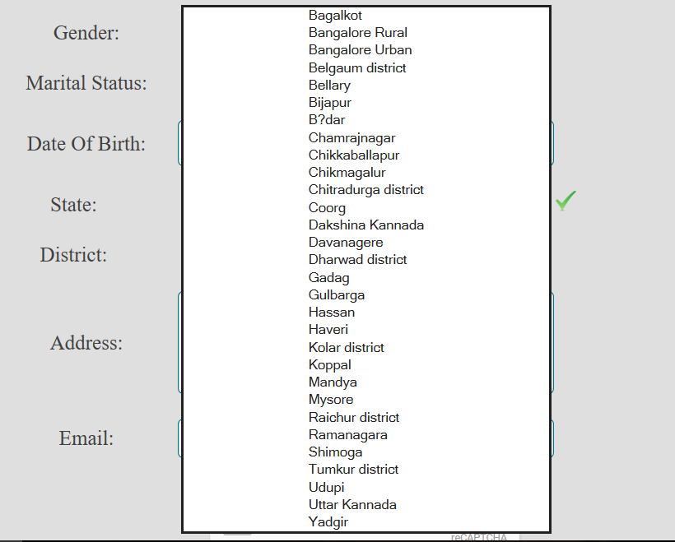

1. Password should match while creating new password with retype password.
2. The date for the Journey in the Viewdetails page is enabled only from present date.

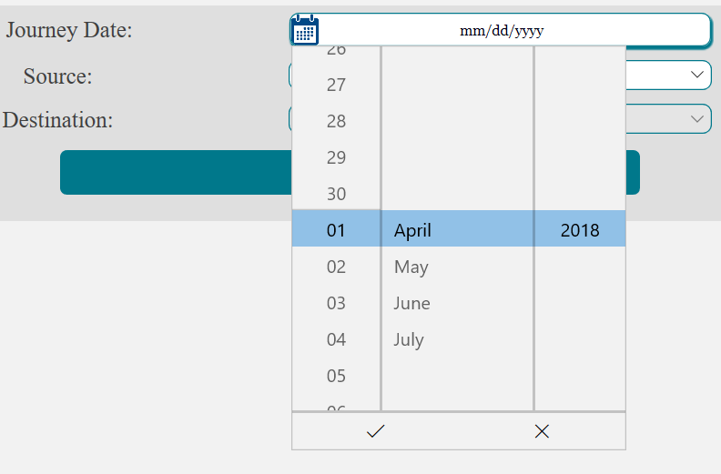

1. Tatkal option in quota is available only within 24 hours of the departure of the train from 10 a.m.
2. The Links in the navigation bar redirects to proper pages.
3. User is not allowed to access the train booking page until he/she is logged in.
4. Corresponding appropriate alert boxes for any failure.

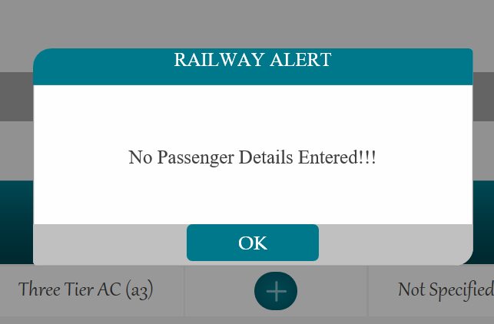

**FUTURE ENHANCEMENTS**

This project could be further enhanced adding the running status of the train with real time update.

Maintaining the record of all the railway Locomotives driving the Train per day. This will give an analysis based on Payment of the employes according to the miles travelled.

It is a research-oriented project as well the task of performance evaluation of different database designs for efficiency, is in this spirit.

**REFERENCES AND BIBLIOGRAPHY**

The references which provided the required information regarding understanding the whole Railway Reservation System are as follows.

Online Websites such as

* [www.irctc.com](http://www.irctc.com)
* [www.trainenquiry.com](http://www.trainenquiry.com)
* [www.indianrail.com](http://www.indianrail.com)
* www.etrain.info

In addition to these above mentioned resources, our Parents, Professors, Guardians also provided us with all the necessary information.